IFITT RMSIG

Reference Model Special Interest Group

Reference Model of an Electronic Tourism Market
(IFITT RM)

Version 1.3

Wolfram Höpken
wolfram.hoepken@etourism-austria.at

Abstract
The IFITT Reference Model Special Interest Group (IFITT RMSIG) serves as a platform for discussing and elaborating a methodology for harmonizing electronic tourism markets in an open and flexible manner. Based on a uniform language and standardized building blocks as vocabulary, the reference model enables the flexible description of processes and services within an electronic market, in a way understandable for other market participants. The reference model focuses on the modeling of electronic tourism markets on a conceptual level. In this way, the reference model supports interoperability of different market components, independent of the concrete physical representation of their processes and services.

Mô hình tham chiếu hỗ trợ như một nền tảng cho việc thảo luạn và chi tiết hóa cho chợ du lịch điển tử hỗn tạp. Trên cơ sở ngôn ngữ đồng dạng và tiêu chuẩn hóa các khói building block như bộ từ vựng, mô hình tham chiếu cho phép miểu tả mềm dẻo quá trình xử lý và các dịch vụ trong một chợ điện tử. Mô hình tham chiếu tập chung mô hình hóa các chợ du lịch điện tử ở mức khái niệm. Theo cái cách này, mô hình tham chiếu hỗ trợ liên tác các thành phần trong chợ điện tử khác nhau, độc lập với tầng biểu diễn vật lý về quy trình và các dịch vụ của chúng

Status of this document
This document is the official release 1.3 of the IFITT Reference Model of an Electronic Tourism Market (IFITT RM). This document incorporates the results of four IFITT RMSIG workshops and consists of the agreed methodology for elaborating a reference model, the basic modeling concepts and mechanisms as well as the application of this methodology. The included specification of tourism services and processes is based on the results of a series of surveys executed within the IFITT RMSIG. The aspects of multi-language support, selection hierarchies for selection relevant attributes and the BOI model – the specification of interfaces for distributed business objects as one concrete, physical modeling level – are only partly included in this version.

Content
Abstract 2
Status of this document 2
Content 3
1 Introduction 6
2 Methodology 8
2.1 Objective 8
2.2 Architecture of the reference model 9
2.2.1 Communication levels and mechanisms 9
2.2.2 Modeling levels 10
2.2.3 Tourism modeling language 14
2.2.4 Components of the reference model 15
2.3 Building concrete models 16
2.4 Implications on the tourism market 18
2.5 The modeling process 19
3 Requirement analysis 20
3.1 Requirements customer and broker to supplier 21
3.2 Requirements customer to broker 24
3.3 Requirements front-end supplier to broker 25
4 Conceptual model 28
5 Meta level 28
5.1 The virtual meta model 29
5.2 Structure of the meta level 29
5.3 Basic types 30
5.4 Common elements 32
5.5 Synonyms 33
5.6 Services 34
5.6.1 Composition mechanism 34
5.6.1.1 Structure of a composition 34
5.6.1.2 Construction of concrete compositions 36
5.6.1.3 Multiple person compositions 36
5.6.1.4 Composition mechanism metaclasses 37
5.6.2 Attributes 40
5.6.3 Views 42
5.6.4 Selection hierarchies 43
5.6.5 Component categories 47
5.6.6 Availability 47
5.7 Service states 49
5.8 Processes 51
6 Building blocks 54
6.1 Base layer 54
6.1.1 Basic types 55
6.1.1.1 Common types 55
6.1.1.2 Accommodation types 60
6.1.1.3 Attraction types 62
6.1.1.4 Catering types 63
6.1.1.5 Destination types 64
6.1.1.6 Event types 65
6.1.1.7 Facilities types 66
6.1.1.8 Institution types 68
6.1.1.9 Renting types 72
6.1.1.10 Seat types 75
6.1.1.11 Transport types 76
6.1.2 Base classes 77
6.1.3 Basic elements 78
6.1.4 Session processes 82
6.1.4.1 Open session process 83
6.1.4.2 Close session process 84
6.1.5 Lookup processes 85
6.1.5.1 Request metadata process 86
6.2 Entity layer 87
6.2.1 Common entities 88
6.2.2 Service components 90
6.2.2.1 Core service components 90
6.2.2.1.1 Accommodation components 91
6.2.2.1.2 Attraction components 94
6.2.2.1.3 Catering components 95
6.2.2.1.4 Event components 95
6.2.2.1.5 Renting components 97
6.2.2.1.6 Shopping components 101
6.2.2.1.7 Transport components 102
6.2.2.2 Supplemental components 102
6.2.2.2.1 Basic components 102
6.2.2.2.2 Destination components 105
6.2.2.2.3 Facilities components 106
6.2.2.2.4 Institution components 109
6.2.2.2.5 Means of transport components 112
6.2.2.2.6 Seat components 113
6.2.3 Elementary tourism services 115
6.2.3.1 Classification of elementary tourism services 116
6.2.3.2 Tourism service accommodation 119
6.2.3.2.1 Tourism service campsite 121
6.2.3.2.2 Tourism service hotel 122
6.2.3.2.3 Tourism service vacation apartment 123
6.2.3.3 Tourism service attraction 124
6.2.3.3.1 Tourism service exhibition 126
6.2.3.3.2 Tourism service museum 127
6.2.3.3.3 Tourism service sight 128
6.2.3.3.4 Tourism service sport leisure facility 129
6.2.3.4 Tourism service cruise 131
6.2.3.5 Tourism service destination 132
6.2.3.5.1 Tourism service city 133
6.2.3.5.2 Tourism service country 134
6.2.3.5.3 Tourism service region 135
6.2.3.6 Tourism service event 136
6.2.3.6.1 Tourism service conference 138
6.2.3.6.2 Tourism service course 139
6.2.3.6.3 Tourism service cultural event 140
6.2.3.6.4 Tourism service lecture 141
6.2.3.6.5 Tourism service sport event 142
6.2.3.7 Tourism service gastronomy 143
6.2.3.8 Tourism service hired vehicle 145
6.2.3.8.1 Tourism service hired airplane 147
6.2.3.8.2 Tourism service hired bike 148
6.2.3.8.3 Tourism service hired boat 149
6.2.3.8.4 Tourism service hired bus 149
6.2.3.8.5 Tourism service hired camper 150
6.2.3.8.6 Tourism service hired car 151
6.2.3.8.7 Tourism service hired motorbike 151
6.2.3.9 Tourism service shopping 152
6.2.3.10 Tourism service transportation 154
6.2.3.10.1 Tourism service bus ride 156
6.2.3.10.2 Tourism service flight 156
6.2.3.10.3 Tourism service ship passage 157
6.2.3.10.4 Tourism service train journey 159
6.2.3.11 Composition services 160
6.3 Process layer 164
6.3.1 Information processes 164
6.3.1.1 The selection process 165
6.3.1.2 Search process 166
6.3.1.3 Get availability process 168
6.3.1.4 Entities 169
6.3.2 Booking processes 170
6.3.2.1 Book service process 171
6.3.2.2 Alter booking process 174
6.3.2.3 Cancel booking process 176
6.3.2.4 Entities 178
7 XML model 179
7.1 DTD-based XML model 179
7.2 XMI-based XML model 180
8 BOI model 182
8.1 Meta level 183
8.2 Building blocks 183
8.2.1 Base layer 184
8.2.1.1 Base classes 184
8.2.2 Process layer 185
8.2.2.1 Information processes 186
8.2.2.1.1 Search process 186
8.2.2.1.2 Get availability process 187
References 190

Introduction
The present situation concerning the supply of tourism services is characterized by the coexistence of a multitude of service- and travel-type specific electronic markets (tourism markets). An electronic market is characterized by the set of offered services, the attributes describing the services, and the access to the offered services. The following problems result from the coexistence of heterogeneous electronic markets: các vấn đề là kết quả từ việc các trợ điện tử hỗn tạp cùng tồn tại:
- truy xuất không đồng dạng đến các dịch vụ du lịch khác nhau
- Không đồng dạng thông tin khả dụng hoặc thông tin được cung cấp cho các dịch vụ du lịch trong các chợ khác nhau.
- Không kết hợp được các chợ điện tử khác nhau hoặc là các hệ thống
- Chỉ các dịch vụ cụ thể khả dụng trong mỗi chợ (ví dụ: dịch vụ của các nhà cung cấp hoặc các loại dịch vụ cụ thể). Bao gồm tất cả tìm kiếm hoặc kết hợp các dịch vụ trong các chợ khác nhau là không thể.

- nonuniformity of the access to tourism services in different markets
- nonuniformity of the information which is available or has to be provided for tourism services in different markets
- no interoperability between different electronic markets or systems
- only specific services are available within each marke
- t (e.g. services of specific suppliers or specific service types); an all-embracing search or combination of services of different markets is not possible.
- service offerings have to be duplicated across different markets to reach all customers.
The objective to avoid these problems is the harmonization of different electronic markets and the merging of existing markets into one open electronic tourism market (Figure 1-1). Such a market enables the direct communication between all participants. The complete tourism value chain is integrated into this market.

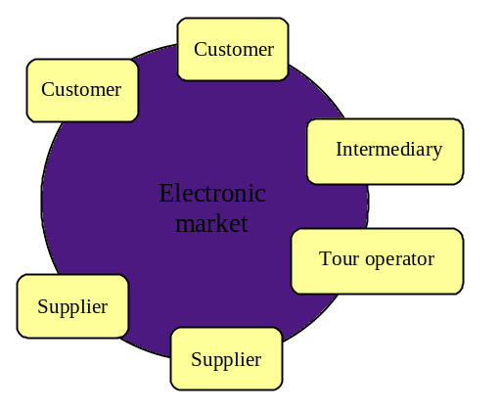
Figure 1-1: Model of the tourism market
Within the field of tourism a lot of initiatives dealing with standardization aspects have evolved in the past. Examples are UN/EDIFACT TT&L (United Nations rules for Electronic Data Interchange for Administration, Commerce and Transport – Travel Tourism & Leisure), HITIS (Hospitality Industry Technology Integration Standards), omnis-online, IATA (International Air Transport Association), TTI (Travel Technology Initiative), and ACRISS (Association of Car Rental Industry System Standards). However, a broad standardization, enabling global interoperability between tourism information systems has up to now not been reached due to the heterogeneity and diversity of tourism markets. A complete standardization of electronic markets for tourism services is unlikely to be achieved for the future as well and would even not be sensible due to the following issues:
- one fix standard is not flexible enough to consider all specific details of different electronic markets
- one fix standard is not flexible enough to be adapted to occurring changes
- one fix standard does not offer the possibility for suppliers of tourism services to differentiate their offer
Instead of fix standards, an open and flexible harmonization of electronic tourism markets is needed. Several current initiatives elaborate XML-based specifications of tourism markets e.g. OTA (Open Travel Alliance) or XML/EDI. Using XML (eXtensible Markup Language, Bray 1998), fix structured data are substituted by semi-structured data and a common vocabulary and a uniform syntax enable a more flexible description of tourism services.
However, XML-based languages only enable the modeling on a physical level, specifying the exact syntax of XML documents (dependent for example off tag naming conventions or the usage of XML attributes vs. embedded elements, etc.). Analog to previous standardization initiatives, it is unlikely that all market participants will commit to one physical representation of their processes and services. Instead, different XML-based languages for different electronic tourism market will evolve without interoperability between those different markets.
In order to reach global interoperability we need a conceptual modeling, focusing on semantic aspects of the tourism domain, which is independent of the concrete physical representation. This conceptual model enables interoperability between different market components, based on different physical representations.

Methodology

Objective
The objective of the IFITT RMSIG is to elaborate and implement a methodology for harmonizing electronic tourism markets. In order to avoid the problems of past standardization initiatives, this methodology has to take into consideration the following requirements:
- Interoperability of different electronic markets or systems, independent of their physical representation
- Flexibility and extendibility (to be adaptable to specific requirements or changes)
This objective will be reached by providing a framework for modeling electronic tourism markets, a reference model. Instead of a fix standard the reference model provides an open specification of electronic tourism markets based on a uniform language and a common vocabulary. In this way, the reference model enables the description of specific models in a form understandable for other market participants.
The reference model focuses on the modeling of market processes and tourism services on a conceptual level, independent of their physical representation (e.g. representation as XML documents or distributed objects). Instead of specifying details of the physical model (e.g. XML DTDs or IDL descriptions), the conceptual model describes semantic aspects of electronic tourism markets, i.e. elements and their relationships. Different physical models can then be derived from the conceptual model and interoperability between different physical models can be achieved. E.g. different physical XML models with different DTDs can be derived from one conceptual model and the conceptual model enables a mapping between those different XML models.
The concept of a uniform language and a common vocabulary for describing electronic tourism markets leads to the following basic components of the reference model:
- Tourism modeling language: A tourism-specific modeling language with standardized building blocks as vocabulary enables the flexible description of components of the electronic market. A supplier, who provides a component within the electronic market, can describe his specific component in a form understandable for other market participants. The tourism specific language is based on the Unified Modeling Language (UML 1999). The UML is a universal, standardized modeling language and enables modeling on a conceptual level, independent of any physical representation.
Building blocks: As vocabulary for describing electronic tourism markets the reference model provides a modeling library in the form of standardized building blocks and in this way, enables the flexible construction of concrete models for components of the electronic market (i.e. tourism information systems). The provided building blocks can be derived and tailored to specific requirements as well as composed to new building blocks or specific models. The modeling library provides building blocks on different levels of granularity – starting with elementary building blocks (e.g. date, time…) over more complex building blocks (e.g. tourism services) up to process building blocks, representing entire processes (e.g. search process, booking process, etc.).
The construction of concrete models for components of the electronic tourism market is based on the following fundamental mechanisms:
- composition
The building blocks provided by the reference model are composed to new, more complex building blocks. A specific booking object for example can be composed of the given building blocks customer data and tourism service or a new tourism service can be composed of the elementary building blocks date, time, location or meal plan. The standardized building blocks, being part of the specific building blocks and the use of a language with a uniform syntax for describing the structure of building blocks enable the interoperability between different market components.
- derivation
The building blocks provided by the reference model are derived and tailored to meet specific requirements. The service hotel for example can be extended by the attribute cure services or the building block customer data by a supplier-specific customer number. Participants, who know the new building block, can use its specific characteristics. Participants, who do not know the new building block, can use it in the same way as the original one.
The use of the reference model and the resulting harmonization of heterogeneous electronic tourism markets and global interoperability between communication partners offer the following advantages:
- Uniform access to the services of different suppliers: The harmonization of electronic tourism markets enables the uniform access to the services of different suppliers. In this way, an all-supplier-embracing search for services is enabled. The services of different suppliers become comparable and can be combined during the selection of an overall service (e.g. a package tour).
- Direct communication between all participants: The global interoperability enables the direct communication between all participants of existing tourism markets (suppliers, tour operators, intermediaries, customers). The complete tourism value chain can be integrated into one open market. The relationships between the participants can be built up dynamically and new services (e.g. specific intermediary services) can be provided in a flexible way.
- Maximal customer reachability: Within the open electronic market, resulting from the global interoperability, a service can be offered to all participants of existing markets. Thus, the open market supports all possible distribution channels and makes a multiple supply of a service within different markets unnecessary.
- Flexible construction of market components: The reference model enables the flexible construction of concrete market components, tailored to meet specific requirements, and nevertheless enables their interoperability.
- Possibility to differentiate offered services: The reference model offers the possibility for suppliers of tourism services to differentiate their offer. Tourism services can be extended by specific attributes (e.g. the service hotel by the attribute cure services) or new tourism services can be constructed from building blocks provided by the reference model.
- Flexibility for change: Building blocks can be extended or new building blocks can be added without affecting existing market components. Therefore, adapting the reference model to new requirements can be done easily.

Architecture of the reference model

Communication levels and mechanisms
The communication between the participants of electronic tourism markets can be based on different communication levels and mechanisms (e.g. exchange of structured messages or documents, distributed objects, etc). Different communication mechanisms result in different physical representations or models, which have to be derived from the conceptual model. This section identifies different communication levels and mechanisms, which are of relevance for the reference model.
Message level. The communication between two participants takes place via the exchange of messages. Using a service is carried out by the exchange of a series of messages following a committed protocol.
According to the type of exchanged messages it can be differentiated between
- structured messages
The communication between two participants takes place via the exchange of fix-structured messages (e.g. EDIFACT). The message structure has to be committed between the participants before the communication starts.
- self-describing documents
The communication between two participants takes place via the exchange of self-describing documents. Beside the exchanged data the documents contain information about their structure (meta data). Therefore, the structure of the documents is not completely fixed, but can vary. The recipient can determine the structure of a document from the meta data. Possible languages for self-describing documents are e.g. SGML or XML.
Due to the extendibility and flexibility of XML (in contrast to fix-structured messages), the reference model will focus on XML documents on the message level. However, any other physical representation, using a different description language or message format (e.g. EDIFACT) can be derived from the conceptual model and market components using these physical representations can be integrated into the open electronic tourism market.
Distributed object level. The communication between two participants takes place based on distributed objects. Here, the fundamental communication mechanism is the remote method invocation (RMI). The services are provided as distributed objects. The market interface corresponds to the interfaces of the distributed objects, which are described by a special, programming language independent interface definition language (IDL).
The message level enables a looser coupling, offers more flexibility and an easier integration of existing applications. The distributed object level enables a tighter coupling, a more efficient communication, a higher semantic consistency and a better support of developing applications for market components (compare Glushko, 1999). As both levels have advantages and disadvantages depending on the type of communicating market components, the reference model will consider both levels. In contrast to the document level, the distributed object level provides a better link between the data and its processing. In this way, the distributed object level ensures the transferability of the document level into market applications.

Modeling levels
The reference model focuses on a modeling of electronic tourism markets on a conceptual level, independent of any physical representation and communication mechanism. For each communication level or mechanism then has to be derived a corresponding physical model. specifying all details of the physical representation (see Figure 2-2). Here, deriving a physical model from a conceptual model is not necessarily unambiguous. E.g. different physical XML models can be derived from one conceptual model. XML models could for example differ in the way representing attributes of an object (as embedded XML elements or as XML attributes). Based on a common conceptual model for different physical models, the reference model enables a mapping between different physical models. Therefore, the reference model does not define a fix schema for deriving a physical model for a specific communication mechanism but just provides one possible derivation schema.

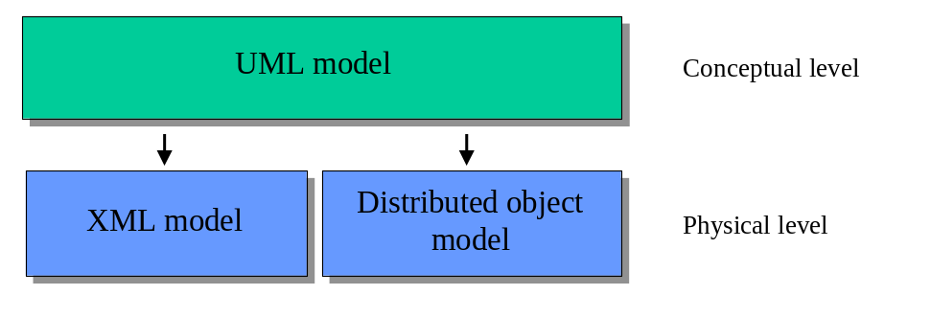
Figure 2-2: Levels of the reference model
XML models
The descriptions of specific XML models (i.e. the metadata) are provided to the communication partners in the form of DTDs (Document Type Definition). XML DTDs concentrate on structural information and lack in the ability of expressing semantic aspects of the model (e.g. relationships between elements of the problem domain), which can be expressed within UML models and are necessary for the interoperability of different market components. XML tags certainly contain semantic information for a human observer (at least if they follow a common understanding of the problem domain or if they are defined within a common vocabulary) but not any machine-readable semantic information. Approaches to replace XML DTDs by more expressive metadata languages, e.g. XML Data (Layman 1998), SOX (Schema for Object-oriented XML, Davidson 1999) or DDML (Document Definition Markup Language, Bourret 1999), aim to eliminate this shortcoming.
Because of the shortcomings of XML DTDs, the reference model additionally considers XMI (XML Metadata Interchange) for exchanging modeling information between the communication partners. XMI is a standardized, XML-based language for serializing UML models and can replace or complement XML DTDs. In this way, the complete information of the UML models is available for the communication partners in machine-readable form.
Figure 2-3 illustrates the architecture of the reference model from the XML perspective. The abstract, conceptual UML model specifies all relevant elements of the problem domain tourism (their characteristics, their relationship, etc.). For all elements of the UML model XMI documents and XML DTDs (Document Type Definitions) are generated, which are exchanged between the communication partners. The concrete communication takes place based on XML documents, which are constructed from the XMI documents (or the XML DTDs).
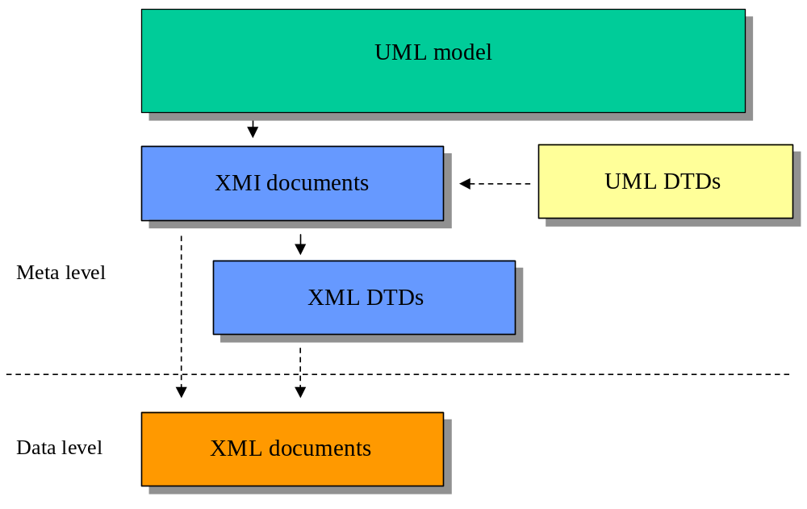
Figure 2-3: XML perspective
The relationship between the different levels is demonstrated in Figure 2-4 by the example of the tourism service Hotel. From the tourism service Hotel a XMI document and a XML DTD are generated containing the characterization of the service Hotel and providing it to the communication partners. The description of a concrete Hotel is then exchanged between the communication partners as a XML document. Extensions of the model, e.g. the derivation of a specific tourism service SportHotel, are executed within the UML model and the corresponding XMI documents and XML DTDs are derived.
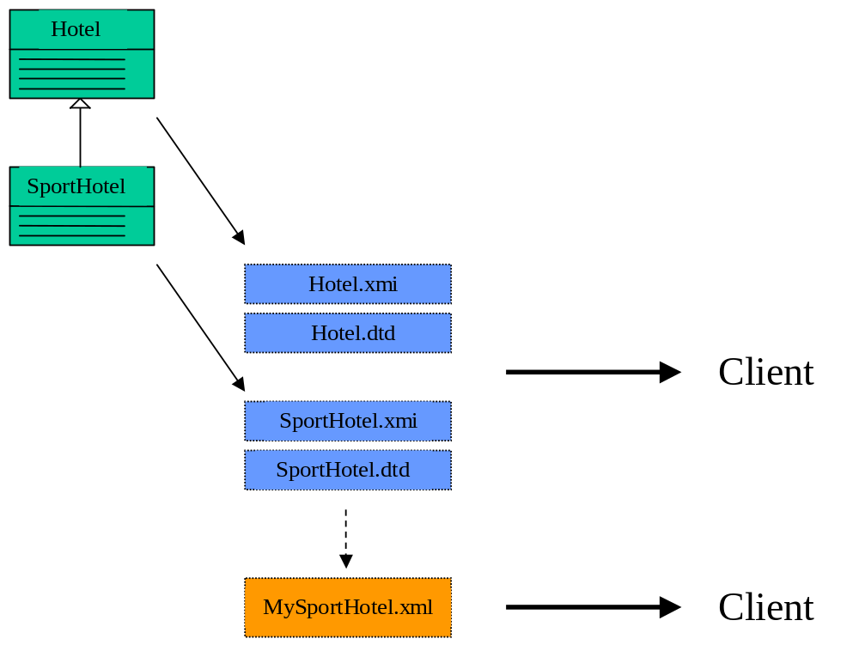
Figure 2-4: Example XML perspective
Distributed object models
The descriptions of specific distributed object models (i.e. the metadata) are provided to the communication partners in the form of interface descriptions using the IDL (Interface Definition Language). Analogous to XML DTDs, IDL descriptions cannot express the complete UML models and the reference model additionally considers XMI descriptions to replace or complement IDL descriptions.
Figure 2-5 illustrates the architecture of the reference model from the perspective of distributed objects. For modeling distributed objects the conceptual UML model has to be extended by specifications of the business objects i.e. their interfaces (BOIs). In order to enable maximal flexibility and extendibility as well as seamless transition from distributed object models to XML models, the elements of the conceptual model are reused within the modeling of the distributed objects. Therefore, for an element of the conceptual UML model an element within the BOI model is provided containing the element of the conceptual model. In this way, fix object attributes are substituted by semi-structured data (based on XML). Analogous to the elements of the conceptual model, XMI documents as well as IDL descriptions are provided for the BOIs. The runtime objects (BOs), instantiated of the XMI documents or IDL descriptions, then contain the corresponding XML document, which itself contains the object data.
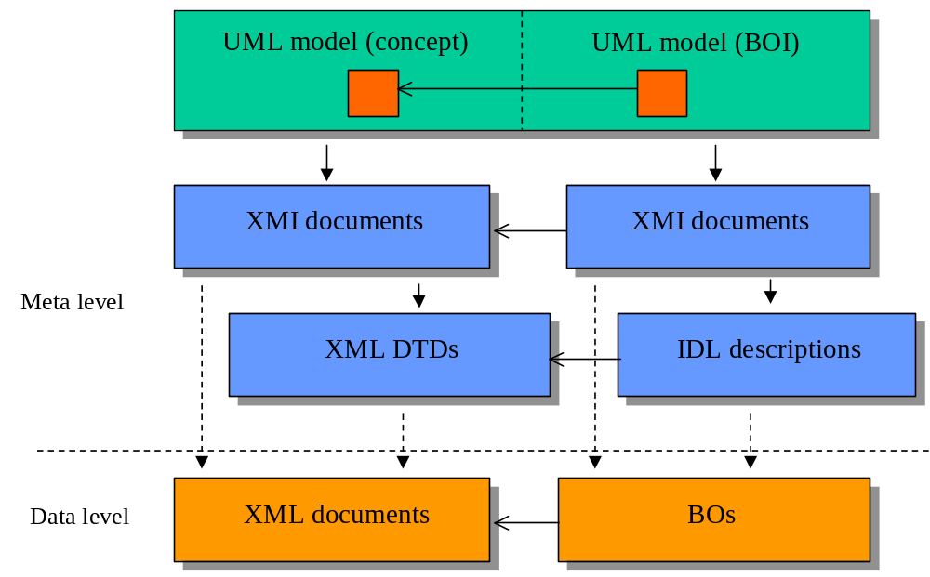
Figure 2-5: Distributed object perspective
Figure 2-6 demonstrates the relationship between the different levels by the example of the tourism service Hotel. In addition to the element Hotel within the conceptual model, there now exists a business object BOIHotel. For this business object the corresponding XMI document and IDL description are generated. The instantiated runtime object contains its data not as fix attributes but as an XML document. While deriving the specific tourism service SportHotel it is now possible to simply add a specific element within the conceptual model with specific characteristics. It is not necessary to modify the business object. In this way, extensions of the model on the level of distributed objects can be executed without implicating changes of the applications. When moving from the level of distributed objects to the XML level the XML documents contained within the business objects can be reused directly.
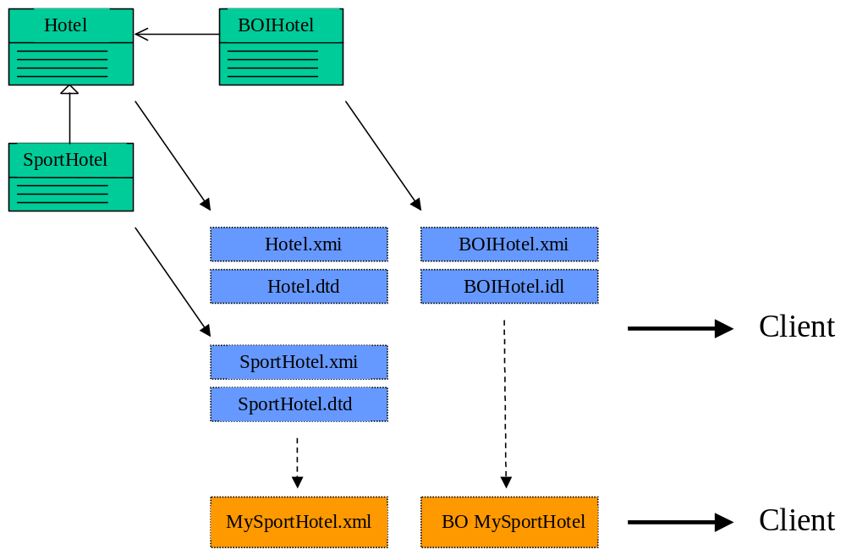
Figure 2-6: Example distributed object perspective

Tourism modeling language
The reference model provides a tourism modeling language, based on the UML (Unified Modeling Language). The tourism modeling language extends the UML by domain specific concepts and mechanisms and enables the flexible description of specific models for specific tourism market components. In addition to basic concepts and mechanisms and common types at the fringe of the language, the tourism modeling language uses common building blocks as specific modeling elements.
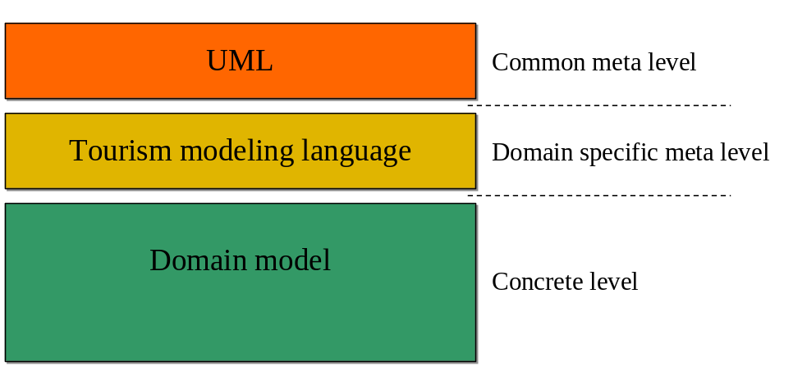
Figure 2-7: Tourism modeling language

Components of the reference model
Figure 2-8 shows the different components of the reference model. The metalevel extends the UML (UML metamodel) and provides metaclasses as tourism specific modeling elements. The metalevel of the reference model is further subdivided into the following packages:

- types: metaclasses, providing basic type concepts.
- common elements: metaclasses, which are used in different
packages of the metamodel
- tourism services: metaclasses, providing concepts for constructing tourism services
- service states: metaclasses, providing concepts for different states of tourism services (potential service, offered service, booked services,…).
- processes: metaclasses for describing market
processes and interfaces
- synonyms: metaclasses for defining synonyms for elements of the reference model

The building blocks are common modeling components for reuse and support the construction of concrete models on different levels of granularity. The building blocks provided by the reference model are divided into three layers, building on one another (Figure 2-8):
- base layer
The base layer provides modeling elements for common, not problem-domain-specific services, basic elements (e.g. period, address, temperature), base classes and basic types (e.g. room type, bed type) and serves as a foundation for building the upper layers.
- entity layer
The entity layer contains common entities of the problem domain tourism, e.g. tourism services like flight or hotel, composition services or customer data.
- process layer
The process layer provides building blocks, which represent complex processes of the domain tourism (e.g. searching, booking, canceling) or which are necessary for the execution of such processes. Functional related processes or process steps are put together to independent modules.
The structuring of the reference model into layers and modules supports the flexible construction of concrete models. Single modules can be used, extended or modified separately and new modules and building blocks can be provided founding upon the lower layers. The layers of the reference model provide building blocks in differing granularity. In this way, the reusability and interoperability is supported from the layer of basic elements up to the layer of complex processes.
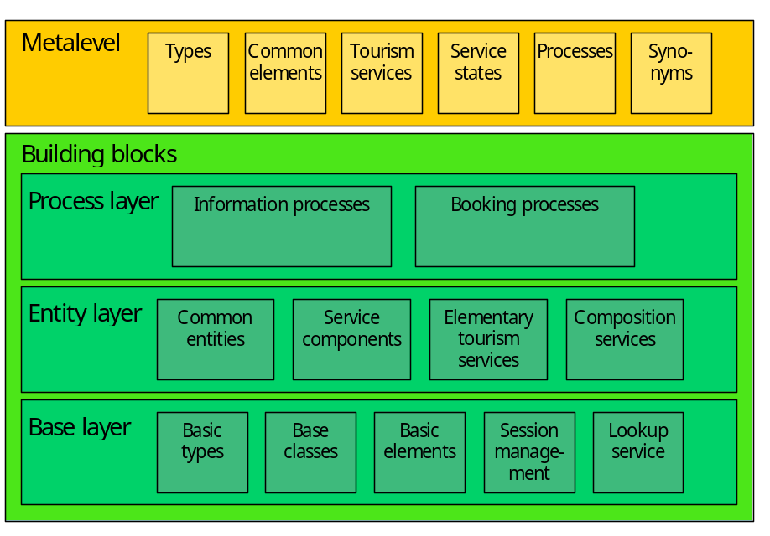
Figure 2-8: Components of the reference model

Building concrete models
The reference model enables the construction of specific models for specific market components. Based on the tourism specific modeling language, providing basic concepts and mechanisms for modeling electronic tourism markets, specific models can be described in a flexible way, understandable for other market participants. By using the tourism modeling language a supplier could for example describe a specific tourism service, its structure, its characteristics and its relationships to other tourism services.
In the first place, the reference model enables the construction of specific models on a conceptual level, independent of any details of the concrete physical representation (e.g. representation as XML documents). Such a conceptual model then serves as basis for deriving specific physical representations or physical models. Communicati ng market participants could therefore in a first step construct their specific conceptual model, containing all concepts and semantic aspects of their specific model, and in a second step derive one or several concrete physical models (e.g. different XML representations or different physical representations for different communication mechanisms like XML, structured messages, distributes objects, etc.). Thus, the reference model not only enables the construction of specific conceptual models but as well supports the derivation of specific physical models or physical representations from a conceptual model.
As one important mechanism for constructing specific models, the reference model provides common building blocks as specific modeling elements. These building blocks can be used in the following ways:
- specific building blocks are constructed by composing existing building blocks (especially of the underlying layers)
- specific building blocks are derived from provided building blocks and tailored to meet specific requirements
- provided building blocks are taken over without changes
From this result the following possibilities of using the building blocks of the reference model for constructing concrete models for components of the electronic market:
- Specific building blocks of the market component are constructed by composing the building blocks provided by the reference model, e.g. a specific tourism service MoonFlight is constructed by composing general building blocks like Category, Room and Time or a specific flight service by composing the building blocks Time, Route, Class and MealPlan. The specific building blocks can be understood and used by other market components because of the contained general building blocks.
- Specific building blocks of the market component are derived from the building blocks provided by the reference model and tailored to meet specific requirements. A specific tourism service CureHotel for example could own the additional building block CureServices. If those specific characteristics of a building block are not known by other market components, such building blocks can be used just as the general building block provided by the reference model. If the specific characteristics are known, e.g. the additional attribute of a booking, they can be used, for example for the selection of a service.
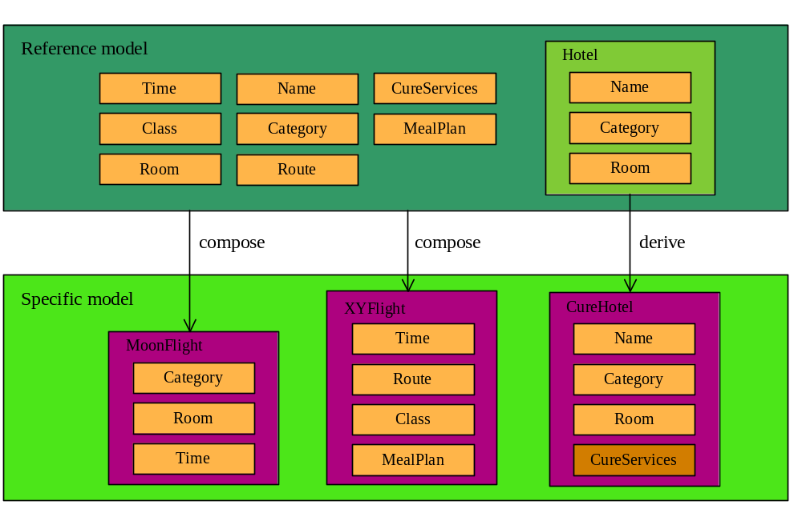
Figure 2-9: Building concrete models
Figure 2-10 illustrates the use of the reference model. The building blocks, provided by the reference model are available for all communication partners. A supplier can provide a specific tourism service by selecting building blocks of the reference model (1) and composing a specific building block (2). On demand the customer obtains a description of the specific building block (4). The customer can understand the specific building block because he knows the way the building block is structured, due to the use of a common language, and he knows the contained components (5). In this way, the collection of building blocks of the reference model can be extended dynamically and sub-vocabularies for parts of the tourism domain can evolve.
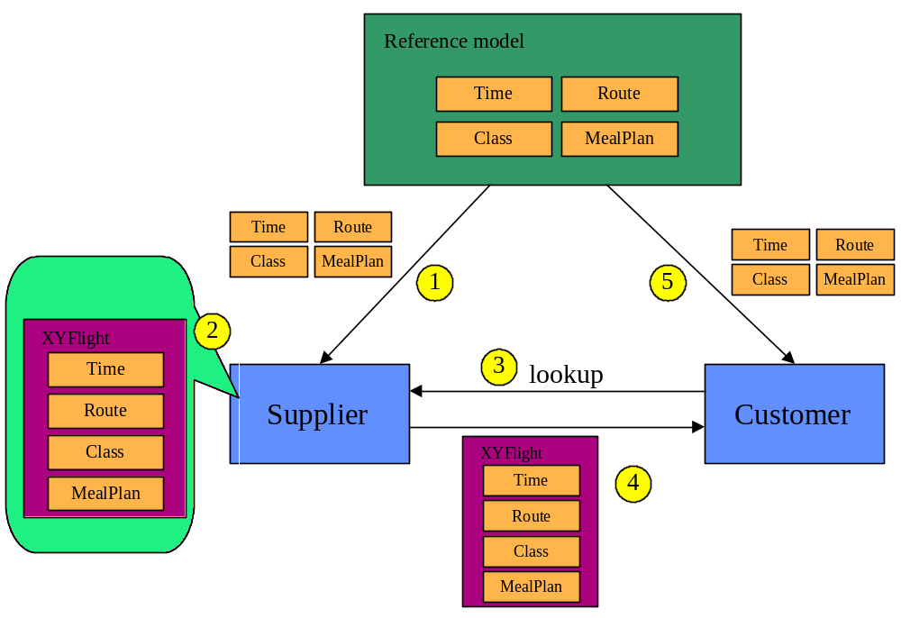
Figure 2-10: Extendibility

Implications on the tourism market
The reference model enables the uniform description of heterogeneous electronic markets and their interoperability. The use of such a reference model has the following implications on the tourism market and its participants:
- The interoperability of different systems leads to one open electronic tourism market instead of the different existing markets. The complete value chain is integrated into this open market.
- All participants of this open electronic market can communicate directly. Because of the possible direct communication between suppliers (tour operators) and customers, the intermediaries (as a link between customer and supplier) can be bypassed, especially in the case of experienced customers and elementary, not advice-intensive services. Therefore, the field of activity of the intermediary will shift to the supply of intermediary services within the electronic market.
- In an open market with a great amount of available services the need for intermediary services will increase. The supply of metadata, bundling of requests, forwarding of requests to relevant suppliers and supply of additional information will be typical intermediary services within the open electronic market.
- Due to the easy access to all tourism services and the comparability of the services of different suppliers, the market transparency for the customer and the power of demand of the customer over the supplier will increase. The open market will become more customer-oriented than the existing markets and the customer will be increasingly integrated into the value chain.
- The access to the open electronic market is easier than to existing markets. Therefore, the number of participants will increase (especially small suppliers and tour operators) and industry newcomers will enter this open market, especially as intermediaries.
- Increasing competition between participants will lead to increasing consolidation. Consolidation will not only take place between participants on the same level of the value chain (e.g. suppliers of the same services or tour operators) but as well between participants on different levels of the value chain. Especially an increasing expansion of suppliers (particularly of several suppliers of different services) in the direction of the corresponding tour operators and vice versa can be expected.

The modeling process
The elaboration of the reference model is mainly done by the method of the domain analysis (Booch, 1994). Executing a survey within the IFITT RMSIG as well as analysing existing standards of the tourism domain and tourism information systems, i.e. electronic tourism markets, are the main techniques used for analysing the tourism domain. For specific parts of the model, i.e. layers or modules, the domain analysis is complemented by the use case analysis (i.e. scenario analysis).
The elaboration of a set of standardized building blocks is started on the level of elementary building blocks (e.g. date, location, meal plan…). These elementary building blocks are gradually composed to more complex building blocks up to process building blocks, which represent complex processes like searching or booking.
The following modeling process is laid down for the elaboration of the reference model:

Phase | Activities | Results
Requirement definition | - Specification of the participants of the electronic market and their requirements  - Specification of general requirements | - Requirement catalogue  - Relevant processes / function points
Domain analysis | - Analysis of existing markets or systems  - Survey within the IFITT RMSIG | - Domain information base
Specification of tourism modeling language | - Identification of basic concepts and mechanism for modeling tourism markets  - Specification of all necessary elements of the tourism specific modeling language | - Tourism Modeling Language
Specification of building block library | - Modeling of all building blocks and their relationships, beginning with elementary building blocks, over more complex building blocks up to process building blocks  - Classification of tourism services as central building blocks | - Library of general building blocks
Table 2-1: The Modeling Process

Requirement analysis
The requirement analysis aims to identify all requirements for electronic tourism markets, which have to be taken into consideration within the reference model. In a first step, all relevant types of market participants have to be identified (e.g. customer or supplier). In a second step, the functional and non-functional requirements of all market participants to each other as well as the resulting use cases of electronic tourism markets have to be identified.

Mục đích phân tích yêu cầu để xác định tất cả các yêu cầu cho các thành phần trong chợ điện tử, mà được suy xét trong mô hình tham chiếu. Trong bước đầu tiên, tất cả các kiểu người tham dự thích hợp được xác đinh (customer, supplier). Trong bước 2, các yêu cầu chức năng và phi chức năng của các thành phần tham dự chợ với nhau cũng như các use case kết quả của chợ điện tử được xác định.

Figure 3-11 shows all different types of participants of electronic tourism markets.
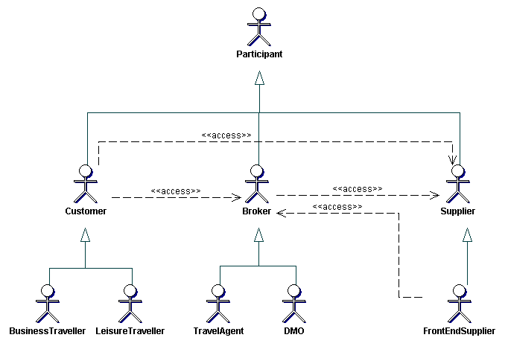
Figure 3-11: Participants of electronic tourism markets
Class Broker
The participant class Broker represents all participants, acting as a broker or intermediary within the electronic market. Brokers may offer special market functions or processes like periodical requests (search requests or availability requests), execution of event-triggered requests (e.g. booking by falling below a price limit), provision of market information (who offers which services) or bundling of requests.
Thành phần tham gia lớp broker biểu diễn cho tất cả các bên tham gia, hoạt động như một broker hoặc thành phần trung gian trong chợ. Broker có thể đưa ra các chức năng hoặc xử lý yêu cầu (yêu cầu tìm kiếm hoặc yêu cầu độ khả dụng), thực thi event-trigger (ví dụ: đặt dưới giá giới hạn),

Class BusinessTraveller
The participant class BusinessTraveller represents all customers demanding tourism services for business purpose.
Lớp thành phần tham gia BusinessTraveller biểu diễn tất cả các khách hàng đòi hỏi các dịch vụ du lịch cho mục đích thương mại
Class Customer
The participant class Customer represents all participants demanding a tourism service. Concerning the access of the customer to the electronic market, the direct access of the customer to a supplier or broker within the electronic market as well as the indirect access via a travel agent has to be considered.

Lớp thành phần Customer biểu diễn tất cả các thành phàn yêu cầu 1 dịch vụ du lịch. Việc truy nhập của khách hàng vào chợ điện tử, Khách hàng truy xuất trực tiế đến một nhà cung cấp hoặc broker trong chợ điện tử, cũng như truy xuất trực tiếp thong qua một đại lý agent.
Class DMO
The participant class DMO (Destination Management Organisation) represents a specific participant type, acting as a broker between a tourism destination and the customer.

Lớp thành phàn DMO biểu diễn loại thành phần thành phần tham gia hoạt động như một broker giữa một địa điểm du lich và khách hàng.

Class FrontEndSupplier
The participant class FrontEndSupplier represents all suppliers using the market component of a broker to offer tourism services instead of operating their own market component (application server). A typical front end suppliers would be a small hotel, providing and maintaining its services on the server of a broker (e.g a system like Tiscover).

Thành phần tham gia Front end supplier biểu diễn tất cả các nhà cung cấp sử dụng thành phần chợ của 1 broker đưa ra các dịch vụ du lịch thay vì tự thực thi các thành phần chọ của chúng (áp dụng cho server ). Một loại front end supplier đặc biệt là một khách sạn nhỏ, cung cấp và bảo trì các dịch vụ của nó trên server của broker

0
Class LeisureTraveller
The participant class LeisureTraveller represents all customers demanding tourism services for leisure purpose.
Người du lịch sử dung các dịch vụ du lịch cho mục đích giả trí
Class Participant
The class Participant represents all participants of electronic tourism markets.
Biểu diễn tất cả các thành phần của các chợ điện tử
Class Supplier
The participant class Supplier represents all participants offering tourism services within the electronic market like airlines, hotels, car rental companies or tour operators.

Biểu diễn tất cả các thành phần tham gia đưa ra các dịch vụ du lịch trong chợ điện tử như airlient, hotel, công ty thuê xe ô tô hoặc người điều kiển tuor
Class TravelAgent
The participant class TravelAgent represents a specific type of broker, acting as an agent for a customer. Beside traditional travel agents (high street travel agents) online travel agents have to be taken into consideration, offering their services within the electronic tourism market.

Requirements customer and broker to supplier
Customers and brokers have got the following requirements to suppliers of tourism services:
Khách hàng và các nhà trung gian có các yêu cầu sau tới nhà cung cấp các dịch vụ du lịch:
Lựa chọn một dịch vụ du lichj
Một thành phần nhà cung cấp đưa ra chức năng tìm kiếm cho một dịch vụ du lịch, Nó thực hiện yêu cầu cụ thể của người dùng (customer hay broker). Trong quá trình xửa lý lựa chọn này, các khía cạnh được suy xét:
  - phát biểu mập mờ, yêu cầu không chính xác. Khi tìm kiếm dịch vụ du lịch với các đặc điểm rõ rang, người sử dụng có thể phát biểu mập mờ, các yêu cầu không chính xác ví dụ: Tìm kiếm một dịch có nhiệt đô ám, một khách sạn trung bình
  - Biểu diễn các kết quả tương tự. Như kết quả của việc tìm kiếm yêu cầu được biểu diễn các kết quả tương tự. Thực hiện các yêu cầu chỉ đến một mức độ chắn chán nào đấy
  - Kết hợp các dịch vụ: Quy trình lựa chọn để hỗ trợ lựa chọn đồng thời nhiều dịch vụ, kết hợp tạo ra một gói dịch vụ (ví dụ: dịch vụ accommodation và dịch vụ đi lại tao thành một gói du lịch). Quá trình xử lý này chắc chán c
Selection of a tourism service
A supplier component has to offer the functionality of searching for a tourism service, which fulfills specific requirements of the user (customer or broker). Within this selection process, the following aspects have to be considered:
- formulation of vague, imprecise requests
When searching for a tourism service with specific characteristics, the user has the possibility to formulate vague, imprecise requests, e.g. searching for a destination with warm temperature or a hotel with a medium category.
- presentation of similar results
As result of a search request are presented similar results, fulfilling the requirements only to a certain degree.
- composition of services
The selection process has to support the simultaneous selection of several services, composed to a service package (e.g. an accommodation and transportation service to a package tour). This process especially has to ensure the combinability of composed services as well as the completeness of the composition.

Yêu cầu sẵn sang. Yêu cầu sẵn sang kiểm tra hoặc xác định tính sẵn sang của một dịch vụ
Xử lý đặt: xử lý đặt chuyển hoàn toàn quy trình xử lý đặt dịch vụ. cụ thể, các chức năng dưới được cung cấp:
  - Đặt một dịch vụ du lich. Một dịch vụ du lịch được lựa chọn hoăc dịch vụ kết hợp được đặt cho một khách hàng cụ thể, được miêu tả bởi tát cả dữ liệu cần thiết về khách hàng. Quy trình đặt kết hợp nhiều dịch vụ cơ bản được thực thi như một hành động nguyên tử (nhỏ nhất)
  - Thay đổi và hủy đặt (booking of a tourism service): việc đặt dịch vụ đã được thự hiện trước có thể được thay đổi (ví dụ: thay đổi dữ liệu khách hàng hoặc dịch vụ du lịch) và bị hủy.
  - Giới hạn trả tiền (term of payment): Khi đặt một dịch vụ du lịch, việc trả tiền cho phép thực thi bằng các phương thức khác nhau và trong 1 hình thức chắc chán.
Availability request
The availability request checks or determines the availability of a tourism service.
Booking execution
The booking execution has to cover the complete process of booking a tourism service. In particular, the following functionality has to be provided:
- booking of a tourism service
A selected tourism service or service composition is booked for a specific customer, described by all necessary customer data. The process of booking a composition of several elementary services has to be executed as an atomic action.
- booking modification and cancellation
A previously executed booking can be modified (e.g. changing customer data or the tourism service) and cancelled.
- terms of payment
When booking a tourism service, the payment has to be enabled by different methods of payment and in a secure way.

Yêu cầu các thong tin xa hơn (Request for further information ). Thong tin xa hơn về dịch vụ du lich (ví dụ. Nhiều thông tin miêu tả chi tiết, hình ảnh, video..), được cung cấp bởi nhà cung cấp

Quản lý thong tin người dùng (User profile management). Thông tin người sử dụng, chứa thông tin về khách hàng để hỗ trợ việc lựa chọn và xử lý đặt dịch vụ. Các hồ sơ này được tạo và quản lý bởi khách hàng.

Request for further information
Further information about tourism services (e.g. more detailed descriptions, pictures, videos etc.) have to be provided by the supplier and made available additionally to the selection relevant characteristics.
User profile management
User profiles, containing information about the customer e.g. preferences, have to be used to support the selection and booking process. Those profiles have to be created and managed by the customer.
Enabling customer bonus (Cho phép thưởng cho khách hàng)
Các cơ chế thưởng cho khách cho phép thực hiện trong quy trình đặt
Customer bonus mechanisms (e.g. frequent flyer programs etc.) have to be enabled within the booking process.

Feedback management ( quản lý phản hồi)
Quản lý phản hồi phủ tất cả các khía cạnh cung cấp phản hồi được sử dụng các dịch vụ du lịch đến nhà cung cấp và đến các khach hàng khác. Khách hàng, sử dụng dụng dịch vụ cụ thể có thể cung cấp phản hồi đến nhà cung cấp. Trong suốt quy trình lựa chọn một khách hàng có thể yêu cầu phản hồi cho dịch vụ du lịch được lựa chọn bởi các khách hàng khác.

Feedback management covers all aspects of providing feedback about used tourism services to the supplier and to other customers. The customer, who used a specific tourism service can provide feedback to the supplier. During the selection process a customer can request the feedback for a selected tourism service given by other customers.

Request for metadata
When accessing a market component, the user must have the possibility to request a description of the market component - the available services and the service structure. The availability of such metadata is a prerequisite for learning the structure of specific market components and reaching interoperability between specific market components.

Cơ chế truy cập: Access mechanisms
Khi cho phép truy cập dữ liệu của một thành phần chợ (ví dụ: các dịch vụ du lich, thong tin đặt, dữ liệu khách hàng), một cơ chế truy cập đảm bảo chắc chắn và cho phép truy xuất.

Access mechanisms
When enabling access to data of a market component (e.g. tourism services, booking information, customer data), an access mechanism has to ensure secure and authorized access.

Hỗ trợ các ngôn ngữ khác và chuyển tiền (Support of different languages and currencies )

Cho phép thực thi rộng khắp và trao đổi thong tin, các ngôn ngữ khác nhau và các định dạng cụ
To enable world-wide interoperability and information exchange, different languages and country-specific formats (e.g. currencies) have to be considered.
Figure 3-12 shows all use cases of a supplier market component for a customer or broker.
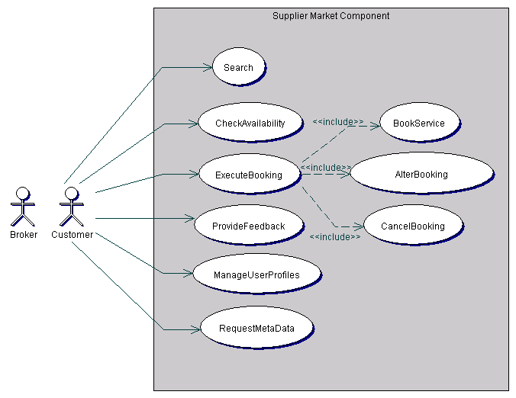
Figure 3-12: Use cases of a supplier market component for a customer or broker
UseCase AlterBooking
The use case AlterBooking represents the process of altering a booking, i.e. adding, removing or altering the booked tourism service or altering the customer data.
Thay đổi đặt: biểu diễn quy trình thay đổi việc đặt ví dụ: thêm, xóa thây đổi dịch vụ đã đặt hoặc thay đổi dữ liệu khách hàng.
UseCase BookService
The use case BookService represents the process of booking a tourism services or a composition of several tourism services.

Dặt dịch vụ biểu diễn quy trình đặt 1 dịch vụ hoặc kết hợp nhiều dịch vụ du lịch

UseCase CancelBooking
The use case CancelBooking represents the process of canceling a booking.

Hủy đặt: biểu diễn quy trình hủy đặt dịch vụ
UseCase CheckAvailability
The use case CheckAvailability represents the process of checking the availability of a tourism service.

Kireemr tra tính sẵn sang biểu diễn quy trình kiểm tra tính sẵn sang của một dịch vụ du lịch
UseCase ExecuteBooking
The use case ExecuteBooking represents the complete booking process, consisting of booking a tourism service, altering a booking and canceling a booking.

Thực thi đặt: Biểu diễn quy trình đặt hoàn thiện, bao gồm đặt 1 dịch vụ du lịch, thay đổi dịch vụ và hủy bỏ dịch vụ
UseCase ManageUserProfiles
The use case ManageUserProfiles represents the complete process of managing user profiles.
Quản lý thong tin người dùng: biểu diễn quy trình hoàn thiện về quản lý thong tin người dùng
UseCase ProvideFeedback
The use case ProvideFeedback represents the process of providing feedback about a used tourism service to the supplier of the tourism service or other customers.

Cung cấp phản hổi: biểu diễn quy trình cung cấp phản hồi về 1 dichjvuj du lịch được sử dụng đến người cung cấp dịch vụ hoặc các khách hàng khác.
UseCase RequestMetaData
The use case RequestMetaData represents the process of requesting metadata of a market component like descriptions of the structure of offered tourism services or market processes.

UseCase Search
The use case Search represents the process of searching for a tourism service with specific characteristics.
Biểu diễn quy trình tìm kiếm dịch vụ du lịch với các đăc điểm cụ thể

Requirements customer to broker
Yêu cầu khách hàng đến nhà cung cấp
Bên cạnh các yêu cầu đến nhà cung cấp, khách hàng thêm các yêu cầu sau đến nhà trung gian:

Beside the requirements to a supplier the customer has got the following additional requirements to a broker:
Truy xuất nhiều nhà cung cấp
Multi-supplier access

Nhiệm vụ trung tâm của một nhà trung gian là cho phép truy cập của 1 khách hàng đến nhiều nhà cung cấp đưa ra các dịch vụ được yêu cầu. Truy cập nhiều nhà cung cấp được cung cấp theo cách bảo mật và tiện lợi. đặc biệt xử lý đặt các dịch vụ của các nhà cung cấp khác nhau cần được thực thi như các giao tác bảo mật.

The central task of a broker is to enable access of a customer to several suppliers offering the requested services. This multi-supplier access has to be provided in a comfortable and secure way. Especially processes like booking services of different suppliers must be executed as secure transactions.

Yêu cầu dữ lieu chợ (ví dụ: danh sách các nhà cung cấp)

Các thành phần trung gian cung cấp chức năng để yêu cầu thông tin về chợ điện tử, nó phù hợp với các khách hàng của họ. ví dụ: Thông tin về các nhà cung cấp, đưa ra các dịch vụ du lịch cụ thể

Request for market data (e.g. list of suppliers)
Brokers should provide the functionality to request information about the electronic tourism market, which is of relevance for their customers, e.g. information about suppliers, offering specific tourism services.

Yêu cầu đưa ra sự kiện và chu kỳ
Broker nên đưa ra chức năng để

Periodical and event triggered request
Brokers should offer the functionality to formulate periodical and event triggered requests.

Dịch vụ đấu giá
Các dịch vụ đấu giá được xem xét như một chức năng của broker trong chợ điện tử. Nhà cung cấp có thể đưa ra một dịch vụ du lịch cho đấu giá và các khách hàng có thể đặt dịch vụ này bằng việc đặt giá rõ rang.

Auction services
Action services have to be considered as a broker functionality within the market. The supplier can offer a tourism services for auction and customers can book this service by specifying a bid.

Đăng ký thong điệp
Khách hàng có thể đăng ký để thu được các thong điệp cụ thể. Ví dụ: Thông tin về các dịch mới được đưa ra, Thay đổi giá, Thay đổi tính khả dụng…
Subscribe to messages
Customers should have the possibility to subscribe to specific messages in order to obtain e.g. information about new offered services, price changes, availability changes etc.
Figure 3-13 shows all use cases of a broker market component for a customer.
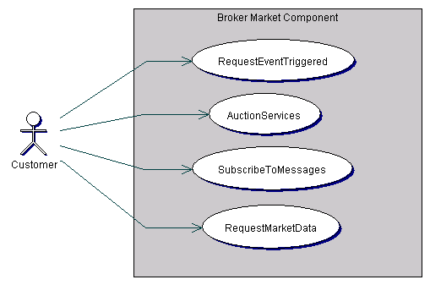
Figure 3-13: Use cases of a broker market component for a customer
UseCase AuctionServices
The use case AuctionServices represents all auction services like specifying or removing a bid or offering a service for auction.

Biểu diễn tất cả các dịch vụ đấu giá như đặt giá cụ thể hoặc xóa hoặc đưa ra một dịch vụ đấu giá.
UseCase RequestEventTriggered
The use case RequestEventTriggered represents the process of formulating an event-triggered request for tourism services, e.g. requesting a tourism service at a specific date or when falling below a price limit.

Use case này biểu diễn quy trình
UseCase RequestMarketData
The use case RequestMarketData represents the process of requesting data about other market participants and offered services within the market.

Yêu cầu dữ liệu chợ: biểu diễn quy trình yêu cầu dữ liệu về các thành phần chợ khác và các dịch vụ được đưa ra trong chợ
UseCase SubscribeToMessages

Đăng ký nhận thong điệp: biểu diễn quy trình đăng ký để loại thong điệp cụ thể để nhận thong điệp loại này tự đông. Các loại thong điệp có thể thong báo về thay đổi giá của các dịch vụ du lịch, thong điệp về thay đổi tính sẵn sang của các dịch vụ du lịch hoặc thong báo về các dịch vụ du lịch với các đặc điểm cụ thể.

The use case SubscribeToMessages represents the process of subscribing to a specific message type in order to receive messages of this type automatically. Message types can be messages about price changes of tourism services, messages about changes of availability of tourism services or messages about tourism services with specific characteristics.

Requirements front-end supplier to broker

Các yêu cầu của nhà cung cấp phụ trợ đến broker
Nhà cung cấp phụ trợ có các yêu cầu sau đến broker, thực thi thành phần chợ các dịch vụ đưa ra đến khách hàng.

The front-end supplier has got the following requirements to the broker, operating the market component on which the services are offered to the customer:

Cung cấp các dịch vụ du lịch
Cung cấp dịch vụ du lịch bao phủ quy trình hoàn thiện của một dịch vụ du lịch phân tán thong qua thành phần chơ của 1 broker. Chức năng sau được cung caaos:
  - Tạo và thay đổi các dịch vụ du lịch. Người cung cấp phụ trợ cần 1 chức năng cho phép tạo dễ dàng và bảo tri fdichj vụ, chúng được đưa ra thành phần chợ thuộc broker
  - Cập nhật giá và độ sẵn sang. Giá và tính sẵn sang của 1 dịch vụ có thể thay đổi 1 cách dễ dàng cho phép bảo trì dữ liệu từ xa cho
  - Định nghĩa các dịch vụ mềm dẻo: quy trình cung cấp các dịch vụ du lịch nên được hỗ trợ bởi các cơ chế định nghĩa dịch vụ du lịch theeo cách thức động, mềm dẻo. Ví dụ: dịch vụ với các chọn lựa cho khách hàng

Supply of tourism services
Supply of tourism services covers the complete process of distributing a tourism service via a market component of a broker. The following functionality has to be provided:
- creation and modification of tourism services
The front-end supplier needs a functionality enabling a comfortable creation and maintenance of services, which are offered on the market component of the broker.
- availability and price update
The availability and price of a tourism service should be changeable in an easy way to enable comfortable remote data maintenance for time-critical data.
- definition of flexible services
The process of supplying tourism services should be supported by mechanisms for defining tourism services in a flexible and dynamic way, e.g. services with choices for the customer, dynamic price evaluation etc.
- composition of tourism services

Kết hợp các dịch vụ du lịch: quy trình cung cấp cho phé kết hợp mềm dẻo các dịch vụ thành phần thành dịch vụ phức tạp (ví dụ hotel và máy bay tạo thành gói du lich)

The supply process has to enable the flexible composition of elementary services to complex services (e.g. hotel and flight to package tour).

- substitution services các dịch vụ chuyển đổi.
Trong trường hợp không khả dụng, các dịch vụ được yêu cầu có thể thay thế bởi cá dịch vụ khác (ví dụ: kết hợp các dịch vụ ). Khái niệm cho việc xây dựng các dịch vụ du lịch cho phép đưa ra cơ chế thay thế

In the case of non-availability, requested services should be substitutable by other services (i.e. service compositions). The concept for building tourism services has to enable such a substitution mechanism.
Booking processing

Xử lý đặt: các thành phần chợ broker cung cấp chức năng cho việc xử lý đặt bởi nhà cung cấp
Quy trình đặt bao phủ các khía cạnh:
  - Thông báo yêu cầu đặt . Nhà cung cấp được thong báo về 1 yêu cầu đặt của 1 k hách hàng
  - Xử lý nhiệm vụ trong hàng đợi. Để xử ký đặt đồng bộ, nhà cung cấp cần chức năng cụ thể xử lý yêu cầu đặt, được lưu trữ trong hàng đợi nhiệm vụ trong thành phần broker. Các chức năng tiêu biểu lấy ra,b thay đổi xóa vị trí trong hàng đợi

Broker market components have to provide functionality for processing a booking by the supplier of the booked tourism service. Booking processing covers the following aspects:
- notification of booking request
The supplier is notified about a booking request of a customer.
- processing task queue
In order to enable an asynchronous booking mode, the supplier needs specific functionality to process booking requests, stored in a task queue on the broker component. Typical functions are retrieving, modifying and deleting positions within the task queue.
Request user profiles Yêu cầu các thong tin người sử dụng
Để xem xét hồ sơ người dùng trong suốt quá trình tìm kiếm một dịch vụ du lịch, nhà cung cấp cần phải có khả năng lấy ra thong tin của người dùng, lưu trữ trong thành phần broker.

In order to consider user profiles during the process of searching for a tourism service, the supplier must have the possibility to retrieve the information of user profiles, stored on a broker component.

Provide market data Cung cấp dữ liệu thị trường
Dữ liệu thị trường ví dụ: các bản báo cáo bán, được cung cấp trong thành phần broker và có thể cho nhà cung cấp front end.
Market data, e.g. sales reports, have to be provided on a broker component and made available for front-end suppliers.
Figure 3-14 shows all use cases of a broker market component for a front-end supplier.
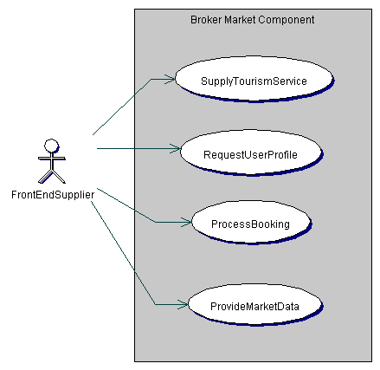
Figure 3-14: Use cases of a broker market component for a front-end supplier
UseCase ProcessBooking
The use case ProcessBooking represents the complete booking process via a broker component and includes all services needed by a front-end supplier to process a booking of tourism services, which are provided on the market component of the broker.

Biểu diễn quy trình đặt hoàn thiện thong qua broker và bao gồm tất cả các dịch vụ cần bởi 1 nhà cung cáp phụ đến quy trình đặt các dịch vụ du lich, chúng được cung cấp trong broker.
UseCase ProvideMarketData
The use case ProvideMarketData represents the process of providing data about the electronic tourism market, e.g. sales reports.

Cung cấp dữ liệu thị trường: Biểu diễn quy trình cung cấp dữ liệu về thị trường du lịch điện tử

UseCase RequestUserProfile
The use case RequestUserProfile represents the process of requesting a user profile from a market component of a broker, which is used for supplying own services. The user profile will be necessary for processing a booking of tourism services.

Biểu diễn quy trình yêu cầu thong tin người dùng từ 1 thành phần chọ của 1 broker, nó được sử dụng cho việc tự cung cấp các dịch vụ. Thông tin người sử dung sẽ cần thiết cho quy trình đặt các dịch vụ du lịch
UseCase SupplyTourismService
The use case SupplyTourismServices represents the complete process of supplying tourism services within the market. In this way, suppliers can provide their services on the market component of a broker. This process includes the processes of requesting and providing tourism services.

Cung cấp dịch vụ du lịch: biểu diễn quy trình hoàn thiên cung cấp các dịch vụ du lịch. theo cách này, các nhà cung cấp có thể cung cấp các dịch vụ của họ trong thành phần chợ của broker. Quy trình này bao gồm quy trình yêu cầu và cung cấp dịch vụ

Conceptual model
Within the reference model the modeling of electronic tourism markets takes place on a conceptual and abstract, communication mechanism independent level, based on the UML (Unified Modeling Language). The concrete models on the different communication levels, e.g. on the XML level and the distributed object level are derived from this conceptual, abstract model.
The conceptual model focuses on the basic processes within an electronic tourism market, the necessary elements, their characteristics and relationships between each other. The conceptual model is comprised of a metalevel, providing metaclasses as tourism specific extensions of the UML, and building blocks, itself divided into three different layers of granularity, the base layer, the entity layer and the process layer (see chapter 2.2.3). Figure 4-15 shows the package structure of the conceptual model of the reference model.
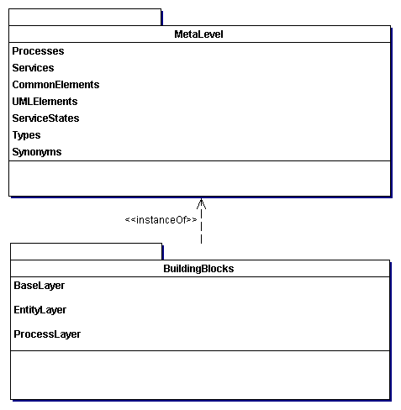
Figure 4-15: Package structure of the conceptual model

Meta level
The meta level of the reference model provides a virtual meta model. The virtual meta model extends the UML by domain specific modeling elements, covering domain specific semantics, and builds up a tourism specific modeling language. This tourism specific modeling language enables the flexible description of specific models for specific market components and supports their interoperability. Specific market components can be described in a way understandable for other market participants.

The virtual meta model
Figure 5-16 illustrates the relationship between the different levels of the conceptual model. The virtual meta model provides a collection of specific modeling elements by using the UML profiling mechanism (see UML 1999 for a detailed description of the UML profiling mechanism). In this example, the specific meta classes Entity, Service and Component are defined using stereotypes. Those stereotypes are then used to build up a concrete domain model. Inheritance relationships between stereotypes specify that one stereotype is a subtype of another stereotype and inherits all its characteristics and semantics (E.g. Service as a subtype of Entity). Association relationships between stereotypes, defined within the virtual meta model, enforce corresponding relationships between the instantiated modeling elements of the concrete domain model. E.g. the aggregation relationship between the stereotypes Service and Component enforces, that a concrete class with the stereotype Service must have an aggregation relationship to a class with the stereotype Component. I.e. the meta model enforces that tourism services like hotel are comprised of components like room.
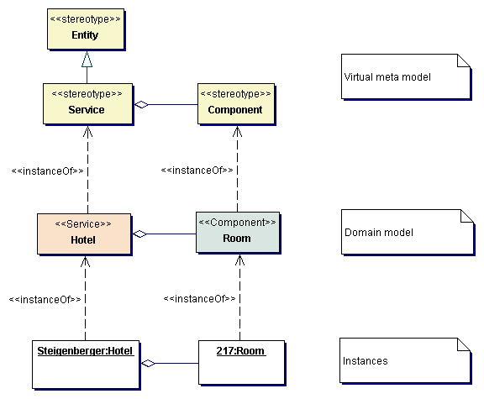
Figure 5-16: Levels of the conceptual model

Structure of the meta level
The metalevel of the reference model is further subdivided into packages, representing different concepts or mechanisms, relevant for modeling electronic tourism markets. Figure 5-17 shows the package structure of the metalevel of the reference model. The package UMLElements contains all UML elements, which are used within the metalevel of the reference model. Types provides metaclasses for modeling specific basic types. CommonElements contains common elements of the tourism domain, which are used in different packages of the metalevel. Synonyms provides metaclasses for defining synonyms for modeling elements. Services contains all metaclasses, necessary to support the mechanism for constructing tourism services. ServiceStates contains metaclasses for dealing with different states of tourism service. Processes contains metaclasses for describing processes (e.g. booking), which are offered within a market component.
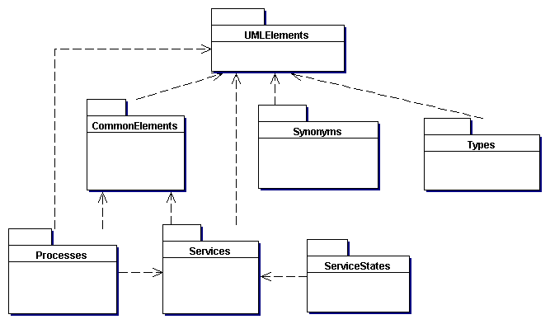
Figure 5-17: Package structure of the metalevel

Basic types
The package Types provides metaclasses for modeling specific basic types, enabling the consideration of different languages and country-specific formats. As basic types are provided type families, specifying a union of simple types, where each member of the union represents a specific format or language as well as multitypes, containing different instances of a simple type as variants (e.g. for different languages). Figure 5-18 shows all metaclasses for basic types.
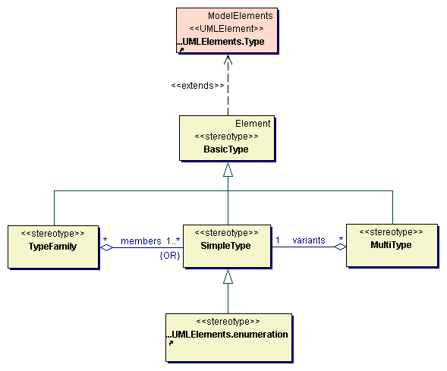
Figure 5-18: Basic types
Class descriptions
Class BasicType
The class BasicType is an abstract base class for the different type classes SimpleType, TypeFamily and MultiType and enables the consideration of different types for specific formats (e.g. country specific formats for currency or date) or different variants of a type (e.g. for different languages).
Class MultiType
The class MultiType is responsible for specifying an element, which is represented in different variants. A multitype is an aggregation of a collection of different simple types. The persistent state of a multitype consists of all its variants. Multitypes can be used for example for hotel names or hotel descriptions in different languages.
Associations
The association variants is an aggregation relationship of a multitype to a simple type as type of its variants. This association specifies that a multi type must aggregate exactly one simple type and that a simple type may be aggregated by several multi types.
Class SimpleType
The class SimpleType represents simple types, i.e. common types like integer, string or tourism specific types like bed type, person type or room type.
Class TypeFamily
The class TypeFamily is responsible for specifying families (i.e. unions) of different types, used for expressing the same information in different formats, e.g. different formats for date or time, different currencies or enumeration types for different languages (e.g. bed type or room type in different languages).
Associations
The association members specifies an aggregation relationship of a type family to its different possible simple types. The association members specifies that a type family must aggregate one or more simple types and that a simple type may be aggregated by several type families. A type family contains exactly one of its members at a given time. In order to switch from one simple type to another, a transformation between the different members of a type family has to be provided.
Figure 5-19 shows an example for a type family. Currency contains different simple types for different currencies. The persistent state of an element containing a currency will only consist of one of the different currency types. The other types have to be evaluated as needed.
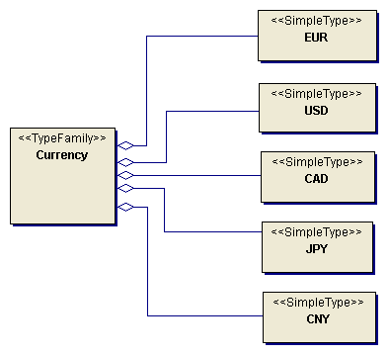
Figure 5-19: Example currency type family

Common elements
The package CommonElements contains common elements, which are used in different packages of the MetaClasses package. Figure 5-20 shows the common elements of the reference model metalevel.
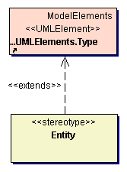
Figure 5-20: Common elements
Class descriptions
Class Entity
The class Entity represents independent entities of the tourism domain. Entities have a specific lifetime and can contain dependent elements, which can only exist within an entity.

Synonyms
The package Synonyms provides a mechanism for defining synonyms for elements of the reference model. Within a specific model, synonyms can be defined for modeling elements, enabling a mapping between parts of the reference model and the specific model. Synonyms are defined as tagged values associated with the modeling elements. The synonym mechanism supports the integration of existing models or data formats into a reference model based specific model. Figure 5-21 illustrates the synonym mechanism.
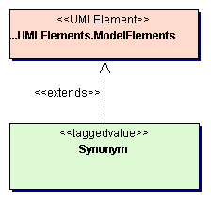
Figure 5-21: Synonyms
Class descriptions
Class Synonym
The class Synonym enables the specification of a synonym for a modeling element. Within a specific model, the tagged value Synonym specifies, for which element of the reference model this element is a synonym.
Figure 5-22 shows an example for defining synonyms. The element MyHotel is a synonym for the reference model element Hotel, containing the attribute myCategory as a synonym for the original attribute category.
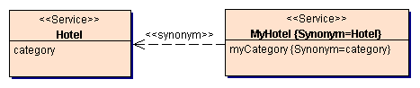
Figure 5-22: Example for synonyms

Services
The package Services contains metaclasses for building tourism services. This package provides metaclasses for the basic composition mechanism for building tourism services, metaclasses for selection relevant attributes, selection hierarchies, component categories and metaclasses for managing the availability of tourism services.

Composition mechanism
The package CompositionMechanism provides the mechanism for building or constructing tourism services (e.g. hotel, flight, package tour). The reference model provides a specific composition mechanism to support the flexible construction of tourism services as central building blocks of the reference model. This mechanism supports the flexible construction of compositions - compositions of building blocks to elementary services (e.g. the building blocks room and catering to the elementary service hotel) as well as compositions of elementary services to complex composition services (e.g. the elementary services hotel and flight to the composition service journey). The composition mechanism, involved in object-oriented paradigms (i.e. the aggregation of several object by one object), has to be extended by specific mechanisms to support the composition of tourism services like evaluation instructions for attributes or composition constraints. In this way, the construction of specific tourism services (elementary services as well as composition services) is supported within the construction of specific models.
Forming complex composition services (from elementary services) is done either by suppliers to provide ready-made packages (possibly with choices), as well as by the customer to create individual packages. The comparability of different customer- and supplier-initiated composition services is an essential requirement for the composition mechanism.

Structure of a composition
The approach to provide comparable customer- and supplier-initiated compositions is the consideration of the degree of freedom of a composition. The degree of freedom is the number of combination possibilities existing within a composition. A supplier-initiated, ready-made combination of determined services is a composition without degree of freedom (e.g. the composition service travel consisting of a flight and a hotel). Combination possibilities within a supplier-initiated composition lead to a corresponding degree of freedom (e.g. the possibility to combine different hotels and flights of one tour operator). The combination of any services initiated by the customer is a composition with the maximum degree of freedom. The degree of freedom has to be restricted by combination constraints, if not all combination possibilities are allowed.
The following parts of a composition result from this approach:
- components: | A component represents a building block being part of the composition. A component consists of:  - a set of building blocks (to consider combination possibilities within the composition)  - the role (in the case of a composition service) of the tourism service within the composition, defined as a collection of relationships to other components
- attributes: | A composition owns attributes, which depend on the attributes of contained components. The value of a dependent attribute is evaluated by an evaluation instruction (see below).
- evaluation instructions: | Evaluation instructions enable the evaluation of the value of an attribute from the attributes of the contained components.
- constraints: | Constraints enable the restriction of the combination possibilities. Constraints refer to the attributes of the contained components.
In order to enable the flexible construction of compositions of elementary services, a common base interface is defined for all tourism services. This base interface provides all attributes, necessary for composing tourism services. The base interface especially contains attributes describing the starting and end state of the tourism service, concerning the dimension place and time. Depending on the roles of the components, the evaluation instructions and constraints of a composition can be defined universally, based on the attributes of the base interface:
Evaluation instructions: All attributes of the base interface of a composition service can be evaluated of the corresponding attributes of the contained components. E.g. the starting point of time of a composition service results from the starting point of time of its first component or the end point of time from the end point of time of the last component.
Constraints: The constraints for composing two components result from the relationship of the two components. E.g. if a service is the successor of another service, its starting point of time has to coincide with the end point of time of the other service.
The flexible definition of composition services is enabled by the consideration of the following relationships between components:
Successor: If a service is a successor of another service, the service is used following the other service. The starting point and the starting point of time of the service correspond to the end point and end point of time of the other service.
Complement: If a service is a complement of another service, the service is uses parallel to the other service. Its usage period is situated within the usage period of the other service and the starting points and end points of the two services coincide to each other.
The common base interface for all tourism services enables the recursive composition of tourism services. Because of the uniform interface, a composition service can be used within a composition in the same way as an elementary service. In this way, recursive compositions can be constructed, without the need for specific evaluation instructions or constraints.
Example: A composition service is created consisting of the components: outward flight (service: flight), return flight (service: flight) and hotel. The component hotel is successor of the component outward flight and the component return flight is successor of the component hotel. The evaluation instructions and constraints result from the contained components as follows:
- evaluation instructions:
starting point of time of the journey = starting point of time of the outward flight
starting point of the journey = starting point of the outward flight
end point of time of the journey = end point of time of the return flight
end point of the journey = end point of the return flight
price = price outward flight + price hotel + price return flight
- constraints:
outward flight + hotel: end point of the outward flight = starting point (i.e. place) of the hotel
end point of time of the outward flight = starting point of time of the hotel
hotel + return flight: end point (i.e. place) of the hotel = starting point of the return flight
end point of time of the hotel = starting point of time of the return flight

Construction of concrete compositions
Concerning the construction of concrete compositions, it has to be differentiated between customer- and supplier-initiated compositions.
Customer-initiated compositions
The customer initiates a composition by selecting a set of building blocks or elementary services. Each elementary service has to be related to a role within the composition, i.e. to its relationships to other components. For the attributes of the base interface as well as the attributes of all contained components can then be defined selection constraints.
Supplier-initiated compositions
Elementary services: Elementary services contain a fix set of components. The supplier provides a concrete elementary service by assigning each component a set of available building blocks. For the elementary service hotel for example would have to be assigned a set of available catering services and hotel rooms. Based on the composition mechanism, specific types of elementary services can be constructed by individually composing general building blocks. A specific hotel type, for example, could be constructed by composing the building blocks room and catering services, however using specific evaluation instructions and constraints or by adding a new building block, e.g. sporting facilities.
Composition services: A general composition object with any components is provided for composition services. The supplier builds a concrete composition by specifying the components of the composition and assigning a set of elementary services and roles. For example, a supplier could provide an event journey, consisting of a bus journey as outward journey, a set of hotel rooms as accommodation service and successor of the bus journey, a set of theatre tickets as complement of the accommodation service and a bus journey as backward journey and successor of the accommodation service. Special composition types can be derived from the general composition to support the supplier in building compositions. At this, special evaluation instructions and constraints can be defined.

Multiple person compositions
To support a comfortable selection process, the above composition mechanism has to be extended by the consideration of compositions for several persons traveling together. In doing so, each component of the composition has to be integrated into the composition in the required quantity.
The request for a multiple person composition is initiated by the specification of the traveling persons (by person-related data, such as name, age, person type...). For each component of a multiple person composition, several parallel building blocks for subsets of the specified persons can be defined.
A concrete composition contains the building blocks for each component in the required quantity. The evaluation instructions and constraints of the composition are to be extended to the parallel building blocks.
Example 1: A journey for three people (two adults, one child) is requested, consisting of an outward and return flight and an accommodation service. In addition to three outward and return flights, as accommodation services come into question: one apartment for at least three people, one double and one single room, or one double room with an extra bed. Specifying a set combination (of room types) restricts the search. Within supplier-initiated compositions, special price rates can be offered for specific combinations (e.g. two adults and one child in a double room with an extra bed).
Example 2: An accommodation service for a married couple with one diabetic is requested. Within the composition a double room is combined with two catering services. For one of the catering services can then be specified as additional constraint the suitability for diabetics.

Composition mechanism metaclasses
The diagram in Figure 5-23 shows the metaclasses for constructing tourism services and their relationships. A composition contains a set of components, were a component can be a composition itself or an elementary component. In this way, complex aggregation structures can be defined with a composition as root element and elementary components as leafs.

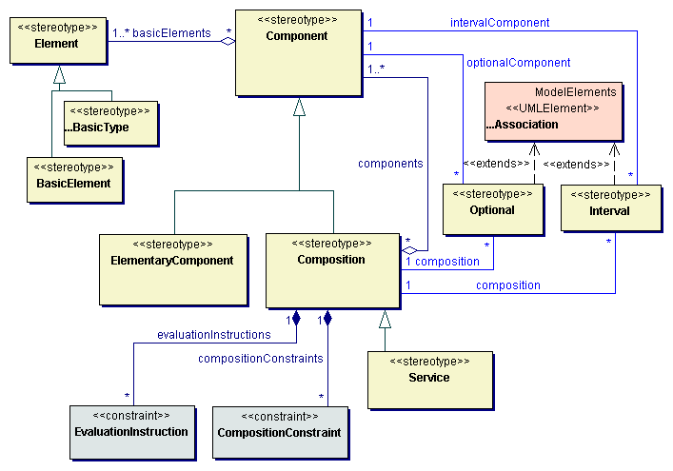
Figure 5-23: Mechanism for composing tourism services
Class descriptions
Class BasicElement
The class BasicElement represents the basic elements of which components and especially elementary components are built of.
Class Component
The class Component is responsible for specifying a component of a tourism service. A component can be an elementary component, consisting only of basic elements or basic type instances or a component can be a composition of other components. A component has got a specific state (see service states).
Associations
The association basicElements specifies an aggregation relationship between a component and its basic elements as attributes. This association specifies that a component must aggregate one or more elements and that an element may be aggregated by several components.
Class Composition
The class Composition represents complex components, composing elementary components or other compositions. Compositions can represent elementary tourism services (e.g. hotel or flight) as well as composition services (e.g. package tour).
Associations
The association components specifies an aggregation relationship between a composition and its components. This association specifies that a composition must aggregate one or more components and that a component may be aggregated by several compositions.
The association evaluationInstructions specifies an aggregation relationship between a composition and its evaluation instructions. This association specifies that a composition can have several evaluation instructions and that an evaluation instruction is associated to exactly one composition.
The association compositionConstraints specifies an aggregation relationship between a composition and its composition constraints. This association specifies that a composition can have several composition constraints and that a composition constraint is associated to exactly one composition.
Class CompositionConstraint
The class CompositionConstraint represents a constraint for composing components of a composition. Composition constraints are specified as constraints.
Class Element
The class Element represents elements a component and especially an elementary component is built of.
Class ElementaryComponent
The class ElementaryComponent represents elementary components of tourism services. Elementary components are composed to more complex components (compositions).
Class EvaluationInstruction
The class EvaluationInstruction represents an evaluation instruction for evaluating the value of an attribute of a composition out of the attributes of components of the composition. Evaluation instructions are specified as constraints.
Class Interval
The class Interval enables to specify an association between a composition and a collection of components, from which several elements may be selected as an interval.
Associations
The association composition specifies a relationship between an interval association and a composition. This association specifies that a composition may participate in interval associations and that exactly one composition must participate in each interval association.
The association intervalComponent specifies a relationship between an interval association and a component. This association specifies that a component may participate in interval associations and that exactly one component must participate in each interval association.
Class Optional
The class Optional enables to specify an optional association between a composition and its component.
Associations
The association composition specifies a relationship between an optional association and a composition. This association specifies that a composition may participate in optional associations and that exactly one composition must participate in each optional association.
The association optionalComponent specifies a relationship between an optional association and a component. This association specifies that a component may participate in optional associations and that exactly one component must participate in each optional association.
Class Service
The class Service represents tourism services - elementary services like hotel or flight as well as complex services like package tour.

As an example Figure 5-24 shows the tourism service hotel as a composition of the components catering, room category and room. Optional components enable the modeling of a multistage selection (or booking) process. Optional components can be omitted when booking a tourism service and may be added successively during the overall booking process.

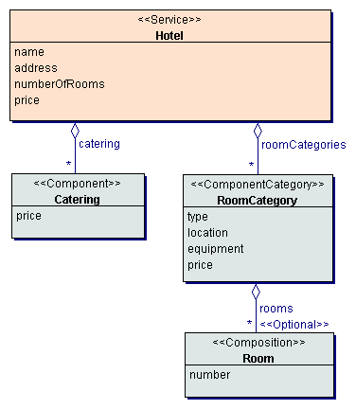
Figure 5-24: Tourism service Hotel
Figure 5-25 shows the tourism service Train as a composition of the components route, seat category, seat and compartment. Here again, optional components enable a two-step booking process. A seat or a compartment can be selected and booked in a second step independent of the booking of the train journey itself.
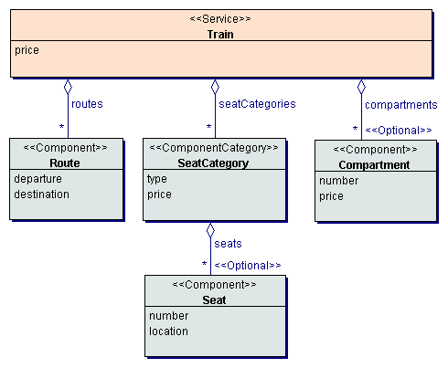
Figure 5-25: Tourism service Train

Attributes
The package Attributes contains metaclasses for specifying attributes and especially selection relevant characteristics of tourism services or service components. For each selectable attribute is provided a selection hierarchy. Figure 5-26 shows all metaclasses for specifying attributes.
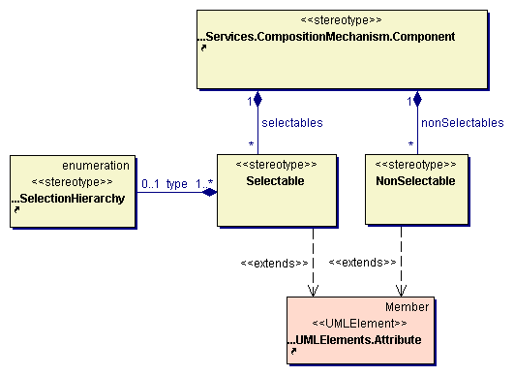
Figure 5-26: Attributes
Class descriptions
Class Component
The class Component is responsible for specifying a component of a tourism service. A component can be an elementary component, consisting only of basic elements or basic type instances or a component can be a composition of other components. A component has got a specific state (see service states).
Associations
The association nonSelectables specifies an aggregation relationship of a component to a collection of non-selectable attributes. This association specifies that a component may contain non-selectable attributes and that a non-selectable attribute may only be contained by a component.
The association selectables specifies an aggregation relationship of a component to a collection of selectable attributes. This association specifies that a component may contain selectable attributes and that a selectable attribute may only be contained by a component.
Class NonSelectable
The class NonSelectable is responsible for specifying a non-selectable attribute of a tourism service. Non-selectable attributes must not be specified within a search request. NonSelectable extends the UML element Attribute.
Class Selectable
The class Selectable is responsible for specifying a selectable attribute of a tourism service. Selectable attributes of a tourism service can be used for searching for a service of this service type. Selectable extends the UML element Attribute.
Associations
The association type specifies an aggregation relationship between a selectable attribute and a selection hierarchy as its type. This association specifies that a selectable attribute may use a selection hierarchy as its type expression and that a selection hierarchy must be specified as a type expression of one or several selectable attributes.

Views
The package Views provides metaclasses for specifying views on tourism services. Views may depend on the market, in which the service is offered and the role of the market participant. Views provide additional attributes for tourism services (see Figure 5-27). In this way, views enable the tailorization of the interface of a tourism service to the accessing market participant. Tourism services may be offered with different interfaces within different markets and to different customers (e.g. leisure traveler, business traveler). Figure 5-28 shows the metaclasses for views.
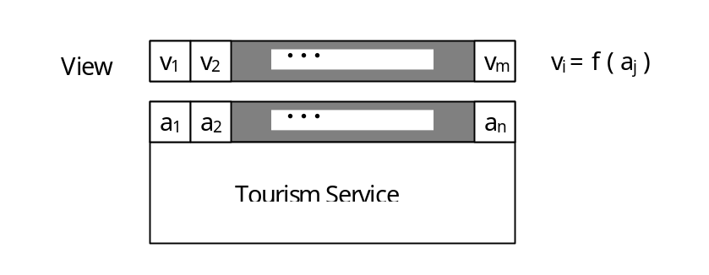
Figure 5-27: View on tourism service
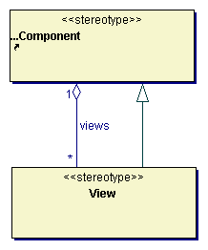
Figure 5-28: Views
Class descriptions
Class Component
The class Component is responsible for specifying a component of a tourism service. A component can be an elementary component, consisting only of basic elements or basic type instances or a component can be a composition of other components. A component has got a specific state (see service states).
Associations
The association views specifies an aggregation relationship of a component to corresponding views. The associated view depends on the market, in which the tourism service is offered and the role of the participant, accessing the tourism service. The association views specifies that a component may aggregate several views and that a view is aggregated by exactly one component.
Class View
The class View is responsible for specifying a specific view on a tourism service. A view provides a collection of attributes, which are evaluated of the original attributes of the tourism service or component.

Selection hierarchies
The package SelectionHierarchies contains metaclasses for specifying selection hierarchies for selectable attributes. Selection hierarchies are introduced in the present model to support the flexible derivation of specific building blocks and a comfortable selection process. The central approach of selection hierarchies is the consideration of different abstraction levels within the representation of selection-relevant characteristics (attributes) of a service. Then, the selection hierarchy for a characteristic results from the hierarchical arrangement of its values on different abstraction levels.
A selection hierarchy has the following structure:
- The lowest abstraction level consists of all values of the corresponding attribute (the base set).
- Elements of a higher abstraction level, named generic terms, are formed by collecting several elements of the underlying abstraction level as subordinated terms. A generic term is a fuzzy set on the subordinated terms, i.e. a subordinated term has a gradual membership of a generic term.
- A selection hierarchy contains exactly one element (named root), containing all other elements directly or indirectly.
Two aspects are important for the construction of selection hierarchies:
- Selection hierarchies are polydimensional hierarchies, i.e. they can consist of orthogonal part-hierarchies. Two part-hierarchies are called orthogonal, if their root and their base set are identical and they have no more common elements.
- Selection hierarchies are extendable. An extension of a selection hierarchy is created by adding further elements and abstraction levels.
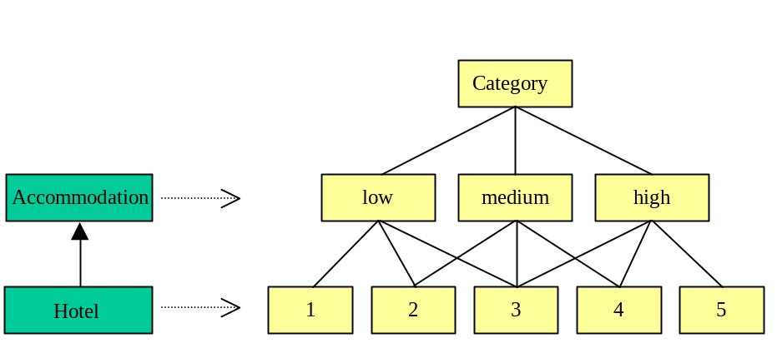
Figure 5-29: Selection hierarchies of the attribute category
Figure 5-29 illustrates, for example, the selection hierarchies of the attribute category of the tourism services accommodation and hotel. The selection hierarchy for the service hotel is an extension of the selection hierarchy for the service accommodation and is created by adding a further, more concrete abstraction level. Analogous, further subclasses with extended selection hierarchies can be created in specific models.
The use of selection hierarchies supports the following mechanisms:
- flexible derivation of specific building blocks
The consideration of different levels of abstraction for the values of attributes (in the form of selection hierarchies) enables the extension of the derivation mechanism. When deriving a more concrete class (or building block), i.e. changing the level of abstraction, not only classes are extended by attributes, but also the selection hierarchies of the attributes by more concrete levels of abstraction. In this way, domains of attributes can be tailored to specific requirements and the flexible derivation of specific building blocks is supported.
- selection by uncertain represented characteristics
A characteristic is called uncertain represented, if the corresponding attribute is not determined certainly. The extension of the derivation mechanism enables the use of uncertain represented characteristics within the selection of a service by defining the higher abstraction levels of the selection hierarchies identically.
- fuzzy requests
The use of values on higher abstraction levels enables formulating fuzzy requests. The hierarchical arrangement of the values supports the successive refinement of a request during an iterative selection process.
- fuzzy data
Selection hierarchies enable the consideration of similar results on the basis of similarity relations between values of an attribute. As a similarity relation, which is obvious for the user, selection hierarchies provide the distance between two values.
Figure 5-30 shows the metaclasses for selection hierarchies.
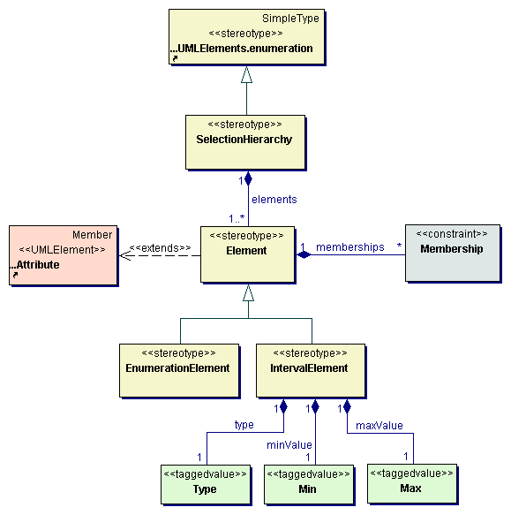
Figure 5-30: Selection hierarchies
Class descriptions
Class Element
The class Element is responsible for specifying elements of a selection hierarchy. Elements of a selection hierarchy are represented as attributes of the selection hierarchy class and the class Element extends the UML element Attribute. Elements may be enumeration elements, representing single values of an enumerable value domain, or interval elements, representing an interval of values of a numeric value domain. By default, elements are enumeration elements.
Associations
The association memberships specifies an aggregation relationship between an element of a selection hierarchy and the constraints, defining its membership to the elements of the next higher level of the selection hierarchy. This association specifies that each element of a selection hierarchy has zero or more membership constraints and that membership constraints are only used within elements of selection hierarchies.
Class EnumerationElement
The class EnumerationElement is responsible for specifying enumeration elements. Enumeration elements are generic terms of a selection hierarchy or elements of an enumerable value domain as base set of the selection hierarchy (e.g. sporting facilities).
Class IntervalElement
The class IntervalElement is responsible for specifying interval elements, representing an interval of values of a numeric value domain as base set of the selection hierarchy (e.g. temperature or price). An interval element is specified by its type of value domain and the value interval by its minimum and maximum.
Associations
The association type specifies an aggregation relationship between an interval element and its type. This association specifies that each interval element must have a tagged value Type and that the tagged value Type is only used within interval elements.
The association minValue specifies an aggregation relationship between an interval element and the minimal value of its value domain. This association specifies that each interval element must have a tagged value Min and that the tagged value Min is only used within interval elements.
The association maxValue specifies an aggregation relationship between an interval element and the maximal value of its value domain. This association specifies that each interval element must have a tagged value Max and that the tagged value Max is only used within interval elements.
Class Max
The class Max specifies the maximal value of the value domain of an interval element. MaxValue is specified as a tagged value of the interval element class.
Class Membership
The class Membership specifies the degree of membership of an element of a selection hierarchy to another element of the next higher level of the hierarchy. In the case of an enumeration element the degree of membership will be defined as a concrete value, in the case of an interval element as a characteristic function. The membership is defined by a constraint.
Class Min
The class Min specifies the minimal value of the value domain of an interval element. MinValue is specified as a tagged value of the interval element class.
Class SelectionHierarchy
The class SelectionHierarchy is responsible for specifying a hierarchy of values of a value domain, used for evaluating similarities between values and defining search constraints. An instance of the class SelectionHierarchy represents one level of a selection hierarchy and is derived from the instance, representing the next higher level. Extensions of a selection hierarchy are defined by deriving a new level from the lowest level of the hierarchy. The class SelectionHierarchy is a subtype of the stereotype enumeration predefined by the UML. Analog to the class enumeration, the class SelectionHierarchy contains all possible values of the defined type, i.e. selection hierarchy, as attributes.
Associations
The association elements specifies an aggregation relationship between a selection hierarchy and its elements, provided as attributes of the selection hierarchy class. This association specifies that a selection hierarchy contains at least one element and that elements are only used within selection hierarchies.
Class Type
The class Type specifies the type of an interval element (i.e. the type of its value domain e.g. integer). Type is specified as a tagged value of the interval element class.

Component categories
The package ComponentCategories contains metaclasses for specifying categories of components of a composition, e.g. categories for hotel rooms. Component categories are separate components of a composition, which aggregate a corresponding component. Figure 5-31 shows the metaclasses for component categories and their relationships.

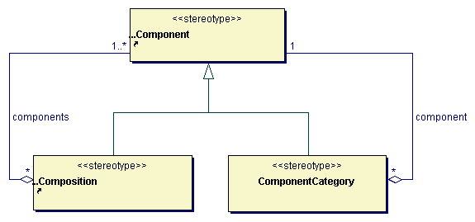
Figure 5-31: Component categories
Class descriptions
Class ComponentCategory
The class ComponentCategory is responsible for specifying a category of components of a composition.
Associations
The association component specifies an aggregation relationship of a component category to its component. This association specifies that a component category must aggregate exactly one component and that a component may be aggregated by several component categories.

Availability
The package Availability contains metaclasses for specifying the availability of components of a tourism service. The availability of a component may depend on other components and can be defined for several components of a tourism service. The metaclass Availability itself is a component (a subtype of the metaclass Component) and can be defined as obligatory or optional. Figure 5-32 illustrates the metaclass Availability and its relationships to other metaclasses.

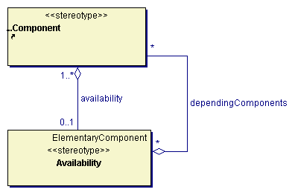
Figure 5-32: Availability of service components
Class descriptions
Class Component
The class Component is responsible for specifying a component of a tourism service. A component can be an elementary component, consisting only of basic elements or basic type instances or a component can be a composition of other components. A component has got a specific state (see service states).
Associations
The association availability specifies an aggregation relationship of a component to its availability. This association specifies that a component may aggregate one availability class and that an availability class must be aggregated by one or more components.
Class Availability
The class Availability represents the availability of a component of a composition. The availability may depend on other components of the composition.
Associations
The association dependingComponents specifies an aggregation relationship of an availability to components, the availability depends on. This association specifies that an availability class may aggregate several components as depending components and that a component may be aggregated by several availability classes as depending component.
Figure 5-33 shows an example for the availability of hotel rooms, where the availability of a room depends on the period of time, for which the room is requested.
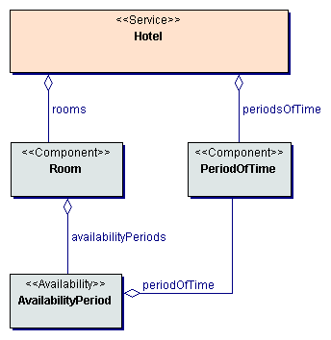
Figure 5-33: Availability of hotel rooms

Service states
The package ServiceStates contains metaclasses for dealing with the different states of tourism services (e.g. accommodation or transportation services) during their lifecycle. The reference model differentiates between the following states of tourism services:
- potential service: A potential service is provided by a supplier within a market component. A potential service contains all optional components and all component variants and can be seen as an instruction for building a concrete tourism service. A potential hotel service, for example, could contain the basic characteristics of the hotel, the different available catering services (like half-board or full-board), all available categories of rooms of the hotel (e.g. single or double rooms) and as optional components all concrete rooms of the hotel as well as instructions and constraints for composing a concrete hotel service out of these components (e.g. an instruction for evaluating the price, depending of the composed components).
- requested service: A requested service is specified by the client, searching for a tourism service. A requested service principally has the same structure then a potential service and contains all requested characteristics of the searched tourism service. During the search process, the offered service is constructed based on the specification of the requested service, i.e. the search process searches for services, similar to the requested service (search method 'query by example'). When searching for a hotel service, for example, the client would specify basic hotel characteristics (e.g. name, category, etc.), the desired catering service and room category.
- offered service: An offered service is provided to the customer as result of a search request. An offered service only consists of component variants, which fulfill all requirements specified within the requested service. During an iterative search process, an offered service can be refined in a stepwise manner by reducing the amount of component variants due to a refined requested service. An offered hotel service, for example, could still contain several concrete catering services and several concrete room categories (e.g. different categories of double rooms). During the search process, a concrete catering service and a concrete room category would be selected.
- booked service: Offered services, with one concrete variant selected for each obligatory component can be booked. Booked services have the same structure than the corresponding offered service. Analog to offered services, booked services can be further refined, if possible (multi-step booking process). A booked hotel service, for example, could, in a first step, only consist of a selected catering service and room category. A concrete room is not necessarily selected and the hotel service may still contain all available rooms of the selected room category. In a second step, the booked hotel service could be refined by selecting and booking a specific room, which is normally done during the check-in in the hotel.
- used service: A used service has been provided by the supplier and used by the customer. A used service has got the same structure as a booked service. A used service may not take part in any further state transitions.
Figure 5-34 shows the different states of tourism services and the possible state transitions. The reference model supports the specification of tourism services in all different states. Of course, the usage of the specifications of the reference model can be restricted to specific states of the overall process. For example, potential services could be represented within a legacy system (e.g. a Computer Reservation System), which is integrated into the overall process. The customer provides a requested service, based on the reference model. According to the characteristics of the requested service, a search request to the legacy systems is generated. According to the results of the legacy system, offered services are created and provided to the customer, based on the reference model.
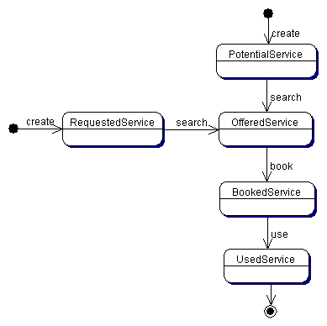
Figure 5-34: States of tourism services
Figure 5-35 shows the metaclasses for states of tourism services.

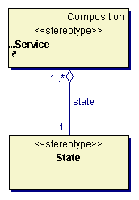
Figure 5-35: States of tourism services
Class descriptions
Class Service
The class Service represents tourism services - elementary services like hotel or flight as well as complex services like package tour.
Associations
The association state specifies an aggregation relationship of a tourism service to its state. This association specifies that a service must aggregate exactly one state and that a state must be aggregated by one or more services.
Class State
The class State represents states of tourism services.

Processes
The package Processes contains metaclasses for describing processes, which are offered within a market component. Processes are contained by a market component and are described by a name and its input and output data. The metaclasses of the Processes package enable the description of specific market components in a way understandable for other market participants. Figure 5-36 illustrates the metaclasses for describing market components and their processes.

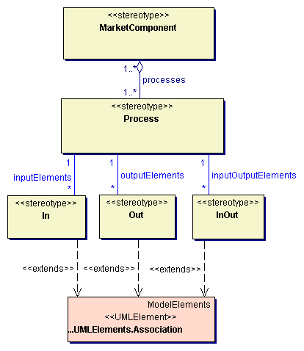
Figure 5-36: Market components and processes
Class descriptions
Class In
The class In enables to specify an association between a process and an input element of the process. The class In extends the UML element association.
Associations
The association inputElements specifies a relationship between input element associations and a process. The association inputElements specifies that a process may participate in associations specifying input elements and that exactly one process must participate in each such association.
Class InOut
The class InOut enables to specify an association between a process and an input-output element of the process. The class InOut extends the UML element association.
Associations
The association inputOutputElements specifies a relationship between input-output element associations and a process. The association inputOutputElements specifies that a process may participate in associations specifying input-output elements and that exactly one process must participate in each such association.
Class MarketComponent
The responsibility of the class MarketComponent is to specify a market component. A market component provides a set of services (processes) within the market, which can be used by other market participants.
Associations
The association processes specifies an aggregation relationship between a market component and processes, offered by the market component. This association specifies that a market component must aggregate one or more processes and that a process must be aggregated by one or more market components.
Class Out
The class Out enables to specify an association between a process and an output element of the process. The class Out extends the UML element association.
Associations
The association outputElements specifies a relationship between output element associations and a process. The association outputElements specifies that a process may participate in associations specifying output elements and that exactly one process must participate in each such association.
Class Process
The class Process specifies a process, offered by a market component. A process is described by its name and input and output elements.

Building blocks
The package BuildingBlocks contains general building blocks for an electronic tourism market. Together with the classes of the virtual metamodel, the building blocks enable the flexible construction or description of specific models for specific market components. Building blocks are provided on different levels of granularity. Figure 6-37 shows the package structure of the different layers of building blocks.
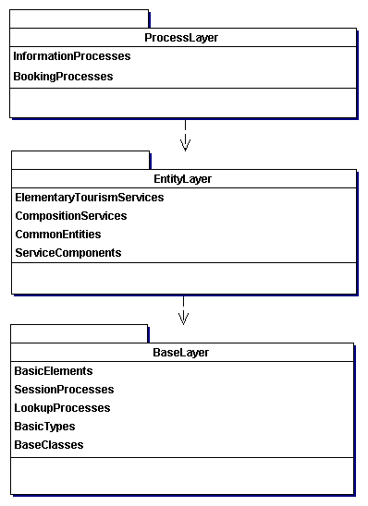
Figure 6-37: Layers of building blocks

Base layer
The base layer serves as a foundation for the higher layers. The base layer encapsulates fundamental conceptual aspects and provides base classes and common, not domain specific services. In detail, the base layer provides basic tourism specific types, a set of fundamental, abstract base classes, basic modeling elements, session processes for managing user sessions and lookup processes providing information about services and objects. Figure 6-38 shows the package structure of the base layer.
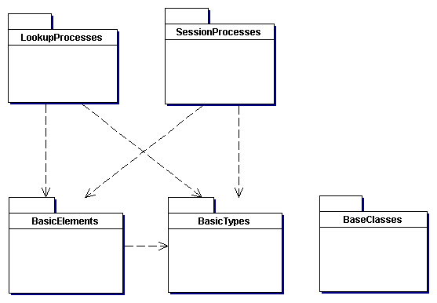
Figure 6-38: Package structure of the base layer

Basic types
The package BasicTypes contains basic types of the reference model, which are used within other class or type definitions as basic type specifications. Basic types are tourism specific types at the fringe of the reference model. In contrast to other elements of the reference model, types are atomic elements and are not made up of other elements or building blocks of the reference model. The package BasicTypes provides common types of the reference model as well as types for specific tourism service components.

Common types
The package CommonTypes provides common types of the reference model, used in different elements and tourism services. Figure 6-39 shows all common types.
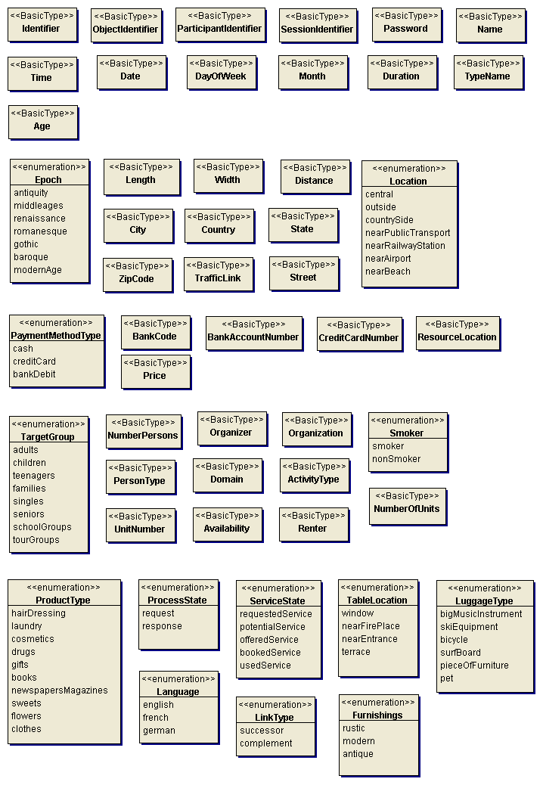
Figure 6-39: Common types
Class descriptions
Class ActivityType
The class ActivityType serves to specify an activity, which is of relevance for a traveler or tourist.
Class Age
The class Age serves to specify the age of a person or in general an entity as an integer.
Class Availability
The class Availability serves to specify the availability of a tourism service. The availability is given as the number of available services.
Class BankAccountNumber
The class BankAccountNumber enables to specify the number of a bank account.
Class BankCode
The class BankCode enables to specify a bank code.
Class City
The class City enables to specify a city by its name (as a character string).
Class Country
The class Country enables to specify a country by its name (as a character string).
Class CreditCardNumber
The class CreditCardNumber enables to specify the number of a credit card.
Class Date
The class Date serves to specify a point of time by day, month and year (as a formatted character string).
Class DayOfWeek
The class DayOfWeek serves to specify a day of the week or a type of day e.g. weekday, public holiday, daily.
Class Distance
The class Distance enables to specify a distance between two points or places.
Class Domain
The class Domain enables to specify the domain or subject of a conference or a similar event.
Class Duration
The class Duration serves to specify a duration by days, hours and minutes.
Class Epoch
The class Epoch enables to specify an epoch within history.
Class Furnishings
The class Furnishings enables to specify the style of the furnishings (e.g. of a gastronomy institution).
Class Identifier
The class Identifier serves to specify an identifier for model elements.
Class Language
The class Language enables to specify a natural language.
Class Length
The class Length enables to specify a length of an object e.g. a vehicle.
Class LinkType
The class LinkType enables to specify the type of link from one component of a composition to another.
Class Location
The class Location serves to specify the location of an entity, relative to tourism relevant objects or places.
Class LuggageType
The class LuggageType enables to specify the type of a piece of luggage (e.g. a big music instrument, a bicyle or a pet).
Class Month
The class Month serves to specify a month in the year by its name.
Class Name
The class Name enables to specify the name of an object as a character string.
Class NumberOfUnits
The class NumberOfUnits enables to specify the number of units of a tourism service (e.g. a transport). The number of units serves for evaluating the price of the corresponding tourism service.
Class NumberPersons
The class NumberPersons serves to specify a number of persons.
Class ObjectIdentifier
The class ObjectIdentifier enables to specify an unequivocal identifier of an object.
Class Organization
The class Organization enables to specify an organization.
Class Organizer
The class Organizer enables to specify an organization or institution organizing an event e.g. a conference, fair, etc.
Class ParticipantIdentifier
The class ParticipantIdentifier enables to specify an unequivocal identifier of a market participant.
Class Password
The class Password enables to specify a password.
Class PaymentMethodType
The class PaymentMethodType enables to specify a type of method of payment.
Class PersonType
The class PersonType enables to specify the type of a person (e.g. student,...).
Class Price
The class Price serves to specify a price of a tourism service or component.
Class ProcessState
The class ProcessState enables to specify the state of a process.
Class ProductType
The class ProductType enables to specify the type of a product (e.g. offered within a shop).
Class Renter
The class Renter enables to specify the name of a company hiring vehicles (e.g. car rental company).
Class ResourceLocation
The class ResourceLocation enables to specify the location of a resource as a URL.
Class ServiceState
The class ServiceState enables to specify the state of a tourism service.
Class SessionIdentifier
The class SessionIdentifier enables to specify an unequivocal identifier of a user session.
Class Smoker
The class Smoker services to specify the type of a tourism service or service component concerning the permission for smoking.
Class State
The class state enables to specify a state or province of a country by its name (as a character string).
Class Street
The class street enables to specify a street and a street number (as a character string).
Class TableLocation
The class TableLocation enables to specify the location of a table e.g. within a gastronomy institution like a restaurant.
Class TargetGroup
The class TargetGroup enables to specify the target group of a tourism service.
Class Time
The class Time serves to specify a point of time by hours and minutes (as a formatted character string).
Class TrafficLink
The class TrafficLinks enables to specify existing traffic links (e.g. railway link, airport link, motorway link, etc.).
Class TypeName
The class TypeName enables to specify the name of a type (or class) as a character string.
Class UnitNumber
The class UnitNumber enables to specify the number of a unit (e.g. living unit like hotel room or apartment or transportation unit like seat or compartment) as unequivocal identifier.
Class Width
The class Width enables to specify a width of an object e.g. a vehicle.
Class ZipCode
The class ZipCode enables to specify the zip code of a city (as a character string).

Accommodation types
The package AccommodationTypes provides all basic types, used for constructing core accommodation services like hotel rooms, apartments, ship cabins, etc. Figure 6-40 shows all accommodation types.

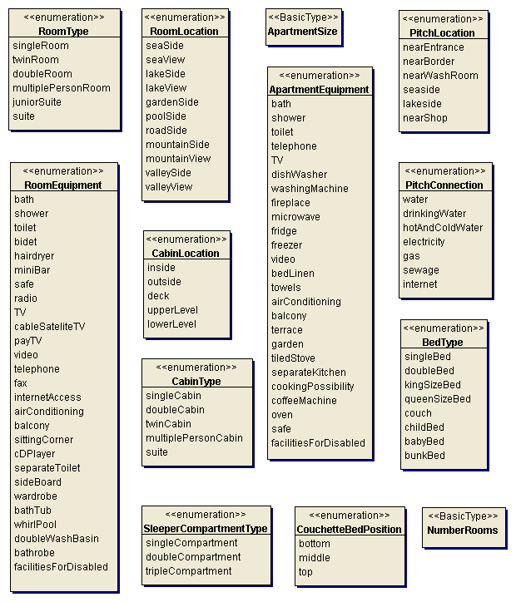
Figure 6-40: Accommodation types
Class descriptions
Class ApartmentEquipment
The class ApartmentEquipment enables to specify equipment details of an apartment.
Class ApartmentSize
The class ApartmentSize enables to specify the size of an apartment.
Class BedType
The class BedType serves to specify a type of bed.
Class CabinLocation
The class CabinLocation enables to specify the location of a cabin on a ship.
Class CabinType
The class CabinType enables to specify the type of a cabin on a ship.
Class CouchetteBedPosition
The class CouchetteBedPosition enables to specify the position of a bed within a couchette car of a train.
Class NumberRooms
The class NumberRooms enables to specify the number of rooms within an apartment.
Class PitchConnection
The class PitchConnection enables to specify available connections of a pitch.
Class PitchLocation
The class PitchLocation enables to specify the location of a pitch within a campsite.
Class RoomEquipment
The class RoomEquipment serves to specify the equipment details of a room.
Class RoomLocation
The class RoomLocation serves to specify the location of a room within a hotel or accommodation.
Class RoomType
The class RoomType serves to specify a type of room (e.g. hotel room).
Class SleeperCompartmentType
The class SleeperCompartmentType enables to specify the type of a compartment within a sleeper train.

Attraction types
The package AttractionTypes provides all basic types, used for constructing core attraction services e.g. exhibition, museum, etc. Figure 6-41 shows all attraction types.

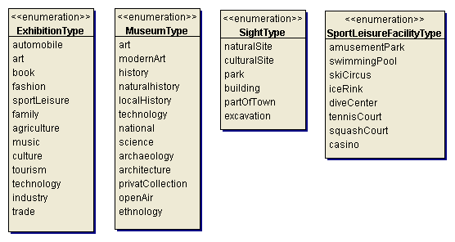
Figure 6-41: Attraction types
Class descriptions
Class ExhibitionType
The class ExhibitionType enables to specify the type of an exhibition or fair.
Class MuseumType
The class MuseumType enables to specify the type of a museum.
Class SightType
The class SightType enables to specify the type of a sight.
Class SportLeisureFacilityType
The class SportLeisureFacilityType enables to specify the type of a sport leisure facility.

Catering types
The package CateringTypes provides basic types for constructing core catering services. Figure 6-42 shows all catering types.

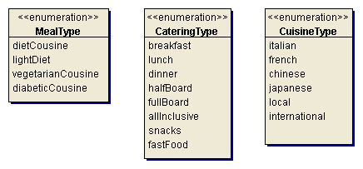
Figure 6-42: Catering types
Class descriptions
Class CateringType
The class CateringType serves to specify a type of catering service.
Class CuisineType
The class CuisineType serves to specify a type of cuisine.
Class MealType
The class MealType enables to specify a meal type.

Destination types
The package DestinationTypes provides all basic types, used for constructing destinatios e.g. city, region, country. Figure 6-43 shows all destination types.

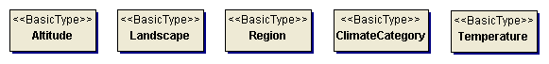
Figure 6-43: Destination types
Class descriptions
Class Altitude
The class Altitude enables to specify the altitude of a city.
Class ClimateCategory
The class ClimateCategory serves to specify a category for a climate (tropical, sub-tropical,...).
Class Landscape
The class Landscape enables to specify the characteristic of the landscape (e.g. flat, hilly, mountainous, etc.).
Class Region
The class Region enables to specify a region by its name (as a character string).
Class Temperature
The class Temperature serves to specify a temperature.

Event types
The package EventTypes provides all basic types, used for constructing core event services e.g. musical, opera, lecture, etc. Figure 6-44 shows all event types.

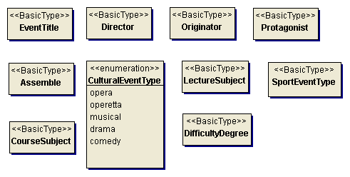
Figure 6-44: Event types
Class descriptions
Class Assemble
The class Assemble enables to specify an assemble performing a cultural event.
Class CourseSubject
The class CourseSubject enables to specify the subject of a course (e.g. sport, language, etc.).
Class CulturalEventType
The class CulturalEventType enables to specify the type of a cultural event (e.g. opera, operetta, drama, comedy, etc.).
Class DifficultyDegree
The class DifficultyDegree enables to specify the degree of difficulty of the course (e.g. novice, advanced, etc.).
Class Director
The class Director enables to specify the director of a cultural event (e.g. conductor, theatre director, etc.).
Class EventTitle
The class EventTitle enables to specify the title of an event.
Class LectureSubject
The class LectureSubject enables to specify the subject of a lecture (e.g. leisure, sport, culture, industrial sector, etc.).
Class Originator
The class Originator enables to specify an originator or artificer of a play or work, which is performed within a cultural event (e.g. composer, author).
Class Protagonist
The class Protagonist enables to specify a protagonist of a cultural event.
Class SportEventType
The class SportEventType enables to specify the type of the sport event e.g. because of the performed sport (e.g. tennis tournament, football match, etc.) or because of the type of competition (e.g. league match, friendly match, international match, etc. in the case of a football match).

Facilities types
The package FacilitiesTypes provides all basic types, used for constructing facilities e.g. hotel facilities, ship facilities, etc. Figure 6-45 shows all facilities types.

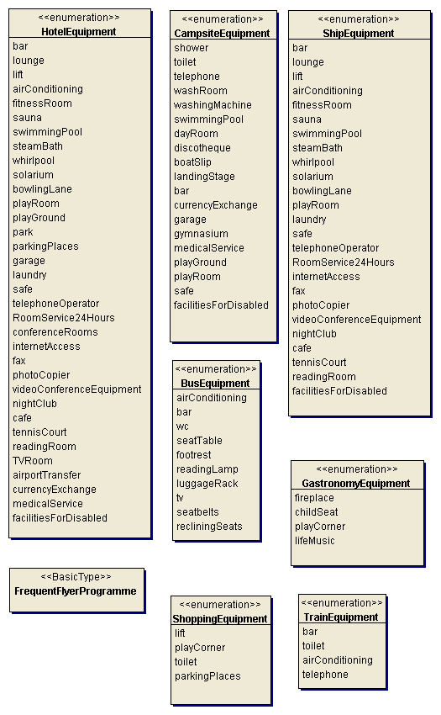
Figure 6-45: Facilities types
Class descriptions
Class BusEquipment
The class BusEquipment enables to specify available equipment details of a bus.
Class CampsiteEquipment
The class CampsiteEquipment enables to specify equipment details of a campsite.
Class FrequentFlyerProgramme
The class FrequentFlyerProgramme enables to specify a frequent flyer programme as a character string.
Class GastronomyEquipment
The class GastronomyEquipment enables to specify available equipment details of a gastronomy service or institution.
Class HotelEquipment
The class HotelEquipment enables to specify equipment details of a hotel.
Class ShipEquipment
The class ShipEquipment enables to specify equipment details of a ship.
Class ShoppingEquipment
The class ShoppingEquipment enables to specify equipment details of a shopping institution.
Class TrainEquipment
The class TrainEquipment enables to specify available equipment details of a train.

Institution types
The package InstitutionTypes provides all basic types and selection hierarchies, used for constructing institutions e.g. hotels, apartment institutions, etc. Figure 6-46 shows all institution types.

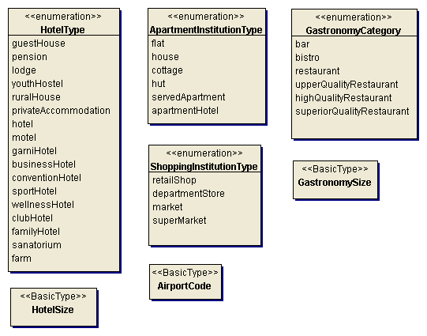
Figure 6-46: Institution types
Class descriptions
Class AirportCode
The class AirportCode serves to specify the unequivocal code of an airport.
Class ApartmentInstitutionType
The class ApartmentInstitutionType enables to specify the type of an apartment institution.
Class GastronomyCategory
The class GastronomyCategory enables to specify the category of a gastronomy institution or service.
Class GastronomySize
The class GastronomySize serves to specify the size of a gastronomy institution e.g. a restaurant as total number of available seats or places.
Class HotelSize
The class HotelSize serves to specify the size of a hotel as total number of beds.
Class HotelType
The class HotelType enables to specify the type of a hotel.
Class ShoppingInstitutionType
The class ShoppingInstitutionType enables to specify the type of a shopping institution.
Figure 6-47 shows the selection hierarchy for the accommodation category.
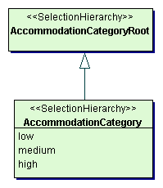
Figure 6-47: Accommodation category selection hierarchy
Class descriptions
Class AccommodationCategory
The class AccommodationCategory represents the selection hierarchy for the accommodation category.
Class AccommodationCategoryRoot
The class AccommodationCategoryRoot represents the root of the accommodation category selection hierarchy.
Figure 6-48 shows the selection hierarchy for the hotel category.
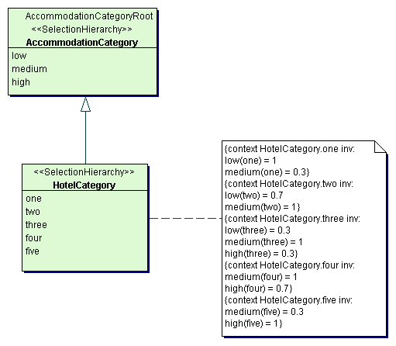
Figure 6-48: Hotel category selection hierarchy
Class descriptions
Class HotelCategory
The class HotelCategory represents the selection hierarchy for the hotel category. HotelCategory is an extension of the selection hierarchy for the accommodation category.
Figure 6-49 shows the selection hierarchy for the apartment category.
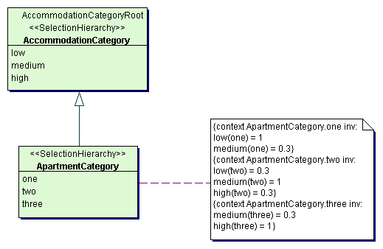
Figure 6-49: Apartment category selection hierarchy
Class descriptions
Class ApartmentCategory
The class ApartmentCategory represents the selection hierarchy for the apartment category. ApartmentCategory is an extension of the selection hierarchy for the accommodation category.

Renting types
The package RentingTypes provides all basic types, used for constructing core renting services e.g. hired vehicle. Figure 6-50 shows all renting types.

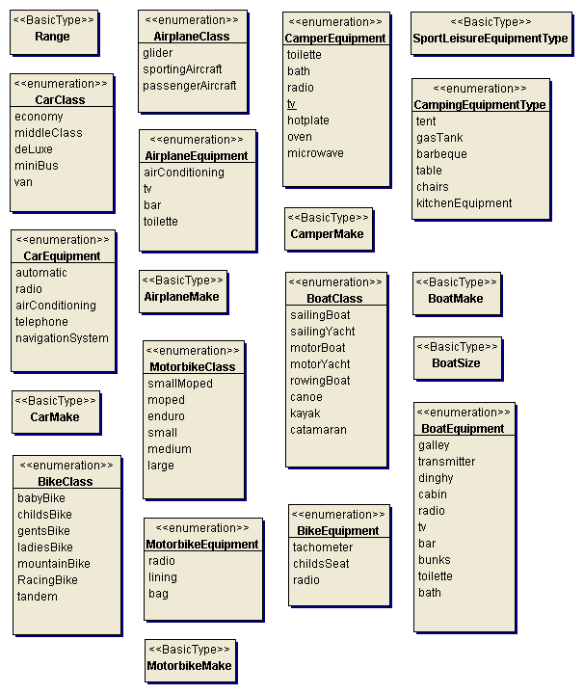
Figure 6-50: Renting types
Class descriptions
Class AirplaneClass
The class AirplaneClass enables to specify the class of an airplane.
Class AirplaneEquipment
The class AirplaneEquipment enables to specify the equipment of an airplane (e.g. instruments, telephone, TV, etc.).
Class AirplaneMake
The class AirplaneMake enables to specify the make and type of the airplane.
Class BikeClass
The class BikeClass enables to specify the class of a bike.
Class BikeEquipment
The class BikeEquipment enables to specify equipment details of a bike.
Class BoatClass
The class BoatClass enables to specify the class of a boat.
Class BoatEquipment
The class BoatEquipment enables to specify the equipment of a boat.
Class BoatMake
The class BoatMake enables to specify the make and type of a boat.
Class BoatSize
The class BoatSize specifies the size (i.e. length) of a boat.
Class CamperEquipment
The class CamperEquipment enables to specify equipment details of a camper (e.g. toilet, shower, TV, etc.).
Class CamperMake
The class CamperMake enables to specify the make and type of the camper.
Class CampingEquipmentType
The class CampingEquipmentType enables to specify types of camping equipment.
Class CarClass
The class CarClass enables to specify the class of the car.
Class CarEquipment
The class CarEquipment enables to specify the equipment of a car.
Class CarMake
The class CarMake enables to specify the make and type of a car.
Class MotorbikeClass
The class MotorbikeClass enables to specify the class of a motorbike.
Class MotorbikeEquipment
The class MotorbikeEquipment enables to specify the equipment of a motorbike.
Class MotorbikeMake
The class MotorbikeMake enables to specify the make and type of a motorbike.
Class Range
The class Range enables to specify the range of an airplane.
Class SportLeisureEquipmentType
The class SportLeisureEquipmentType enables to specify types of sport or leisure equipment.

Seat types
The package SeatTypes provides all basic types, used for constructing seats e.g. seats in a train or a cultural event. Figure 6-51 shows all seat types.

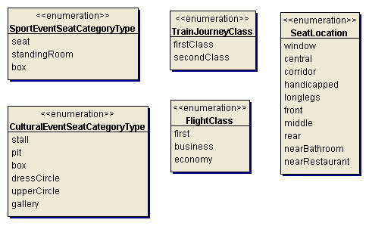
Figure 6-51: Seat types
Class descriptions
Class CulturalEventSeatCategoryType
The class CulturalEventSeatCategoryType enables to specify the type of a category of a seat within a theatre or opera.
Class FlightClass
The class FlightClass enables to specify the class of a flight.
Class SeatLocation
The class SeatLocation enables to specify the location of a seat within a flight, bus or train.
Class SportEventSeatCategoryType
The class SportEventSeatCategoryType enables to specify a type of a category of a seat within a sport event (e.g. seat, standing room, box, etc.).
Class TrainJourneyClass
The class TrainJourneyClass enables to specify the quality class of a train journey.

Transport types
The package TransportTypes provides all basic types, used for constructing means of transport e.g. airplane, bus, ship. Figure 6-52 shows all transport types.

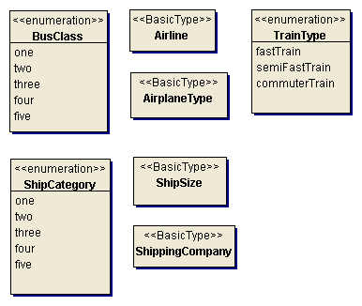
Figure 6-52: Transport types
Class descriptions
Class Airline
The class Airline enables to specify the service provider of a flight.
Class AirplaneType
The class AirplaneType enables to specify the type of an airplane, i.e. the manufacturer and the type specification.
Class ShippingCompany
The class ShippingCompany enables to specify a shipping company.
Class TrainType
The class TrainType enables to specify the type of train.
Class BusClass
The class BusClass enables to specify the quality class of a bus (e.g. in accordance with the Gütezeichen Buskomfort RAL).
Class ShipCategory
The class ShipCategory enables to specify the category of a ship (by the classification of the International Cruise Passengers Association ICPA (MUNDT, 1996, p. 302)).
Class ShipSize
The class ShipSize enables to specify the size of a ship or ferry as the maximal number of passengers.

Base classes
The package base classes provides a set of fundamental, abstract base classes. Base classes are used for deriving classes of the higher layers of building blocks and ensure uniformity and consistency of all building blocks. Figure 6-53 shows the classes of the package BaseClasses.

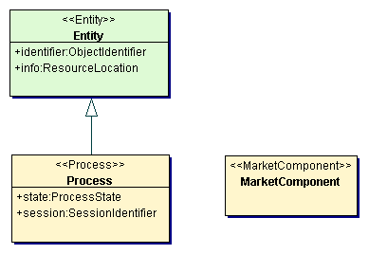
Figure 6-53: Base classes
Class descriptions
Class Entity
The class Entity represents independent entities of the tourism domain. Entities have a specific lifetime and can contain dependent elements, which can only exist within an entity. Entities are identified by an unequivocal object identifier.
Attributes
The attribute identifier specifies an unequivocal identifier of the entity.
The attribute info specifies a resource location, where further information about the entity are available.
Class MarketComponent
The class MarketComponent represents a market component and enables to specify all available processes of the market component.
Class Process
The class Process represents processes of market components.
Attributes
The attribute session specifies the identifier of the session the process is executed in.
The attribute state specifies the state of the process. Possible states are request or response.

Basic elements
The package BasicElements contains basic elements of the reference model. Basic elements are basic building blocks for the construction of tourism entities. They are used for the construction of common entities of the entity layer as well as specific entities of the process layer. Figure 6-54 shows the classes of the package BasicElements.

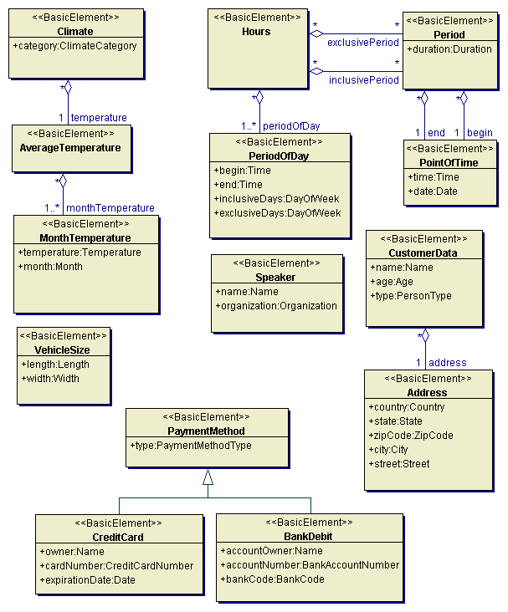
Figure 6-54: Basic elements
Class descriptions
Class Entity
The class Entity represents independent entities of the tourism domain. Entities have a specific lifetime and can contain dependent elements, which can only exist within an entity. Entities are identified by an unequivocal object identifier.
Attributes
The attribute identifier specifies an unequivocal identifier of the entity.
The attribute info specifies a resource location, where further information about the entity are available.
Class MarketComponent
The class MarketComponent represents a market component and enables to specify all available processes of the market component.
Class Process
The class Process represents processes of market components.
Attributes
The attribute session specifies the identifier of the session the process is executed in.
The attribute state specifies the state of the process. Possible states are request or response.
Class descriptions
Class Address
The class Address enables to specify complete address information like country, city, street etc.
Attributes
The attribute city specifies the city of the address.
The attribute country specifies the country of the address.
The attribute state specifies the state or province of the address.
The attribute street specifies the street and street number of the address.
The attribute zipCode specifies the zip code of the city of the address.
Class AverageTemperature
The class AverageTemperature specifies the temperature as monthly averages.
Associations
The aggregation monthTemperature specifies the average temperatures for all month of the year.
Class BankDebit
The class BankDebit specifies the method of payment bank debit.
Attributes
The attribute accountNumber specifies the number of the bank account.
The attribute accountOwner specifies the owner of the bank account by its name.
The attribute bankCode specifies the bank code of the bank account.
Class Climate
The class Climate specifies a climate by the temperature and the category.
Attributes
The attribute category specifies the category of the climate (e.g. tropical, sub-tropical, etc.).
Associations
The aggregation temperature specifies the temperature of a climate.
Class CreditCard
The class CreditCard specifies the method of payment credit card.
Attributes
The attribute cardNumber specifies the number of the credit card.
The attribute expirationDate specifies the expiration date of the credit card.
The attribute owner specifies the owner of the credit card by its name.
Class CustomerData
The class CustomerData enables the specification of a customer by name, address, age and type of person.
Attributes
The attribute age specifies the customer's age.
The attribute name specifies the name of the customer.
The attribute type specifies the type of person of the customer.
Associations
The aggregation address specifies the address of the customer.
Class Hours
The class Hours enables the flexible definition of periods of the day for specific periods (of the year) and days of the week.
Associations
The aggregation periodOfDay specifies the periods of a day.
The aggregation inclusivePeriod specifies a collection of included periods of time.
The aggregation exclusivePeriod specifies a collection of not included periods of time.
Class MonthTemperature
The class MonthTemperature specifies the temperature average for a specific month.
Attributes
The attribute month specifies the month, for which the temperature is given.
The attribute temperature specifies the temperature average for the month.
Class PaymentMethod
The class PaymentMethod enables to specify a method of payment with all the necessary characteristics.
Attributes
The attribute type specifies the type of method of payment e.g. credit card or bank debit.
Class Period
The class period specifies a period of time by a begin point of time and an end point of time.
Attributes
The attribute duration specifies the duration of the period of time.
Associations
The aggregation begin specifies the begin point of time.
The aggregation end specifies the end point of time.
Class PeriodOfDay
The class PeriodOfDay specifies a period for a set of days of the week.
Attributes
The attribute begin specifies the begin time of the period.
The attribute end specifies the end time of the period.
The attribute exclusiveDays specifies a set of days, for which the time period is not valid.
The attribute inclusiveDays specifies the set of days of the week of the period.
Class PointOfTime
The class PointOfTime specifies a point of time by a date and a time.
Attributes
The attribute date specifies the date of the point of time.
The attribute time specifies the time of the point of time.
Class Speaker
The class Speaker specifies a speaker on a conference or similar event by its name and organization.
Attributes
The attribute name specifies the name of the speaker.
The attribute organization specifies the organization of the speaker.
Class VehicleSize
The class VehicleSize enables to specify the size of a vehicle as width and length.
Attributes
The attribute length specifies the length of a vehicle.
The attribute width specifies the width of a vehicle.

Session processes
The package SessionProcesses provides all processes necessary for managing user sessions. The management of user sessions is necessary for enabling secure access mechanisms, transaction management, ownership management etc. Provided processes are opening a user session and closing a user session. Figure 6-55 illustrates the structure of the market component providing the session processes.
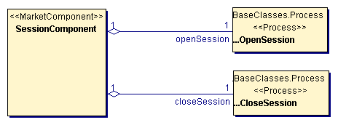
Figure 6-55: Structure of the session component
Class descriptions
Class SessionComponent
The class SessionComponent represents the session component, providing all session processes like opening a session or closing a session. This class definition provides the necessary meta data about the structure of the session component, i.e. the provided processes.
Associations
The aggregation closeSession specifies the close session process of the session component.
The aggregation openSession specifies the open session process of the session component.

Open session process
The package OpenSessionProcess specifies the open session process and provides all entities and scenarios for the open session process. The process open session specifies a request for opening a user session. The open session process requires user login information (user identifier and password) as input elements and provides a session identifier as output element. Figure 6-56 illustrates the structure of the open session process.

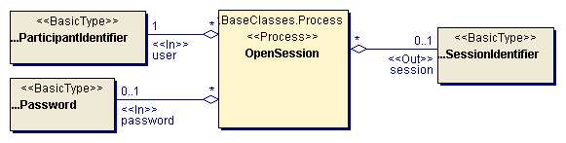
Figure 6-56: Open session process
Class descriptions
Class OpenSession
The class OpenSession represents the process of opening a new user session.
Associations
The aggregation user specifies the identifier of the user (i.e. market participant) opening the session. User is an input element of the OpenSession process.
The aggregation password specifies the password, associated with the specified user, for opening a session. Password is an input element of the OpenSession process.
The aggregation session specifies an identifier for the created user session. Session is an output element of the OpenSession process.

Figure 6-57 illustrates the flow of activity of the open session process.
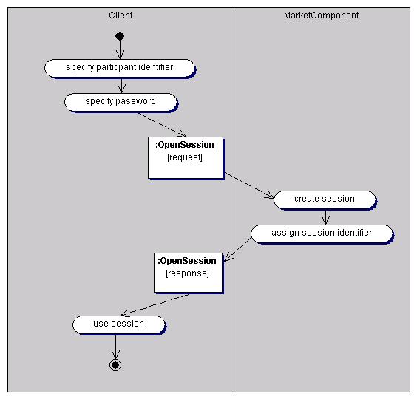
Figure 6-57: Open session scenario

Close session process
The package CloseSessionProcess specifies the close session process and provides all entities and scenarios for the close session process. The process close session specifies a request for terminating a user session. The close session process requires a session identifier as input element. Figure 6-58 illustrates the structure of the close session process.

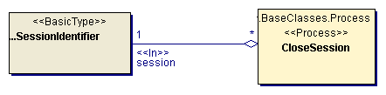
Figure 6-58: Close session process
Class descriptions
Class CloseSession
The class CloseSession represents the process of terminating a user session.
Associations
The aggregation session specifies the identifier of the user session to be terminated. Session is an input element of the CloseSession process.

Figure 6-59 illustrates the flow of activity of the close session process.
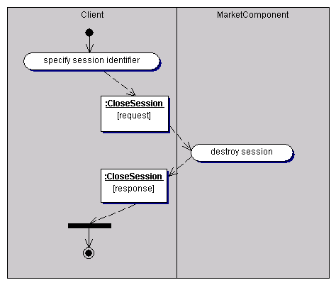
Figure 6-59: Close session scenario

Lookup processes
The package LookupProcesses provides processes for requesting information about the available services of the market component and descriptions of the structure of the used elements. Clients can use the lookup processes to examine the interface of a market component, which services are provided by a specific market component and what is the structure of the input and output elements. Figure 6-60 illustrates the structure of the market component providing the lookup processes.

Figure 6-60: Structure of the lookup component
Class descriptions
Class LookupComponent
The class LookupComponent represents the lookup component, providing all lookup processes like requesting meta data. This class definition provides the necessary meta data about the structure of the lookup component, i.e. the provided processes.
Associations
The aggregation requestMetaData specifies the request meta data process of the lookup component.

Request metadata process
The package RequestMetaDataProcess specifies the process of requesting metadata and provides all entities and scenarios for the request metadata process. The process request metadata specifies a request for a description of an element of a market component (e.g. a process or an entity). The request metadata process requires the name of the element as input element and provides a description of the element as a link to an XMI document (or document type definition) as output element. Figure 6-61 shows the structure of the request metadata process.

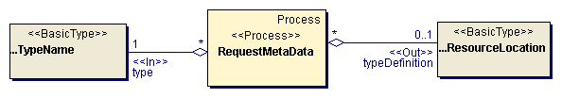
Figure 6-61: Request metadata process
Class descriptions
Class RequestMetaData
The class RequestMetaData represents the process of requesting a definition of an element type of a market component.
Associations
The aggregation typeDefinition specifies the definition of the type as a resource location. TypeDefinition is an output element of the RequestMetaData process.
The aggregation type specifies the type, for which a definition is requested. Type is an input element of the RequestMetaData process.

Figure 6-62 illustrates the flow of activity of the request metadata process.
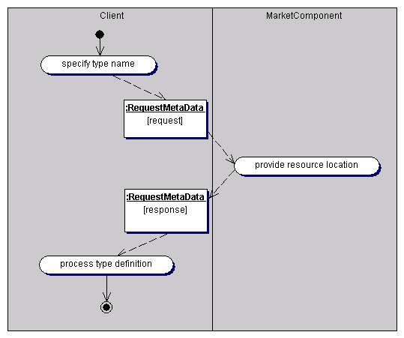
Figure 6-62: Request metadata scenario

Entity layer
The entity layer contains entities of the problem domain tourism. In detail, the entity layer provides common entities, which are used in different packages of the entity layer, service components, used for building tourism services, elementary tourism services (e.g. hotel or flight) and composition services (e.g. a package tour). Figure 6-63 illustrates the structure of the entity layer, its packages and their relationships.

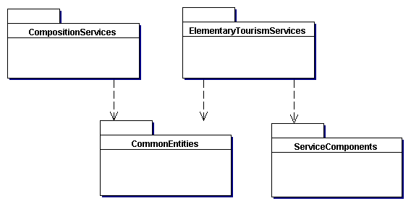
Figure 6-63: Package structure of the entity layer

Common entities
The package CommonEntities contains common entities of the entity layer. Common entities are used in different other packages of the entity layer or the process layer. Figure 6-64 shows all classes of the package CommonEntities.
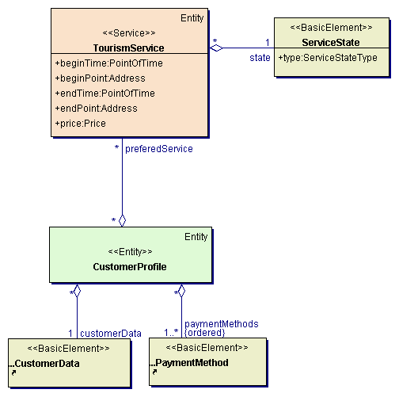
Figure 6-64: Common entities
Class descriptions
Class CustomerProfile
The class CustomerProfile enables to specify a profile of a customer, consisting of the basic customer data, the used methods of payment and preferences, concerning the requested tourism services.
Associations
The aggregation preferedService specifies the preferences of the customer, concerning the characteristics of the searches services. The preferences are describes as a collection of requested services.
The aggregation customerData specifies the basic data of the customer like name, address, etc.
The aggregation paymentMethods specifies the methods of payment the customer is willing to use. The methods of payment are ordered according to the preferences of the customer.
Class ServiceState
The class ServiceState represents the state of a tourism service.
Attributes
The attribute type specifies the type of state of a tourism service (e.g. offered service, booked service, etc.).
Class TourismService
The class TourismService represents tourism services, elementary tourism services as well as composition services. The class TourismService provides a common interface for all tourism services. This common interface provides all attributes, which are necessary for composing tourism services.

Lớp Tourismservices biểu diễn các dịch vụ du lịch, dịch vụ cơ bản hay dịch vụ kết hợp. Lớp này cung cấp một Interface chung cho tất cả các dịch vụ du lịch. Interface chung cung cấp tất cả các thuộc tính mà cần có trong các dịch vụ du lịch.
Attributes
The attribute beginPoint specifies the location, where the usage of the tourism service begins.
The attribute beginTime specifies the point of time, when the usage period of the tourism service begins.
The attribute endPoint specifies the location, where the usage of the tourism service ends.
The attribute endTime specifies the point of time, when the usage period of the tourism service ends.
The attribute price specifies the price of the tourism service.
Associations
The aggregation state specifies the state of the tourism service.

Service components
Các thành phần dịch vụ
Gói ServiceComponent bao gồm tất cả các thành phần dịch vụ du lịch cơ bản cấu trúc. Các thành phàn du lịch cơ bản đưa vào các thành phần du lịch cốt lỗi, và thành phần bổ sung. Các thành phần du lịch cốt lỗi biểu diễn các dịch vụ chính như accommodation, transport, catering, event… Còn các thành phần bổ sung biểu diễn thêm như institution, facility, seat, vehicle…

The package ServiceComponents contains all components elementary tourism services are constructed of. Components of elementary tourism services are divided into core tourism service components and supplemental components. Core tourism service components represent core tourism services like accommodation, transport, catering, event, etc.). Supplemental components represent additional components for constructing tourism services like institution, facilities, seat, vehicle etc. Figure 6-65 illustrates the structure of the package ServiceComponents.

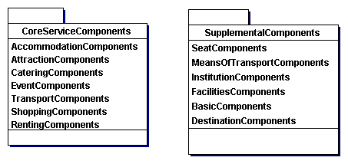
Figure 6-65: Structure of the package ServiceComponents

Core service components
The package CoreServiceComponents provides components representing core tourism services like an accommodation within a hotel room, a transport from one point to another, a catering service, etc. These components are used as central components of corresponding elementary tourism services (e.g. the accommodation within a hotel room as central component of the tourism service hotel) or as additional components of a tourism service (e.g. a catering service within the tourism service hotel or transportation).

Accommodation components
The package AccommodationComponents provides components representing core accommodation services like a room in a hotel, a pitch on a campsite, a cabin on a ship, a sleeper compartment within a train, etc. These core accommodation services can be used as central components of elementary tourism services of the type accommodation as well as optional components of services like train journey, ship passage, etc. Figure 6-66 shows all accommodation components.

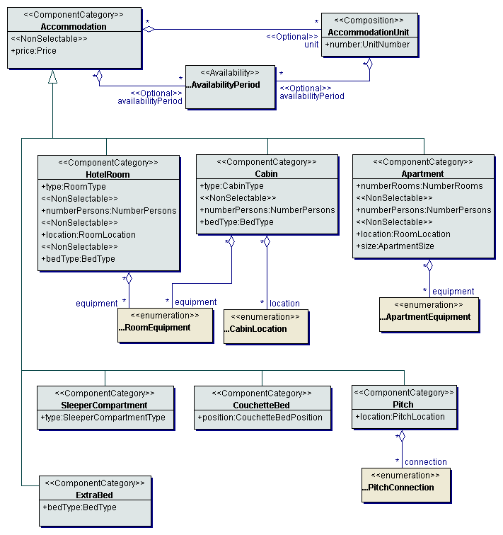
Figure 6-66: Accommodation components
Class descriptions
Class Accommodation
The class Accommodation enables to specify a basic accommodation or accommodation category (e.g. hotel room, ship cabin, etc.).
Attributes
The attribute price specifies the price of an accommodation or accommodation category for a period of time.
Associations
The aggregation availabilityPeriod specifies the availability periods of an accommodation or accommodation category.
The aggregation unit specifies the concrete units of the accommodation.
Class AccommodationUnit
The class AccommodationUnit represents concrete accommodation units of an accommodation category (e.g. rooms, cabins, etc.).
Attributes
The attribute number specifies the number of the accommodation unit (e.g. of the hotel room or ship cabin).
Associations
The aggregation availabilityPeriod specifies the availability periods of an accommodation unit.
Class Apartment
The class Apartment enables to specify an apartment or a category of apartments within an apartment institution.
Attributes
The attribute location specifies the location of the apartment within the institution (e.g. floor, seaside, seascape, etc.).
The attribute numberPersons specifies the number of persons, which can use the apartment.
The attribute numberRooms specifies the number of rooms within the apartment.
The attribute size specifies the size of the apartment.
Associations
The aggregation equipment specifies the equipment of the apartment (e.g. bath, shower, toilet, telephone, tv, dishwasher, fireplace, etc.).
Class Cabin
The class Cabin represents a cabin or a category of cabins within a ship.
Attributes
The attribute bedType specifies the type of the beds of the cabin (single. double, etc.).
The attribute numberPersons specifies the capacity of the cabin as number of persons.
The attribute type specifies the type of the cabin (e.g. single, double, suite, etc.).
Associations
The aggregation location specifies the location of the cabin within the ship.
The aggregation equipment specifies the available equipment within the cabin (e.g. bath, shower, toilet, telephone/fax, internet access, mini-bar, etc.).
Class CouchetteBed
The class CouchetteBed represents a bed or a category of beds within a couchette car of a train.
Attributes
The attribute position specifies the position of the bed within a couchette car (e.g. top, middle, bottom).
Class ExtraBed
The class ExtraBed represents beds, which can be put up additionally within an accommodation e.g. a hotel room.
Attributes
The attribute bedType specifies the type of the extra bed.
Class HotelRoom
The class HotelRoom enables to specify a hotel room or category of hotel rooms within a hotel.
Attributes
The attribute bedType specifies the type of the bed of the hotel room (single, double, king size, etc.).
The attribute location specifies the location of the hotel room (e.g. seaside, seascape, etc.).
The attribute numberPersons specifies the number of persons, which can use the hotel room.
The attribute type specifies the type of the hotel room (e.g. single room, double room, etc.).
Associations
The aggregation equipment specifies the available equipment within the hotel room (e.g. bath, shower, toilet, telephone/fax, internet access, mini-bar, etc.).
Class Pitch
The class Pitch enables to specify a pitch or pitch category within a campsite.
Attributes
The attribute location specifies the location of the pitch within the campsite (e.g. near entrance, near border, near wash-room, seaside, etc.).
Associations
The aggregation connection specifies available connections of the pitch (e.g. water, electricity, gas, etc.).
Class SleeperCompartment
The class SleeperCompartment represents a compartment or a category of compartments within a sleeper-car of a train.
Attributes
The attribute type specifies the type of the sleeper compartment (e.g. single, double, etc.).

Attraction components
The package AttractionComponents provides components representing core attraction services like sights, exhibitions, museums or sporting facilities. These core attraction services can be used as central components of elementary tourism services of the type attraction as well as optional components of services like hotel, cruise, ship passage, train journey, etc. Figure 6-67 shows all attraction components.

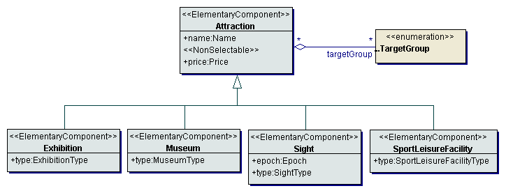
Figure 6-67: Attraction components
Class descriptions
Class Attraction
The class Attraction represents the core tourism service attraction like a museum, exhibition, sight, etc.
Attributes
The attribute name specifies the name of the attraction.
The attribute price specifies the price of the attraction.
Associations
The aggregation targetGroup specifies the target groups of the attraction, i.e. the person types the attraction is suitable for.
Class Exhibition
The class Exhibition represents the basic tourism service exhibition.
Attributes
The attribute type specifies the type of the exhibition or branch of industry (e.g. automobile exhibition, book fair, tourism fair,...).
Class Museum
The class Museum represents the basic tourism service museum.
Attributes
The attribute type specifies the type of the museum (e.g. museum of modern art, nature museum, open air museum, railway museum,...).
Class Sight
The class Sight represents the basic tourism service sight.
Attributes
The attribute epoch specifies the historic epoch of origin of the sight.
The attribute type specifies the type of the sight (e.g. natural monument, listed building, excavation etc.).
Class SportLeisureFacility
The class SportLeisureFacility represents the basic tourism service sport leisure facility.
Attributes
The attribute type specifies the type of the facility, e.g. bath, tennis court, leisure park, etc.

Catering components
The package CateringComponents provides components for the core service catering. These catering services can be used as central components of elementary tourism services of the type restaurant as well as optional components of services like hotel, cruise, ship passage, train journey, etc. Figure 6-68 shows all catering components.

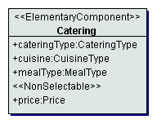
Figure 6-68: Catering components
Class descriptions
Class Catering
The class Catering enables to specify a catering service e.g. during a flight, within a hotel, restaurant or train etc.
Attributes
The attribute type specifies the type of the catering service (e.g. breakfast, half board, a la carte, etc.).
The attribute cuisine specifies the cuisine type of the catering service.
The attribute mealType specifies the specific meal type (e.g. diabetics, etc.).
The attribute price specifies the price of the catering service for a period of time.

Event components
The package EventComponents provides components representing core event services like theatre play, football match, opera, etc. These core event services can be used as central components of elementary tourism services of the type event as well as optional components of services like hotel, cruise, ship passage, train journey, etc. Figure 6-69 shows all event components.

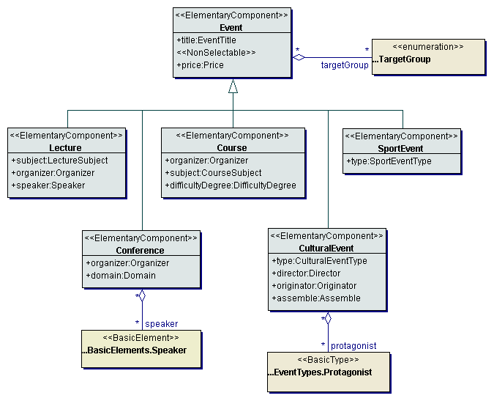
Figure 6-69: Event components
Class descriptions
Class Conference
The class Conference represents the basic tourism service conference.
Attributes
The attribute domain specifies the domain or subject of the conference.
The attribute organizer specifies the institution or organization, executing the conference.
Associations
The aggregation speaker specifies a collection of key-note speakers of the conference.
Class Course
The class Course represents the basic tourism service course.
Attributes
The attribute difficultyDegree specifies the degree of difficulty of the course (e.g. novice, advanced, etc.).
The attribute organizer specifies the institution or organization, executing the course
The attribute subject specifies the subject the course is dealing with (e.g. sport, language, etc.).
Class CulturalEvent
The class CulturalEvent represents the basic tourism service cultural event.
Attributes
The attribute assemble specifies the assemble performing the cultural event.
The attribute director specifies the director of the cultural event (e.g. conductor, theatre director, etc.).
The attribute originator specifies the originator or artificer of the play or work, which is performed within the cultural event (e.g. composer, author).
The attribute type specifies the type of the cultural event (e.g. opera, operetta, drama, comedy, etc.).
Associations
The aggregation protagonist specifies the protagonists of the cultural event.
Class Event
The class Event represents the core tourism service event.
Attributes
The attribute price specifies the basic price of the event service.
The attribute title specifies the title of the event.
Associations
The aggregation targetGroup specifies the types of persons, for whom the event is designed.
Class Lecture
The class Lecture represents the basic tourism service lecture.
Attributes
The attribute organizer specifies the institution or organization, executing the lecture.
The attribute speaker specifies the name of the speaker of the lecture.
The attribute subject specifies the subject of the lecture (e.g. leisure, sport, culture, industrial sector, etc.).
Class SportEvent
The class SportEvent represents the basic tourism service sport event.
Attributes
The attribute type specifies the type of the sport event e.g. because of the performed sport (e.g. tennis tournament, football match, etc.) or because of the type of competition (e.g. league match, friendly match, international match, etc. in the case of a football match).

Renting components
The package RentingComponents provides components representing the core tourism service of renting an object (e.g. a car or a bike). These core renting services can be used as central components of elementary tourism services of the type hired vehicle as well as optional components of services like hotel, cruise, ship passage, etc. Figure 6-70 shows all renting components.
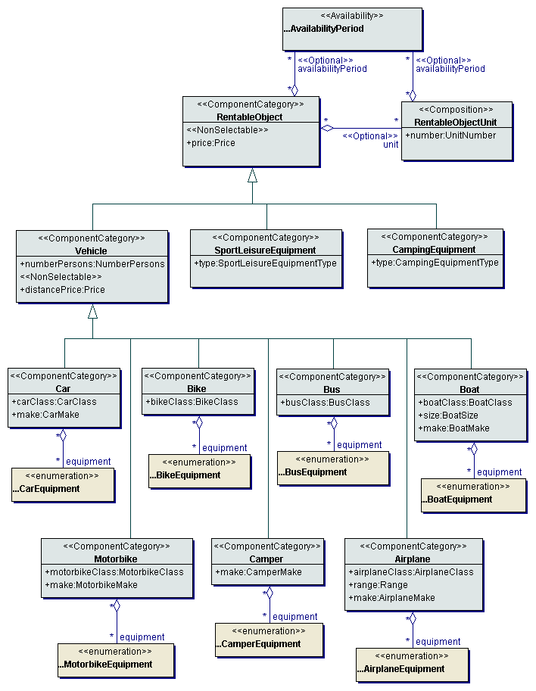
Figure 6-70: Renting components
Class descriptions
Class Airplane
The class Airplane represents an airplane or a category of airplanes used as a hired vehicle.
Attributes
The attribute airplaneClass specifies the class of the airplane (e.g. glider, sporting aircraft, passenger aircraft, etc.).
The attribute make specifies the make and type of the airplane.
The attribute range specifies the range of the airplane.
Associations
The aggregation equipment specifies the equipment of the airplane (e.g. instruments, telephone, TV, etc.).
Class Bike
The class Bike represents a bike or a category of bikes used as a hired vehicle.
Attributes
The attribute bikeClass specifies the class of the bike (e.g. mountain bike, racing bike, tandem, etc.).
Associations
The aggregation equipment specifies equipment details of the bike (e.g. tachometer, childs seat etc.).
Class Boat
The class Boat represents a boat or a category of boats used as a hired vehicle.
Attributes
The attribute boatClass specifies the class of the boat (e.g. sailing boat, motorboat, etc.).
The attribute make specifies the make and type of the boat.
The attribute size specifies the size (i.e. length) of the boat.
Associations
The aggregation equipment specifies the equipment of the boat (e.g. galley, transmitter, dinghy, etc.).
Class Bus
The class Bus represents a bus or a category of busses used as a hired vehicle.
Attributes
The attribute busClass specifies the quality class of the bus.
Associations
The aggregation equipment specifies the equipment of the bus (e.g. air-conditioning, wardrobe, toilet, telephone, etc.).
Class Camper
The class Camper represents a camper or a category of campers used as a hired vehicle.
Attributes
The attribute make specifies the make and type of the camper.
Associations
The aggregation equipment specifies equipment details of the camper.
Class CampingEquipment
The class CampingEquipment enables the specification of equipment, which can be rented within a campsite (e.g. tent, caravan, etc.).
Attributes
The attribute type specifies the type of equipment, which can be rented within a campsite (e.g. tent, caravan, etc.).
Class Car
The class Car represents a car or a category of cars used as a hired vehicle.
Attributes
The attribute carClass specifies the class of the car (e.g. economy, middle class, de luxe, etc.).
The attribute carMake specifies the make and type of the car.
Associations
The aggregation equipment specifies the equipment of the car (e.g. radio, telephone, air-conditioning, etc.).
Class Motorbike
The class Motorbike represents a motorbike or a category of motorbikes used as a hired vehicle.
Attributes
The attribute make specifies the make and type of the motorbike.
The attribute motorbikeClass specifies the class of the motorbike (e.g. moped, enduro, etc.).
Associations
The aggregation equipment specifies the equipment of the motorbike (e.g. bags, radio, etc.).
Class RentableObject
The class RentableObject enables to specify a rentable object or a category of rentable objects (e.g. car, bike, etc.).
Attributes
The attribute price specifies the price for renting the object for a specific period of time.
Associations
The aggregation availabilityPeriod specifies the availability of a rentable object or a rentable object category for specific periods of time.
The aggregation unit specifies all concrete rentable objects of the category of rentable objects.
Class RentableObjectUnit
The class RentableObjectUnit enables to specify a concrete rentable object.
Attributes
The attribute number specifies the number of the rentable object unit as an unequivocal identifier.
Associations
The aggregation availabilityPeriod specifies the availability of a rentable object unit for specific periods of time.
Class SportLeisureEquipment
The class SportLeisureEquipment enables the specification of equipment, which can be rented within a sport leisure institution.
Attributes
The attribute type specifies the type of equipment, which can be rented within a sport leisure institution (e.g. tennis racket, bathing-trunks, etc.).
Class Vehicle
The class Vehicle represents a hired vehicle or category of hired vehicles. The component vehicle is used as central component of the tourism service hired vehicle or as additional components of e.g. accommodation services.
Attributes
The attribute distancePrice specifies the price for the moved distance.
The attribute numberPersons specifies the number of persons, which can be transported with the used vehicle.

Shopping components
The package ShoppingComponents provides components representing the core service shopping. These components are used as central component of the tourism service shopping or as additional components of tourism services like accommodation, transportation, etc. Figure 6-71 shows all shopping components.

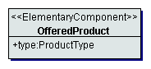
Figure 6-71: Shopping components
Class descriptions
Class OfferedProduct
The class OfferedProduct enables to specify offered products or services. This component can be used as central component of a shopping service or as a component of an accommodation or transportation service.
Attributes
The attribute type specifies the type or group of the product e.g. hair-dresser, grosser, sport equipment, etc.

Transport components
The package TransportComponents provides components representing core transport services as a transport from one point to another. These core transport services are used as central components of elementary tourism services of the type transportation. Figure 6-72 shows all transport components.

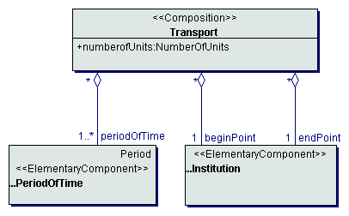
Figure 6-72: Transport components
Class descriptions
Class Transport
The class Transport represents an elementary unit of transport. A transport is composed of a route, consisting of a begin and end point and a collection of periods of time, for which the transport is available.
Attributes
The attribute numberOfUnits specifies the number of units of the transport (normally corresponding to the transport distance). The attribute numberOfUnits serves for evaluating the price of the transport service.
Associations
The aggregation beginPoint specifies the begin point of the transport service.
The aggregation endPoint specifies the end point of the transport service.
The aggregation periodOfTime specifies the periods of time, for which the transport is available.

Supplemental components
The package SupplementalComponents provides supplemental components for constructing tourism services. Supplemental components are used in conjunction with core service components and represent basic components like availability or period of time as well as environmental components like institution, facilities, etc.

Basic components
The package BasicComponents contains basic components for constructing tourism services (e.g. availability, period of time, etc.). Figure 6-73 shows all basic components.

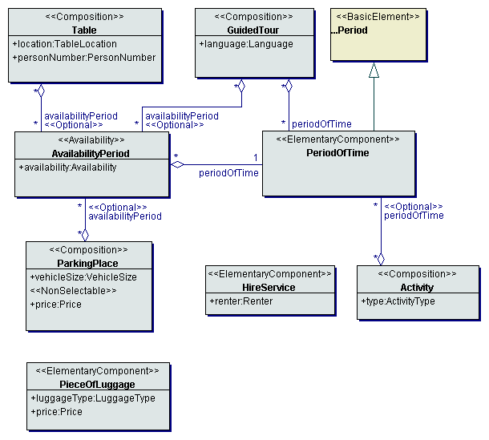
Figure 6-73: Basic components
Class descriptions
Class Activity
The class Activity enables the representation of activities, which are of relevance for a journey or business trip.
Attributes
The attribute type specifies the type of the activity.
Associations
The aggregation periodOfTime specifies during which periods of time the activity can be executed.
Class AvailabilityPeriod
The class AvailabilityPeriod enables the specification of the availability of a tourism service or service component (for a specific period of time).
Attributes
The attribute availability specifies the availability as the number of available entities.
Associations
The aggregation periodOfTime specifies the period of time, for which the availability is given.
Class GuidedTour
The class GuidedTour represents guided tours, which are offered and executed e.g. within an institution (e.g. museum, sight).
Attributes
The attribute language specifies the language, in which the guided tour is executed.
Associations
The aggregation periodOfTime specifies the periods of time, when guided tours are offered.
The aggregation avialabilityPeriod specifies the availability of the guided tour for different periods of time.
Class HireService
The class HireService represents a hire service, offering hired vehicle services (e.g. the car rental company).
Attributes
The attribute renter specifies the renting company by its name.
Class ParkingPlace
The class ParkingPlace specifies a parking place for vehicles of any type (e.g. on a ship for transporting a vehicle).
Attributes
The attribute price specifies the price of the parking place for a period of time.
The attribute vehicleSize specifies the size of the vehicle, which can be transported on the parking place.
Associations
The aggregation availabilityPeriod specifies the availability of a parking place for specific periods of time.
Class PeriodOfTime
The class PeriodOfTime enables to specify a period of time as a component of a tourism service.
Class PieceOfLuggage
The class PieceOfLuggage specifies a piece of luggage, which e.g. has to be transported during a transportation service or stored during an accommodation service.
Attributes
The attribute luggageType specifies the type of the piece of luggage.
The attribute price specifies the price for the piece of luggage to be integrated into the tourism service (e.g. to be transported during a flight or to be stored within a hotel).
Class Table
The class Table specifies a table e.g. within a restaurant.
Attributes
The attribute location specifies the location of the table within the institution e.g. the restaurant.
The attribute personNumber specifies the number of persons the table is suitable for.
Associations
The aggregation availabilityPeriod specifies the availability of a table for specific periods of time.

Destination components
The package DestinationComponents contains components representing destination characteristics. Figure 6-74 shows all destination components.

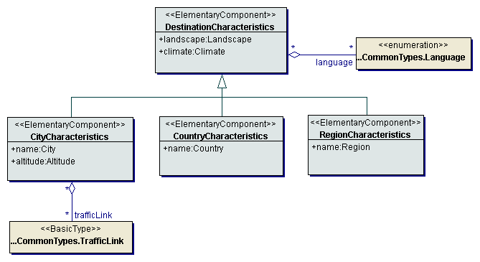
Figure 6-74: Destination components
Class descriptions
Class CityCharacteristics
The class CityCharacteristics represents basic characteristics of a city.
Attributes
The attribute altitude specifies the altitude of the city.
The attribute name specifies the name of the city.
Associations
The aggregation trafficLink specifies existing traffic links (e.g. railway link, airport link, motorway link, etc.).
Class CountryCharacteristics
The class CountryCharacteristics represents basic characteristics of a country
Attributes
The attribute name specifies the name of the country.
Class DestinationCharacteristics
The class DestinationCharacteristics represents basic characteristics of a destination.
Attributes
The attribute climate specifies the climate of the destination.
The attribute landscape specifies the characteristic of the landscape (e.g. flat, hilly, mountainous, etc.).
Associations
The aggregation language specifies languages spoken within the destination.
Class RegionCharacteristics
The class RegionCharacteristics represents basic characteristics of a region.
Attributes
The attribute name specifies the name of the region.

Facilities components
The package FacilitiesComponents contains components representing facilities and equipment details e.g. of a hotel, a ship, a train, etc. Figure 6-75 shows all facilities components.

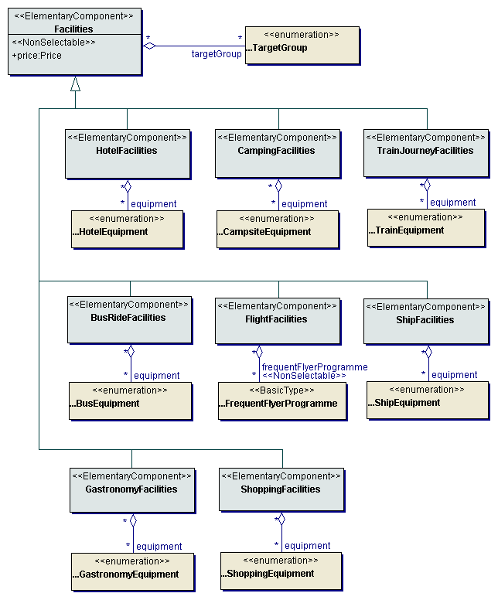
Figure 6-75: Facilities components
Class descriptions
Class BusRideFacilities
The class BusRideFacilities enables to specify basic facilities of a bus ride service.
Associations
The aggregation equipment specifies available equipment details of the bus (e.g. air-conditioning, bar, tv, etc.).
Class CampingFacilities
The class CampingFacilities enables to specify basic facilities of a camping service.
Associations
The aggregation equipment specifies equipment details of the campsite (e.g. shower, toilet, telephone, wash-room, swimming pool, etc.).
Class Facilities
The class Facilities enables to specify basic facilities of a tourism service e.g. facilities of an accommodation institution like hotel or camping site or facilities of a means of transport like train or ship.
Attributes
The attribute price specifies the price of the facilities for a period of time or a transport unit.
Associations
The aggregation targetGroup specifies the target groups of the tourism service.
Class FlightFacilities
The class FlightFacilities enables to specify basic facilities of a flight service.
Associations
The aggregation frequentFlyerProgramme specifies the frequent flyer programmes, this flight participates in.
Class GastronomyFacilities
The class GastronomyFacilities enables to specify basic facilities of a gastronomy service or institution.
Associations
The aggregation equipment specifies available equipment details of the gastronomy service or institution (e.g. fireplace, child-seat, play corner etc.).
Class HotelFacilities
The class HotelFacilities enables to specify basic facilities of a hotel service.
Associations
The aggregation equipment specifies a set of equipment details of the hotel (e.g. conference room, bar, lift, air-conditioning, etc.).
Class ShipFacilities
The class ShipFacilities enables to specify basic facilities of a ship passage or cruise service.
Associations
The aggregation equipment specifies equipment details of the ship.
Class ShoppingFacilities
The class ShoppingFacilities enables to specify basic facilities of a shopping service or institution.
Associations
The aggregation equipment specifies available equipment details of the shopping service or institution (e.g. lift, play corner etc.).
Class TrainJourneyFacilities
The class TrainJourneyFacilities enables to specify basic facilities of a train journey service.
Associations
The aggregation equipment specifies all equipment details of the train.

Institution components
The package InstitutionComponents contains components representing institutions used for providing tourism services (e.g. a hotel as an institution providing accommodation services, a theatre providing a cultural event, a sport center providing a sport event, etc.). Figure 6-76 shows all institution components.

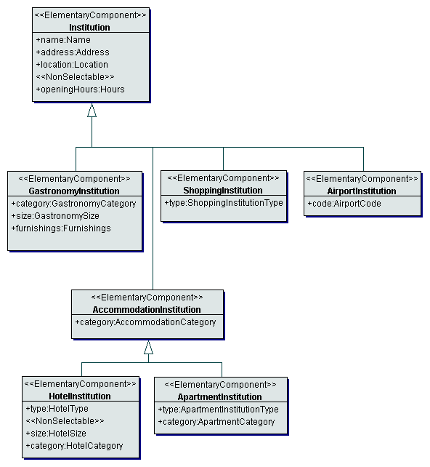
Figure 6-76: Institution components
Class descriptions
Class AccommodationInstitution
The class AccommodationInstitution specifies the characteristics of an accommodation institution e.g. a hotel institution or an apartment institution.
Attributes
The attribute category specifies the quality category of the accommodation.
Class AirportInstitution
The class AirportInstitution specifies the characteristics of an airport..
Attributes
The attribute code specifies the code of the airport as an unequivocal identifier of the airport.
Class ApartmentInstitution
The class ApartmentInstitution specifies the characteristics of an apartment institution (e.g. an apartment house, apartment hotel, holiday club, etc.).
Attributes
The attribute category specifies the quality category of the apartment. The apartment category is an extension of the accommodation category.
The attribute type specifies the type of the apartment institution (e.g. flat, house, apartment hotel, etc.).
Class GastronomyInstitution
The class GastronomyInstitution specifies the characteristics of a gastronomy institution e.g. a restaurant.
Attributes
The attribute category specifies the category of the gastronomy institution or service e.g. bar, bistro, restaurant (upper quality, high quality, etc.).
The attribute furnishings specifies the style of the furnishings (rustic, modern, antique, etc.).
The attribute size specifies the size of the gastronomy institution as the overall number of available seats or places.
Class HotelInstitution
The class HotelInstitution specifies the characteristics of a hotel.
Attributes
The attribute category specifies the quality category of the hotel. The hotel category is an extension of the accommodation category. There exist a multitude of different categorizations of different organizations: WTO - World Tourism Organisation, AIT - Alliance Internationale de Tourisme, DEHOGA - Deutscher Hotel und Gaststätten Verband (MUNDT, 1996, p. 109; BLEILE, 1995, p. 28). The Tourism Information Norm (TIN - Touristische Informationsnorm) contains a catalogue of characteristics for categorizing hotels and guest houses (TIN, 1992, pp. 34-46).
The attribute size specifies the size of the hotel as overall number of beds.
The attribute type specifies the type of the hotel or hotel-like accommodation.
Class Institution
The class Institution enables to specify an institution involved in providing tourism services like a hotel, a theatre, a car renting station, etc.
Attributes
The attribute address specifies the address of the institution.
The attribute location specifies the location of the institution (e.g. central, outside, near railway station, near airport, near the beach, etc.).
The attribute name specifies the name of the institution, e.g. the name of the hotel or the theatre.
The attribute openingHours specifies the opening hours of the institution.
Class ShoppingInstitution
The class ShoppingInstitution specifies the characteristics of a shopping institution e.g. a department store.
Attributes
The attribute type specifies the type of the shopping institution (e.g. retail shop, department store, market, etc.).

Means of transport components
The package MeansOfTransportComponents contains components representing means of transport e.g. airplane, train, ship, etc. Figure 6-77 shows all means of transport components.

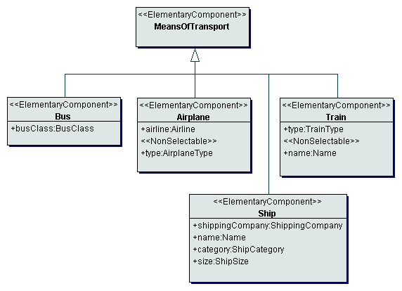
Figure 6-77: Means of transport components
Class descriptions
Class Airplane
The class Airplane represents the means of transport airplane.
Attributes
The attribute airline specifies the service provider of the flight.
The attribute type specifies the type of the airplane, i.e. the manufacturer and the type specification.
Class Bus
The class Bus represents the means of transport bus.
Attributes
The attribute busClass specifies the quality class of the bus (e.g. in accordance with the Gütezeichen Buskomfort RAL).
Class MeansOfTransport
The class MeansOfTransport represents a means of transport, used within a transportation service (e.g. airplane, train, car, etc.).
Class Ship
The class Ship represents the means of transport ship.
Attributes
The attribute category specifies the category of the ship or ferry.
The attribute name specifies the name of the ship or ferry.
The attribute shippingCompany specifies the company providing the shipping passage.
The attribute size specifies the size of the ship as the maximal number of passengers.
Class Train
The class Train represents the means of transport train.
Attributes
The attribute name specifies the name of the train.
The attribute type specifies the type of the train.

Seat components
The package SeatComponents provides components for seats within means of transports (e.g. airplane, train) or within events (e.g. theatre, sport event). Figure 6-78 shows all seat components.

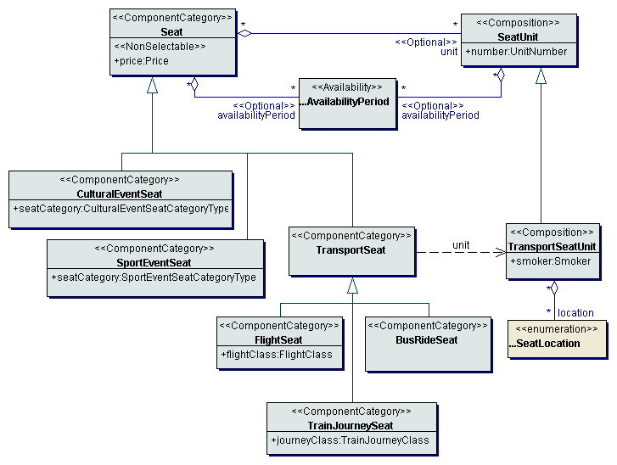
Figure 6-78: Seat components
Class descriptions
Class BusRideSeat
The class BusRideSeat represents a seat or a category of seats within a bus ride service.
Class CulturalEventSeat
The class CulturalEventSeat represents a seat or category of seats within a cultural event.
Attributes
The attribute seatCategory specifies the category of the seat within the place of the event (e.g. stall, box, first circle, etc.).
Class FlightSeat
The class FlightSeat represents a seat or a category of seats within a flight service.
Attributes
The attribute flightClass specifies the class of the flight (e.g. first class, business class, economy class).
Class Seat
The class Seat represents a seat or category of seats e.g. within a transportation or event service.
Attributes
The attribute price specifies the price of a seat or a seat category for a complete tourism service e.g. an event or a transport unit of a transportation service.
Associations
The aggregation availabilityPeriod specifies the availability of a seat or a seat category for specific periods of time.
The aggregation unit specifies the concrete seats of the seat category.
Class SeatUnit
The class SeatUnit represents concrete seats within a tourism service (e.g. a seat within a flight or railway service).
Attributes
The attribute number specifies the number of the seat.
Associations
The aggregation availabilityPeriod specifies the availability of the concrete seat within specific periods of time.
Class SportEventSeat
The class SportEventSeat represents a seat or category of seats within a sport event.
Attributes
The attribute seatCategory specifies the category of the seat within the event (e.g. seat, standing room, box, etc.).
Class TrainJourneySeat
The class TrainJourneySeat represents a seat or a category of seats within a train journey service.
Attributes
The attribute journeyClass specifies the quality class of the train journey (e.g. first class, second class, etc.).
Class TransportSeat
The class TransportSeat represents a seat or a category of seats within a transport.
Class TransportSeatUnit
The class TransportSeatUnit represents a concrete transport seat unit within the transport.
Attributes
The attribute smoker specifies whether the seat is located within a smoking area or not.
Associations
The aggregation location specifies the location of the seat (e.g. corridor, central, window, etc.).

Elementary tourism services
The package ElementaryTourismServices contains all elementary tourism services. A tourism service is elementary, if the service cannot be substituted by a composition of other tourism services. An elementary tourism service is the smallest independently selectable and bookable service.
Considerable tourism services are all services relevant in the context of one of the following travel types: business travel, holiday travel and excursion (Schroeder, 1995). Therefore, tourism services are all services provided by service suppliers out of the tourism domain (e.g. airlines, hotels) or tour operators, extended by general services, which are used in the context of one of the above travel types. A hired vehicle for a fair visit for example is a tourism service; a hired vehicle for the execution of a removal is not.
Gói này bao gồm tất cả các dịch vụ du lịch cơ bản, Một dịch vụ là cơ bản mếu dịch vụ ko thể thay thế bằng việc kết hợp các dịch vụ du lịch khác. Một dịch vụ cơ bản là nhỏ nhất có thể chọn độc lập và có thể đặt dịch vụ.
Cá dịch vụ du lich lớn là tất cả các dịch vụ thích hợp trong một ngữ cảnh của 1 trong các loại du lich sau: du lịch thương mai (business travel), du lịch nghỉ ngơi (holiday), hay một cuộc đi chơi. Vì vậy các dịch vụ du lịch là tất cả cá dịch vụ được cung cấp bởi các nhà cung cấp dịch vụ trong miền du lich (airline, hotels) hoặc các nhà điều hành tour, được mở rộng từ các dịch vụ chung, được sử dụng 1 trong số các kiểu du lịch. Thuê xe trong việc đi du lịch là ví dụ về 1 dịch vu du lịch, còn thuê xe để dọn nhà thì ko phải.

Classification of elementary tourism services
Phân loại các dịch vụ co bản
Mục dịch của việc phân loại các dịch vụ cơ bản là tên nhất quan và miêu tả các dịch vụ du lịch cụ thể. Miêu tả các dịch vụ du lich tập trung vào việc đặc tả thông tin sản phẩm và lựa chon đặc điểm thích hợp.
Kết quả của việc phân loại phu thuộc vào cách nhìn dịch vụ. Có các loại nhứ sau:

The aim of classifying tourism services is a uniform naming and description of concrete tourism services. The description of tourism services focuses on the specification of the product information and selection relevant characteristics.
The result of a classification depends fundamentally on the point of view on the services, which have to be classified. For the domain tourism the following points of view can be differentiated:
Lựa chọn các đặc điểm thích hợp: việc phân loại được thực hiện theo cách lựa chọn đặc điểm. ví dụ: 2 dịch vụ thuộc về cùng 1 lớp, nếu chúng được lựa chọn bởi cùng các đặc điểm.
- selection relevant characteristics:
The classification is done by congruent selection relevant characteristics, i.e. two services belong to the same class, if they are selected by the same characteristics.
- congruence from the users point of view:

The classification is done by characteristics, which constitute a service from the users point of view, i.e. two services belong to the same class, if they are sufficiently congruent from the users point of view.

Phần loại được thực hiện bằng các đặc điểm, mà tạo ra 1 dịch vụ thử quan điểm người dùng. Ví dụ: 2 dịch vụ thuộc cùng 1 lớp, nếu chúng tương đương trên quan điểm người dùng
- congruence from the suppliers point of view:
Decisive for the classification is the congruence of the services from the suppliers point of view. In contrast to the congruence from the users point of view, the production and supply of a tourism service is central for the classification and not the consummation.

Từ quan điểm nhà cung cấp: trái ngược với quan điểm người dùng, nó dựa và sản phảm cung cấp dịch vụ du lịch
- legal regulations:
The classification of tourism services is done by legal regulations (e.g. the differentiation between public transport and transport on demand).

Theo các quy định hợp pháp: ví dụ: khác nhau giữa đi lại công cộng với đi lại theo yêu cầu
- Purpose:
The central aspect of the classification is the purpose of a service, i.e. two services belong to the same class, if they are serving the same purpose.
phân loại theo mục dịch: ví dục 2 dịch vụ thuộc cùng 1 lớp nếu nó có cùng mục đích.

If we compare this points of views with general classification approaches, the consideration of selection relevant characteristics, the congruence from the users or suppliers point of view and legal regulations correspond to the classical categorization and the consideration of the purpose to the conceptual assignment (Booch, 1994).
If we concentrate our contemplations on the selection of tourism services by the user, the congruence from the suppliers point of view and legal regulations are inappropriate for our classification. None of the three remaining points of view is alone sufficient for a uniform classification of all tourism services. On the one side, the combination of services with identical selection relevant characteristics is prerequisite for a simultaneous access to the services of a class, on the other side a simultaneous access is meaningful only if all services within a class are similar from the users point of view (e.g. the simultaneous selection of a hotel and an event is meaningless, although both services have selection relevant characteristics like date, location and price in common). The purpose of a service constitutes a supplemental point of view. Therefore, to achieve a classification adequate for the domain tourism the different points of view have to be combined appropriately.
Irrespective of the point of view of the classification, the following qualities have to be demanded of all classes:
- Homogeneity Tính đồng chất
All services belonging to one class, have to constitute a set of meaningful simultaneously selectable elements.
- Encapsulation tính đống gói
All services, which should be selectable simultaneously, have to belong to one class (on the respective level of abstraction).
- Identity tính đồng nhất
All services belonging to one class have a sufficient amount of identical selection relevant characteristics, which enable a selection within this class.
We start the process of classification with the contemplation of tourism services on a high level of abstraction and concretize our contemplations for the defined tourism services if necessary.
The consummation of tourism services serves for the satisfaction of specific requirements (e.g. the requirement for a change of location, comfortable accommodation and information in the case of a business trip or recreation, entertainment and change of climate in the case of a vacation trip). From the users point of view is it not meaningful to combine services satisfying different basic requirements. Therefore, the highest abstraction level of the classification of tourism services has to be done on the basis of the satisfied basic requirements. This approach corresponds to the point of view purpose.
The different basic requirements result in the following classes of elementary tourism services (see Figure 6-79):
- accommodation (basic requirement for a comfortable overnight stay)
- attraction (basic requirement for information, activity or entertainment)
- cruise
- destination (basic requirement for comfortable surroundings and climate)
- event (basic requirement for information, activity or entertainment)
- gastronomy (basic requirement for food and beverage)
- hired vehicle (basic requirement for mobility)
- shopping (basic requirement for specific goods or services)
- transportation (basic requirement for a change of location or climate)
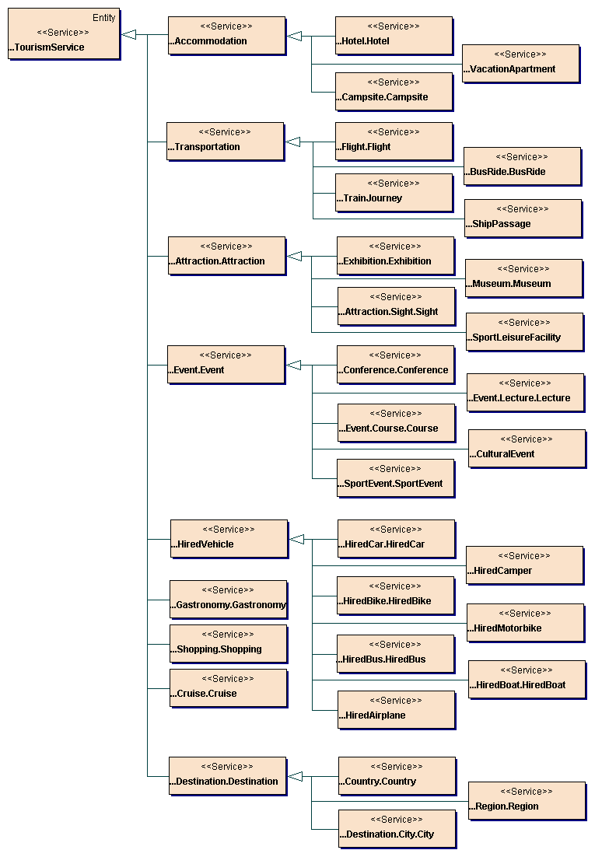
Figure 6-79: Elementary tourism services
Remarks:
- the tourism services Accommodation, Event, Attraction and RentedVehicle clearly demonstrate the meaninglessness of combining services satisfying different basic requirements. In spite of several identical attributes a class of tourism services like destination arrangement, combining the above classes, is not meaningful, because the selection of a service from this class, i.e. from any subclass (e.g. a hotel or an event) is not desirable from the users point of view.
- the tourism services Event and Attraction do not differ by the satisfied basic requirement, but by their temporal availability. Events take place at a fix point of time and have a fix duration. Attraction are available within a specific period of time (opening hours). If selecting this services simultaneously, the common attributes do not enable a meaningful selection of Attraction.
- the tourism service Cruise constitutes an exception within the classification. This service satisfies the basic requirement for a comfortable accommodation as well as a change of location.

Tourism service accommodation
The tourism service Accommodation serves the requirement for a comfortable overnight stay and covers all types of accommodation services. The tourism service accommodation is composed of the components accommodation, facilities, institution, offered products, catering, activity and period of time. Figure 6-80 shows the structure of the tourism service accommodation.

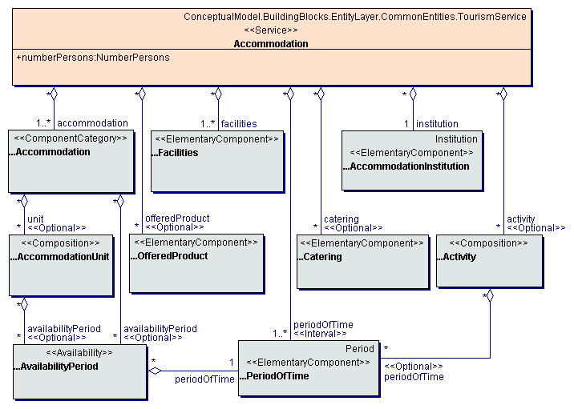
Figure 6-80: Accommodation service

Class descriptions
Class Accommodation
The class Accommodation represents the tourism service accommodation and enables to specify all types of accommodation services.
Attributes
The attribute numberPersons specifies the number of persons, which can use the accommodation service.
Associations
The aggregation institution specifies the institution (e.g. hotel, apartment house) of an accommodation service.
The aggregation activity specifies activities, which are offered by or within the accommodation.
The aggregation catering specifies available catering services.
The aggregation facilities specifies the basic facilities of the accommodation service.
The aggregation accommodation specifies the basic accommodations of the accommodation service (e.g. the rooms of a hotel).
The aggregation offeredProduct specifies products or services offered within the accommodation.
The aggregation periodOfTime specifies the periods of time, for which the accommodation service is bookable.
Figure 6-81 shows all evaluation instructions for the attributes of accommodation services.
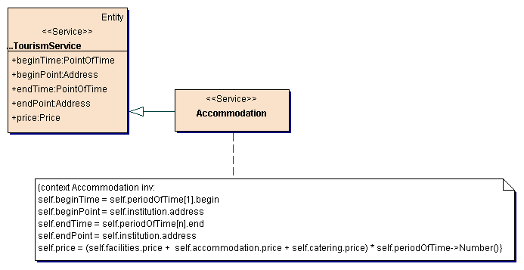
Figure 6-81: Accommodation service evaluation instructions

Classification of accommodation services
The central component of an accommodation service from the users point of view is the accommodation unit (e.g. hotel room). The environment of the accommodation unit (e.g. the hotel or boarding-house as environment of a room) is normally of secondary importance. Therefore, the classification of accommodation services is done by the type of accommodation unit. From this result the following classes of accommodation services (see Figure 6-79):
- hotel (i.e. hotel-like accommodations with a room as accommodation unit)
- vacation apartment
- campsite

Tourism service campsite
The tourism service campsite provides a pitch on a campsite, being used for a tent or a caravan. The tourism service campsite is composed of the specific components pitch, camping equipment and camping facilities. Figure 6-82 shows the structure of the tourism service campsite.

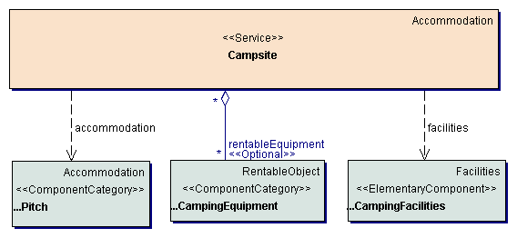
Figure 6-82: Tourism service campsite
Class descriptions
Class Campsite
The class Campsite represents the tourism service campsite and enables to specify a pitch on a campsite as accommodation service.
Associations
The aggregation rentableEquipment specifies equipment, which can be rented within the campsite.
Dependencies
The dependency accommodation specifies that a campsite aggregates pitches as accommodation components.
The dependency facilities specifies that a campsite aggregates camping facilities as facilities components.

Figure 6-83 shows all evaluation instructions for the attributes of campsite services.
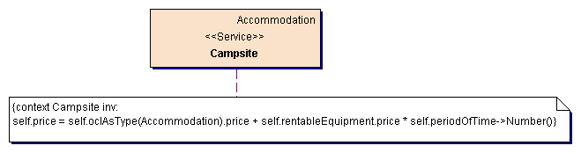
Figure 6-83: Campsite service evaluation instructions

Tourism service hotel
The tourism service hotel is a union of all types of accommodation services with a room as accommodation unit. This are beside hotels in the narrow sense all hotel-like accommodation types like pension or guest house (Mundt, 1996, p.106; Schroeder, 1995, p.34). Because of the incoherent naming of such accommodation types, a more concrete classification as well as a differentiation by one attribute is impossible. Anyway, such labels are synonyms for particular characteristics of the service (e.g. catering, services, size). Hence, the differentiation is done by these characteristics, i.e. their corresponding attributes. The tourism service hotel is composed of the specific components hotel room, extra bed, hotel facilities and hotel institution. Figure 6-84 shows the structure of the tourism service hotel.

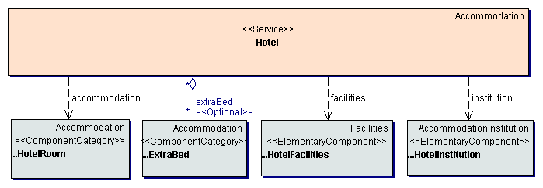
Figure 6-84: Tourism service hotel
Class descriptions
Class Hotel
The class Hotel represents the tourism service hotel and enables to specify all types of hotel-like accommodation services.
Associations
The aggregation extraBed specifies extra beds, which are available within the hotel.
Dependencies
The dependency accommodation specifies that a hotel aggregates hotel rooms as accommodation components.
The dependency facilities specifies that a hotel aggregates hotel facilities as facilities components.
The dependency institution specifies that a hotel aggregates a hotel institution as institution component.

Figure 6-85 shows all evaluation instructions for the attributes of hotel services.
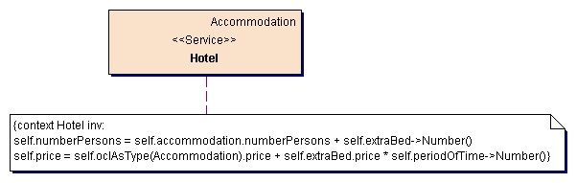
Figure 6-85: Hotel service evaluation instructions

Tourism service vacation apartment
The tourism service vacation apartment covers all accommodation types, containing an apartment as accommodation unit. The decisive characteristic of an apartment is the existence of a kitchen or cooking facilities. The tourism service vacation apartment is composed of the specific components apartment, hotel facilities and apartment institution. Figure 6-86 shows the structure of the tourism service vacation apartment.

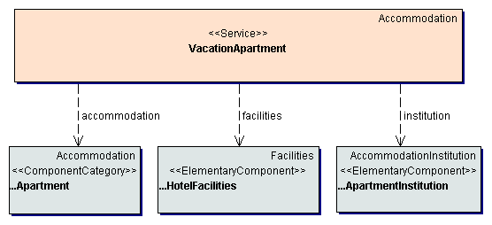
Figure 6-86: Tourism service vacation apartment
Class descriptions
Class VacationApartment
The class VacationApartment represents the tourism service vacation apartment and enables to specify vacation apartments of any kind.
Dependencies
The dependency accommodation specifies that a vacation apartment aggregates apartments as accommodation components.
The dependency facilities specifies that a vacation apartment aggregates hotel facilities as facilities components.
The dependency institution specifies that a vacation apartment aggregates an apartment institution as institution component.

Figure 6-87 shows all evaluation instructions for the attributes of vacation apartment services.
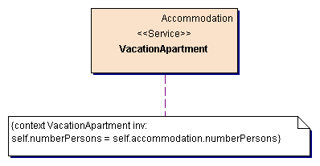
Figure 6-87: Vacation apartment service evaluation instructions

Tourism service attraction
The tourism service attraction serves the satisfaction of the requirement for information or activity. The tourism service attraction covers all private or official institutions, facilities or objects, which are of relevance for a traveler during a journey (e.g. museum, sight, etc). In contrast to the tourism service event an attraction is available for the user during definite periods of time (opening hours) and can be used for an individual duration. Separating the services event and attraction is necessary, because the common attributes would not enable a meaningful selection of attraction services. The tourism service attraction is composed of the components availability period, period of time, attraction and institution. Figure 6-88 shows the structure of the tourism service attraction.

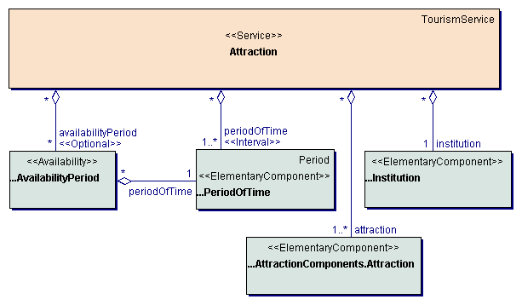
Figure 6-88: Tourism service Attraction
Class descriptions
Class Attraction
The class Attraction represents the tourism service attraction and enables to specify all types of attractions.
Associations
The aggregation availabilityPeriod specifies the availability periods of an attraction service.
The aggregation institution specifies the institution of the attraction.
The aggregation periodOfTime specifies the periods of time, for which the attraction service is bookable.
The aggregation attraction specifies the basic attraction service. The aggregation of several attractions within on attraction service enables to provide an attraction as different offers (with different names, prices, etc.).

Figure 6-89 shows all evaluation instructions for the attributes of attraction services.
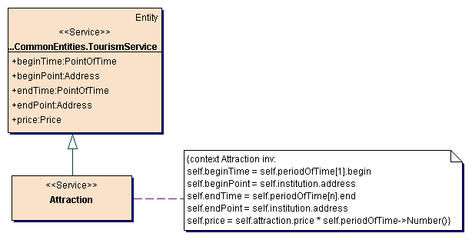
Figure 6-89: Attraction service evaluation instructions

Classification of attraction services
The classification of different attraction types is done by the purpose of the attraction (information, entertainment, activity) and results in the following classes (see Figure 6-79):
- exhibition
- museum
- sight
- sport leisure facility

Tourism service exhibition
The tourism service exhibition mainly serves the purpose of information. The tourism service exhibition covers exhibitions, shows or fairs of any kind. The tourism service exhibition is composed of the specific component exhibition. Figure 6-90 shows the structure of the tourism service exhibition.

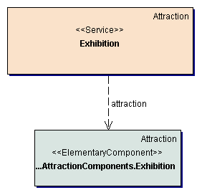
Figure 6-90: Tourism service exhibition

Class descriptions
Class Exhibition
The class Exhibition represents the tourism service exhibition and enables to specify all types of exhibition services (exhibitions, shows, fairs, etc).
Dependencies
The dependency attraction specifies that an exhibition aggregates exhibitions as attraction components.

Tourism service museum
The tourism service museum mainly serves the purpose of education and information. The characteristic of a museum is its artistic or scientific orientation. The tourism service museum is composed of the specific components guided tour and museum. Figure 6-91 shows the components used for constructing museum services.

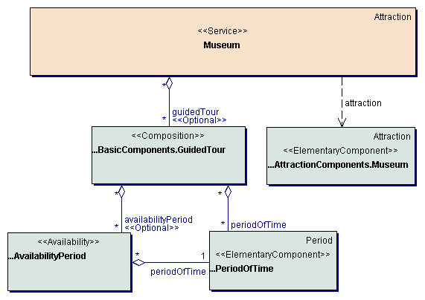
Figure 6-91: Tourism service museum
Class descriptions
Class Museum
The class Museum represents the tourism service museum and enables to specify all types of museum services.
Associations
The aggregation guidedTour specifies guided tours, which are offered within the museum.
Dependencies
The dependency attraction specifies that a museum aggregates museums as attraction components.

Tourism service sight
The tourism service sight mainly serves the purpose of education and information. In contrast to a museum a sight not necessarily has an artistic or scientific value but constitutes a commonly remarkable object or place. The tourism service sight is composed of the specific components guided tour and sight. Figure 6-92 shows the structure of the tourism service sight.
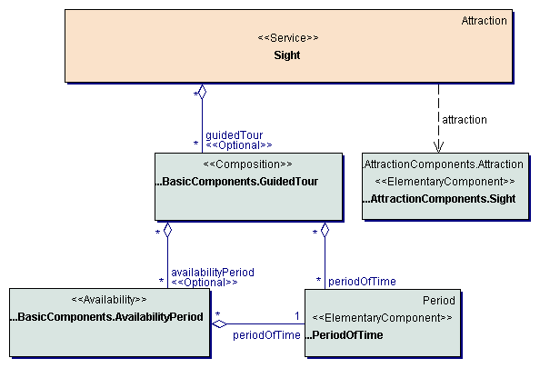
Figure 6-92: Tourism service sight
Class descriptions
Class Sight
The class Sight represents the tourism service sight and enables to specify all types of sight services.
Associations
The aggregation guidedTour specifies guided tours, which are offered for the sight.
Dependencies
The dependency attraction specifies that a sight aggregates sights as attraction components.

Tourism service sport leisure facility
The tourism service sport leisure facility serves the purpose of entertainment and activity and covers services like rentable tennis courts, bathes, entertainment parks, etc. The tourism service sport leisure facility is composed of the specific components sport leisure equipment and sport leisure facility. Figure 6-93 shows the components used for constructing sport leisure facility services.

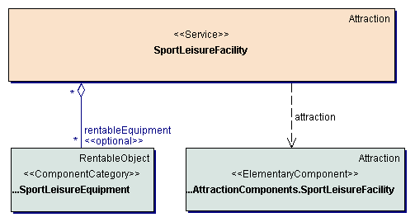
Figure 6-93: Tourism service sport leisure facility
Class descriptions
Class SportLeisureFacility
The class SportLeisureFacility represents the tourism service sport leisure facility and enables to specify all types of sport leisure facilities.
Associations
The aggregation rentableEquipment specifies equipment, which can be rented within the institution.
Dependencies
The dependency attraction specifies that a sport leisure facility aggregates sport leisure facilities as attraction components.

Figure 6-94 shows all evaluation instructions for the attributes of sport leisure facility services.

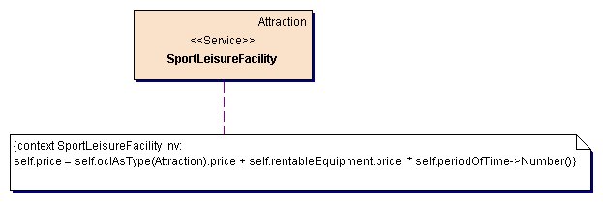
Figure 6-94: Sport leisure facility service evaluation instructions

Tourism service cruise
The tourism service cruise constitutes an exception within the classification of tourism services. This service satisfies the requirement for a comfortable accommodation as well as the requirement for a change of location and therefore can be classified to neither the tourism service accommodation nor the tourism service transportation. On the other side, the tourism service cruise cannot be defined as a composition of elementary services, because the transportation and accommodation on the ship go together inseparably and constitute the characteristic of a cruise (MUNDT, 1996, p. 295). Hence, the tourism service cruise has to be considered as a separate, elementary service. The tourism service cruise is composed of the components cabin, transport, ship, facilities, offered products, catering and activity. Figure 6-95 shows the structure of the tourism service cruise.

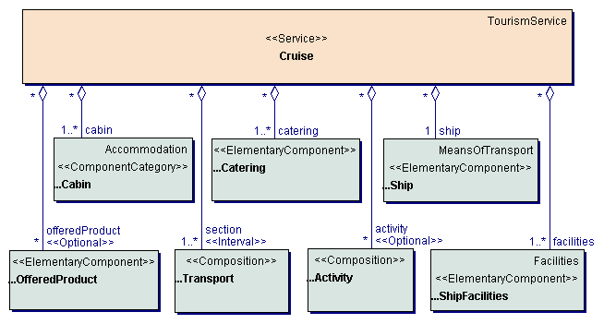
Figure 6-95: Tourism service cruise
Class descriptions
Class Cruise
The class Cruise represents the tourism service cruise and enables to specify all types of cruise services.
Associations
The aggregation activity specifies activities, which are offered during the cruise service. Activities may be activities on board or activities, which can be executed during the stay at one of the stations.
The aggregation cabin specifies the cabins or cabin categories available for the cruise service.
The aggregation catering specifies available catering services, especially available meal plan types.
The aggregation offeredProduct specifies products or services offered during the cruise service.
The aggregation ship specifies the ship used for the cruise service.
The aggregation facilities specifies the basic facilities of the cruise service.
The aggregation section specifies the transport sections of the cruise service, i.e. the different sections of the route of the cruise.

Figure 6-96 shows all evaluation instructions for the attributes of cruise services.

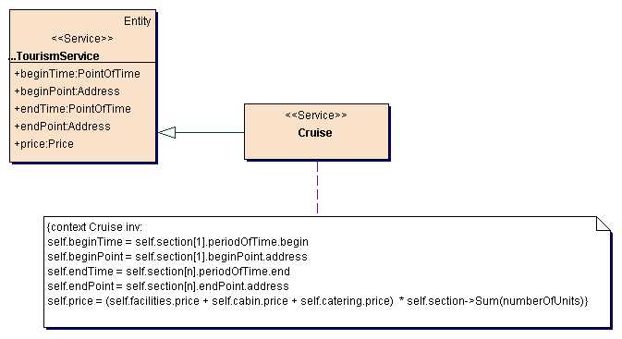
Figure 6-96: Cruise service evaluation instructions

Tourism service destination
Planning a travel (especially a vacation) is first of all a question of the destination and not the transportation or accommodation service. Because of this central signification the destination has to be provided as a separate tourism service. The tourism service destination serves the satisfaction of the requirement for comfortable surroundings and climate. This service covers all tourism relevant conditions and services of a destination. Although the destination is normally not interpreted as a tourism service by the user, the increasing imposition of fees for use (e.g. visitors' tax, car tax) clearly demonstrates that the difference is first of all the present way of marketing (tax-free use of the destination and its services or institutions e.g. beaches, forests or streets). The tourism service destination is composed of the components activity and destination characteristics. Figure 6-97 shows the structure of the tourism service destination.

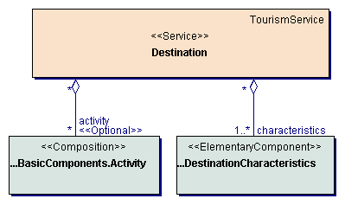
Figure 6-97: Tourism service destination
Class descriptions
Class Destination
The class Destination represents a destination service.
Associations
The aggregation activity specifies activities, which can be executed within the destination.
The aggregation characteristics specifies basic characteristics of the destination. The aggregation of several destination characteristics within a destination service enables to provide a destination service under different topics or views.

Classification of destination services
The classification of different types of destinations is done by the type of unity. The differentiation between political unity, regional and cultural unity or local unity results in the classes (see Figure 6-79):
- country
- region
- city
It has to be noted that there are no specialization relationships between this classes (a city is not a specific type of country), although their attributes suggest this conclusion. Also the consideration of the aggregation relationships existing between the corresponding geographical objects is inexpedient for a flexible selection on the level of regions and cities.

Tourism service city
The characteristic of the tourism service city is the local unity. This service consists of a set of touristic useable institutions and services, e.g. shops, sport or leisure facilities or transportation services. The tourism service city is composed of the specific component city characteristics. Figure 6-98 shows the structure of the tourism service city.

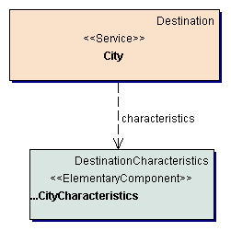
Figure 6-98: Tourism service city
Class descriptions
Class City
The class City represents city services.
Dependencies
The dependency characteristics specifies that a city aggregates city characteristics as destination characteristics components.

Figure 6-99 shows all evaluation instructions for the attributes of city services.

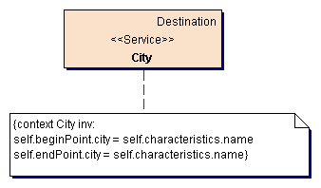
Figure 6-99: City service evaluation instructions

Tourism service country
The characteristic of the tourism service country is the political unity. From this result tourism relevant attributes like language or entry and customs regulations. The tourism service country is composed of the specific component country characteristics. Figure 6-100 shows the structure of the tourism service country.

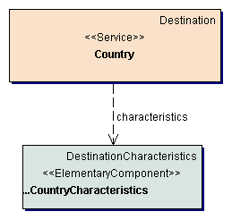
Figure 6-100: Tourism service country
Class descriptions
Class Country
The class Country represents country services.
Dependencies
The dependency characteristics specifies that a country aggregates country characteristics as destination characteristics components.

Figure 6-101 shows all evaluation instructions for the attributes of country services.

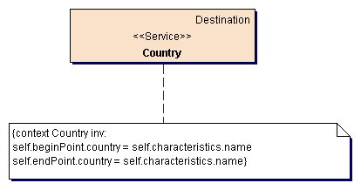
Figure 6-101: Country service evaluation instructions

Tourism service region
The characteristic of the tourism service region is the regional and cultural unity. In contrast to the destination types country and city the formation of regions depends mainly on the viewed, tourism relevant aspect. Considering different aspects there result several possibilities to form regions (e.g. countryside regions like Taunus or Rhein-Main-Region, wine-growing areas, etc.). The tourism service region is composed of the specific component region characteristics. Figure 6-102 shows the structure of the tourism service region.

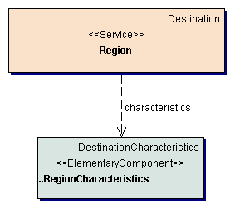
Figure 6-102: Tourism service region
Class descriptions
Class Region
The class Region represents region services.
Dependencies
The dependency characteristics specifies that a region aggregates region characteristics as destination characteristics components.

Figure 6-103 shows all evaluation instructions for the attributes of region services.

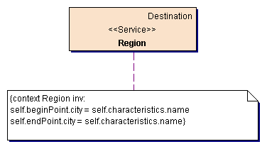
Figure 6-103: Region service evaluation instructions

Tourism service event
The tourism service event serves for satisfying the basic requirement for information, activity and entertainment. In comparison to the tourism service attraction an event takes place at a fix point of time and has a fix duration. The tourism service event is composed of the components period of time, event and institution. Figure 6-104 shows the structure of the tourism service event.
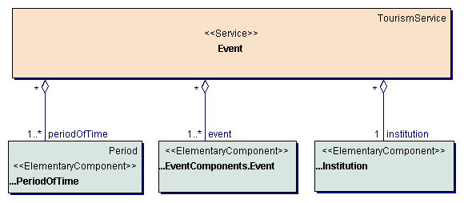
Figure 6-104: Tourism service event
Class descriptions
Class Event
The class Event represents the tourism service event and enables to specify all types of event services like cultural event, sport event etc.
Associations
The aggregation event specifies the basic event service. The aggregation of several events within one event service enables to provide an event as different offers (with different names, prices, etc.).
The aggregation institution specifies the institution, where the event takes place, e.g. the theatre, opera, sport center, etc.
The aggregation periodOfTime specifies the periods of time, when the event takes place.

Figure 6-105 shows all evaluation instructions for the attributes of event services.

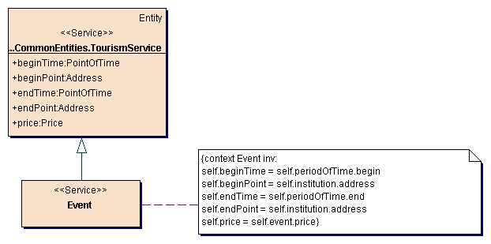
Figure 6-105: Event service evaluation instructions

Classification of event services
The classification of different types of events is done by the purpose or the aim of an event (exchange of information, improvement of skills, education, entertainment, activity) and results in the following classes (see Figure 6-79):
- conference
- course
- cultural event
- lecture
- sport event

Tourism service conference
The tourism service conference principally serves the purpose of exchange of information. This primary characteristic, missing by the other event types, and a normally very domain specific orientation makes necessary a separate class for this tourism service. The tourism service conference is composed of the specific components availability period and conference. Figure 6-106 shows the structure of the tourism service conference.
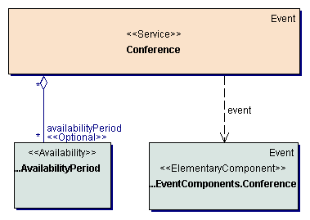
Figure 6-106: Tourism service conference
Class descriptions
Class Conference
The class Conference represents the tourism service conference and enables to specify all types of conference services. Dịch vụ hội thảo
Associations
The aggregation availabilityPeriod specifies the availability periods of a conference service.
Khoảng thời gian khả dụng cho dịch vụ hội thảo
Dependencies
The dependency event specifies that a conference aggregates conferences as event components.

Tourism service course
The determinant characteristic of the tourism service course is the purpose of learning or improving specific skills. The tourism service course is composed of the specific components availability period and course. Figure 6-107 shows the structure of the tourism service course.

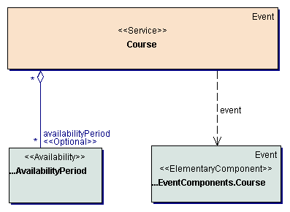
Figure 6-107: Tourism service course
Class descriptions
Class Course
The class Course represents the tourism service course and enables to specify all types of course services.
Associations
The aggregation availabilityPeriod specifies the availability periods of a course service.
Dependencies
The dependency event specifies that a course aggregates courses as event components.

Tourism service cultural event
The tourism service cultural event mainly serves the purpose of entertainment and education. The target group of events of this type (e.g. theater, opera, concert, etc.) clearly differs from the target group of other events like sport event. The tourism service cultural event is composed of the specific components cultural event seat and cultural event. Figure 6-108 shows the components used for constructing cultural event services.

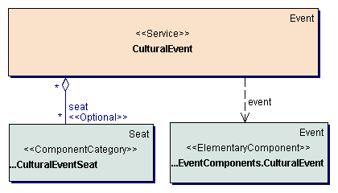
Figure 6-108: Tourism service cultural event
Class descriptions
Class CulturalEvent
The class CulturalEvent represents the tourism service cultural event and enables to specify all types of cultural event services.
Associations
The aggregation seat specifies the seats or categories of seats of the cultural event.
Dependencies
The dependency event specifies that a cultural event aggregates cultural events as event components.

Figure 6-109 shows all evaluation instructions for the attributes of cultural event services.

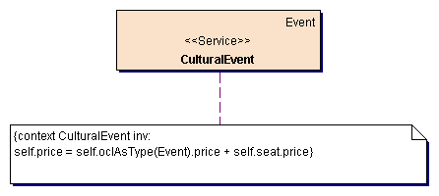
Figure 6-109: Cultural event service evaluation instructions

Tourism service lecture
The tourism service lecture serves the purpose of education and information. The determinant characteristic in comparison to the event types conference and course is the mainly unidirectional communication and the receptive character from the users point of view. The tourism service lecture is composed of the specific components availability period and lecture. Figure 6-110 shows the components used for constructing lecture services.

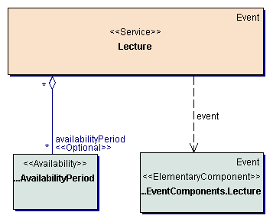
Figure 6-110: Tourism service lecture
Class descriptions
Class Lecture
The class Lecture represents the tourism service lecture and enables to specify all types of lecture services.
Associations
The aggregation availabilityPeriod specifies the availability periods of a lecture service.
Dependencies
The dependency event specifies that a lecture aggregates lectures as event components.

Tourism service sport event
The tourism service sport event serves the purpose of entertainment and activity. The tourism service sport event is composed of the specific components sport event seat and sport event. Figure 6-111 shows the components used for constructing sport event services.

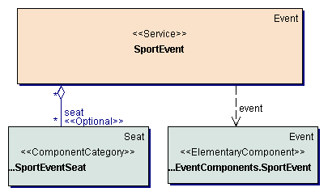
Figure 6-111: Tourism service sport event
Class descriptions
Class SportEvent
The class SportEvent represents the tourism service sport event and enables to specify all types of sport event services.
Associations
The aggregation seat specifies the seats or categories of seats of the sport event.
Dependencies
The dependency event specifies that a sport event aggregates sport events as event components.

Figure 6-112 shows all evaluation instructions for the attributes of sport event services.

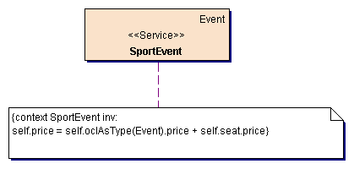
Figure 6-112: Sport event service evaluation instructions

Tourism service gastronomy
The tourism service gastronomy serves the requirement for food and beverage and covers all types of gastronomy services e.g. restaurant, bistro, bar, etc. The tourism service gastronomy is composed of the components catering, facilities, institution, table and period of time. Figure 6-113 shows the structure of the tourism service gastronomy.

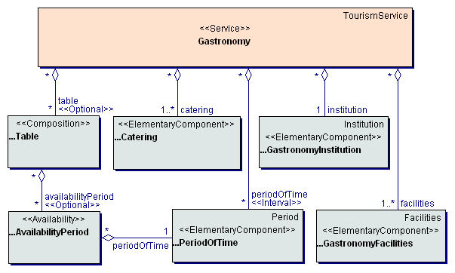
Figure 6-113: Tourism service gastronomy
Class descriptions
Class Gastronomy
The class Gastronomy represents the tourism service gastronomy and enables to specify all types of gastronomy services like restaurants, bars, bistros etc.
Associations
The aggregation catering specifies the catering (catering type, cuisine type, etc.) available within the gastronomy service.
The aggregation facilities specifies the facilities of the gastronomy service or institution.
The aggregation institution specifies the institution (e.g. bar, bistro, restaurant) of a gastronomy service.
The aggregation periodOfTime specifies the periods of time, for which the gastronomy service is bookable.
The aggregation table specifies the tables available within the gastronomy institution or service.

Figure 6-114 shows all evaluation instructions for the attributes of gastronomy services.

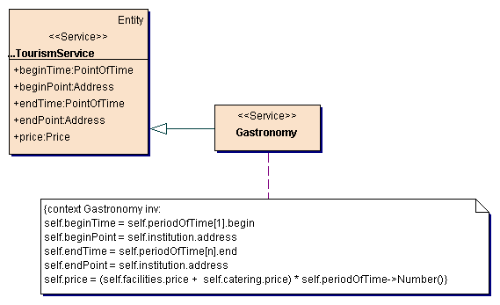
Figure 6-114: Gastronomy service evaluation instructions

Tourism service hired vehicle
The tourism service hired vehicle serves the satisfaction of the requirement for mobility. This service enables not only the transportation from a departure point to a destination point (like the tourism service transportation) but also the flexible movement during a definite period of time. The tourism service hired vehicle is composed of the components vehicle, institution, hire service and period of time. Figure 6-115 shows the components used for constructing hired vehicle services.

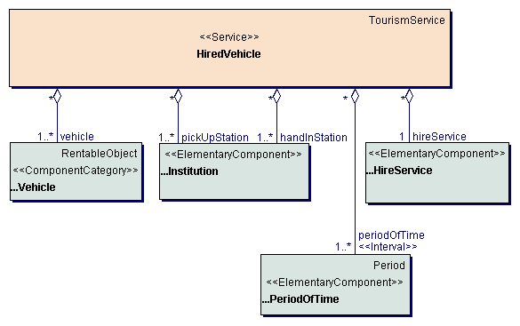
Figure 6-115: Tourism service hired vehicle
Class descriptions
Class HiredVehicle
The class HiredVehicle represents the tourism service hired vehicle and enables to specify all types of hired vehicle services.
Associations
The aggregation hireService specifies the hire service, offering the hired vehicle service.
The aggregation periodOfTime specifies the periods of time, for which the hired vehicle service is bookable.
The aggregation pickUpStation specifies the stations, where the vehicle can be picked up.
The aggregation handInStation specifies the stations, where the vehicle can be handed in.
The aggregation vehicle specifies the vehicles or categories of vehicles of the hired vehicle service.

Figure 6-116 shows all evaluation instructions for the attributes of hired vehicle services.

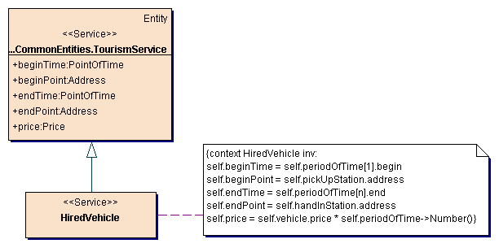
Figure 6-116: Hired vehicle service evaluation instructions

Classification of hired vehicle services
Classifying the tourism service hired vehicle is done by the relevant characteristics of the vehicle. Central characteristics are the number and type of transportable persons and the usability regarding the different types of use (short trip, long distance trip, over-night journey of several days). The consideration of this types results in the following classes of the tourism service hired vehicle (see Figure 6-79):
- hired airplane
- hired bike
- hired boat
- hired bus
- hired camper
- hired car
- hired motorbike

Tourism service hired airplane
The tourism service hired airplane is characterized by its usability only for longer distances. The tourism service hired airplane is composed of the specific component airplane. Figure 6-117 shows the structure of the tourism service hired airplane.

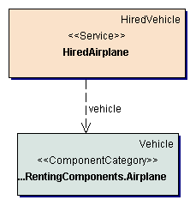
Figure 6-117: Tourism service hired airplane
Class descriptions
Class HiredAirplane
The class HiredAirplane represents the tourism service hired airplane and enables to specify all types of hired airplane services.
Dependencies
The dependency vehicle specifies that a hired airplane aggregates airplanes as vehicle components.

Tourism service hired bike
The tourism service hired bike is characterized by the usability only for short trips as well as the aspect of sporting activity. The tourism service hired bike is composed of the specific component bike. Figure 6-118 shows the structure of the tourism service hired bike.

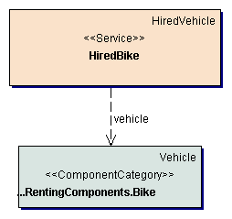
Figure 6-118: Tourism service hired bike
Class descriptions
Class HiredBike
The class HiredBike represents the tourism service hired bike and enables to specify all types of hired bike services.
Dependencies
The dependency vehicle specifies that a hired bike aggregates bikes as vehicle components.

Tourism service hired boat
The tourism service hired boat covers all types of hired vehicle services, using a boat as vehicle. The tourism service hired boat is composed of the specific component boat. Figure 6-119 shows the structure of the tourism service hired boat.

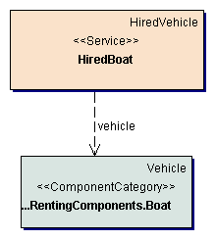
Figure 6-119: Tourism service hired boat
Class descriptions
Class HiredBoat
The class HiredBoat represents the tourism service hired boat and enables to specify all types of hired boat services.
Dependencies
The dependency vehicle specifies that a hired boat aggregates boats as vehicle components.

Tourism service hired bus
The characteristic of the tourism service hired bus is the possibility to transport a greater number of persons. The tourism service hired bus is composed of the specific component bus. Figure 6-120 shows the structure of the tourism service hired bus.

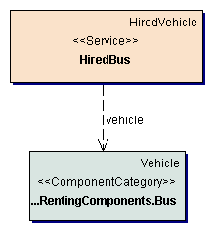
Figure 6-120: Tourism service hired bus
Class descriptions
Class HiredBus
The class HiredBus represents the tourism service hired bus and enables to specify all types of hired bus services.
Dependencies
The dependency vehicle specifies that a hired bus aggregates busses as vehicle components.

Tourism service hired camper
The characteristic of the tourism service hired camper is its usability for over-night journeys or trips, passing the night within the vehicle. The tourism service hired camper is composed of the specific component camper. Figure 6-121 shows the structure of the tourism service hired camper.

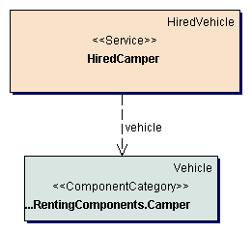
Figure 6-121: Tourism service hired camper
Class descriptions
Class HiredCamper
The class HiredCamper represents the tourism service hired camper and enables to specify all types of hired camper services.
Dependencies
The dependency vehicle specifies that a hired camper aggregates campers as vehicle components.

Tourism service hired car
The tourism service hired car is characterized by its usability for all types of persons and intended purposes. The tourism service hired car is composed of the specific component car. Figure 6-122 shows the structure of the tourism service hired car.

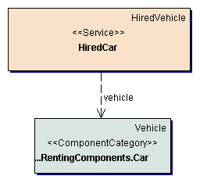
Figure 6-122: Tourism service hired car
Class descriptions
Class HiredCar
The class HiredCar represents the tourism service hired car and enables to specify all types of hired car services.
Dependencies
The dependency vehicle specifies that a hired car aggregates cars as vehicle components.

Tourism service hired motorbike
The peculiarity of the tourism service hired motorbike is its uselessness for specific types of persons (e.g. infants, pensioners) and long distances as well as the small number of transportable persons. The tourism service hired motorbike is composed of the specific component motorbike. Figure 6-123 shows the structure of the tourism service hired motorbike.

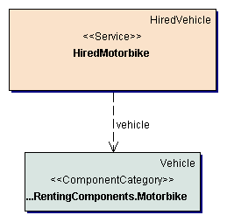
Figure 6-123: Tourism service motorbike
Class descriptions
Class HiredMotorbike
The class HiredMotorbike represents the tourism service hired motorbike and enables to specify all types of hired motorbike services.
Dependencies
The dependency vehicle specifies that a hired motorbike aggregates motorbikes as vehicle components.

Tourism service shopping
The tourism service shopping serves the requirement for specific goods or services and covers all types of shopping services e.g. retail enterprises, department stores, markets, etc. The tourism service shopping is composed of the components offered product, facilities, institution and period of time. Figure 6-124 shows the structure of the tourism service shopping.

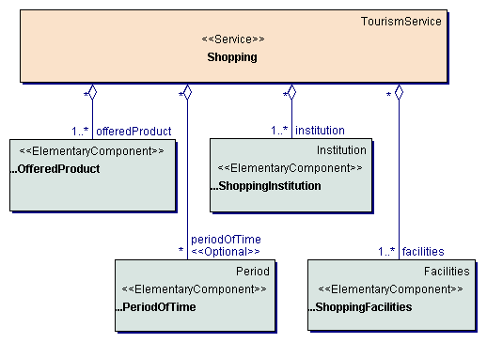
Figure 6-124: Tourism service shopping
Class descriptions
Class Shopping
The class Shopping represents the tourism service shopping and enables to specify all types of shopping services.
Associations
The aggregation offeredProduct specifies the products or services, offered by the shopping service
The aggregation periodOfTime specifies the periods of time, during which the shopping service is to be used.
The aggregation facilities specifies the basic facilities of the shopping service.
The aggregation institution specifies the institutions of the shopping service.

Figure 6-125 shows all evaluation instructions for the attributes of shopping services.

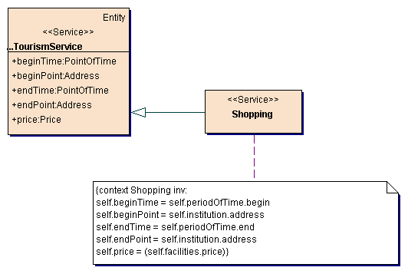
Figure 6-125: Shopping service evaluation instructions

Tourism service transportation
The tourism service transportation serves the satisfaction of the basic requirement for a change of location (e.g. to execute business tasks) or climate. This service consists of a transport from a point of departure to a point of destination. The usual outward and return journey results from a composition of elementary transportation services. The tourism service transportation is composed of the components transport seat, transport, means of transport, facilities, catering and piece of luggage. Figure 6-126 shows the structure of the tourism service transportation.
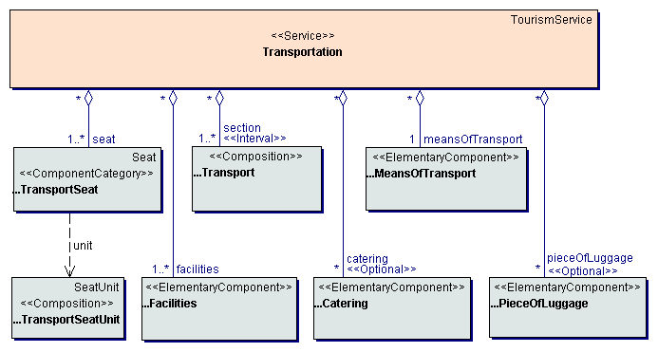
Figure 6-126: Tourism service transportation
Class descriptions
Class Transportation
The class Transportation represents the tourism service transportation and enables to specify all types of transportation services.
Associations
The aggregation catering specifies available catering services.
The aggregation facilities specifies the facilities of the transportation service.
The aggregation meansOfTransport specifies the means of transport, used within the transportation service.
The aggregation pieceOfLuggage specifies pieces of luggage, which cannot be carried as normal luggage but have to be specified explicitly and will normally lead to an extra fee.
The aggregation section specifies the transport sections of the transportation service.
The aggregation seat specifies the seats or categories of seats of the transportation service.

Figure 6-127 shows all evaluation instructions for the attributes of transportation services.
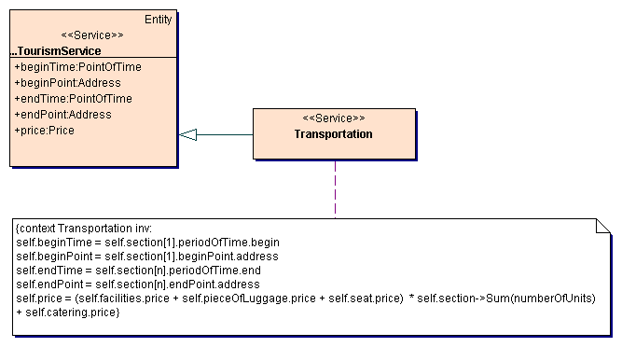
Figure 6-127: Transportation service evaluation instructions

Classification of transportation services
The classification of different types of transportation services is done by the used means of transport. From the users point of view the used means of transport is the central characteristic of a transportation. This classification results in the following classes of transportation services (see Figure 6-79):
- bus ride
- flight
- ship passage
- train journey

Tourism service bus ride
The tourism service bus ride covers all transportation services with the means of transportation bus (including e.g. transfer services between an airport and a hotel). The tourism service bus ride is composed of the specific components bus ride seat, bus ride facilities and bus. Figure 6-128 shows the structure of the tourism service bus ride.

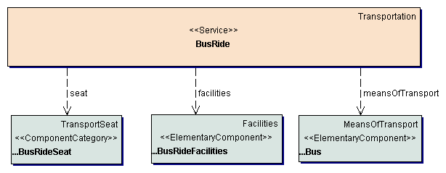
Figure 6-128: Tourism service bus ride
Class descriptions
Class BusRide
The class BusRide represents the tourism service bus ride and enables to specify all types of bus ride services.
Dependencies
The dependency facilities specifies that a bus ride aggregates bus ride facilities as facilities components.
The dependency meansOfTransport specifies that a bus ride aggregates busses as means of transport components.
The dependency seat specifies that a bus ride aggregates bus ride seats as transport seat components.

Tourism service flight
The tourism service flight covers all transportation services with the means of transport airplane. A further classification of the tourism service flight into public flight and flight on demand is not meaningful, because this two transportation types only differ concerning legal aspects and have no different attributes. The tourism service flight is composed of the specific components flight seat, flight facilities and airplane. Figure 6-129 shows the structure of the tourism service flight.

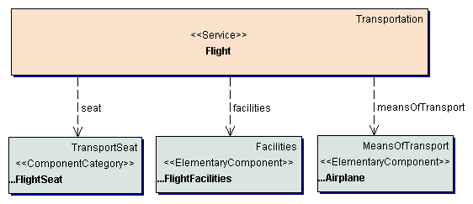
Figure 6-129: Tourism service flight
Class descriptions
Class Flight
The class Flight represents the tourism service flight and enables to specify all types of flight services.
Dependencies
The dependency facilities specifies that a flight aggregates flight facilities as facilities components.
The dependency meansOfTransport specifies that a flight aggregates airplanes as means of transport components.
The dependency seat specifies that a flight aggregates flight seats as transport seat components.

Tourism service ship passage
The tourism service ship passage covers all transportation services with the means of transport ship or ferry. The tourism service ship passage is composed of the specific components cabin, parking place, ship passage facilities and ship. Figure 6-130 shows the structure of the tourism service ship passage.

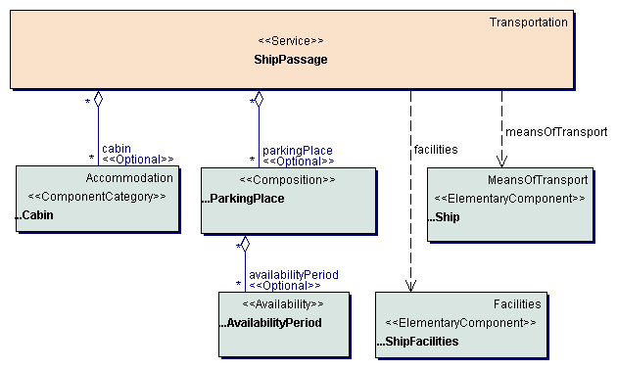
Figure 6-130: Tourism service ship passage
Class descriptions
Class ShipPassage
The class ShipPassage represents the tourism service ship passage and enables to specify all types of ship passage services.
Associations
The aggregation cabin specifies the cabins or cabin categories of the ship.
The aggregation parkingPlace specifies the parking places of the ship.
Dependencies
The dependency facilities specifies that a ship passage aggregates ship facilities as facilities components.
The dependency meansOfTransport specifies that a ship passage aggregates ships as means of transport components.

Figure 6-131 shows all evaluation instructions for the attributes of ship passage services.
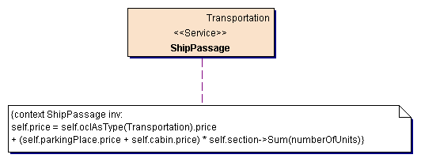
Figure 6-131: Ship passage service evaluation instructions

Tourism service train journey
The tourism service train journey covers all transportation services with the means of transport train. The tourism service train journey is composed of the specific components train journey seat, train journey facilities, couchette bed, sleeper compartment and train. Figure 6-132 shows the structure of the tourism service train journey.
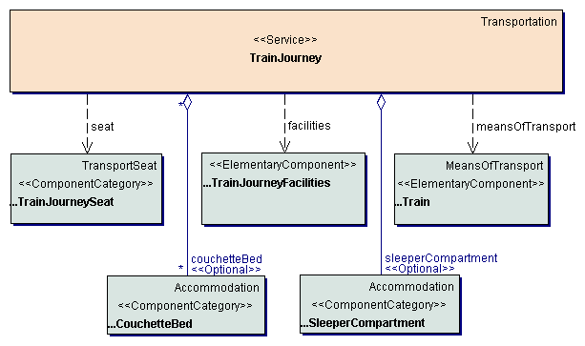
Figure 6-132: Tourism service train journey
Class descriptions
Class TrainJourney
The class TrainJourney represents the tourism service train journey and enables to specify all types of train journey services.
Associations
The aggregation couchetteBed specifies the couchette beds of the train.
The aggregation sleeperCompartment specifies the sleeper compartments of the train.
Dependencies
The dependency facilities specifies that a train journey aggregates train journey facilities as facilities components.
The dependency meansOfTransport specifies that a train journey aggregates trains as means of transport components.
The dependency seat specifies that a train journey aggregates train journey seats as transport seat components.

Figure 6-133 shows all evaluation instructions for the attributes of train journey services.
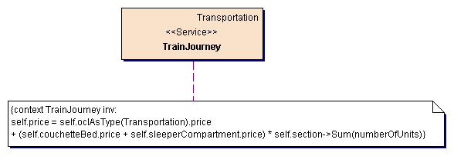
Figure 6-133: Train journey service evaluation instructions

Composition services
The package CompositionServices contains entities necessary for describing composition services, composed by different elementary tourism services (e.g. a package holiday composed by a flight and a hotel). Figure 6-134 shows all classes of the composition mechanism.

Kết hợp các dịch vụ
Gói các dịch vụ kết howpk bao gồm các thực thể cần thiết cho việc miêu tả các dịch vụ kết hợp, đươc kết hợp bởi các dịch vụ du lịch cơ bản khác nhau (ví dụ: gói holiday kết với với 1 flight và 1 hotel). Ví dụ sau biểu diễn tất cả các lớp của cơ chế kết hợp
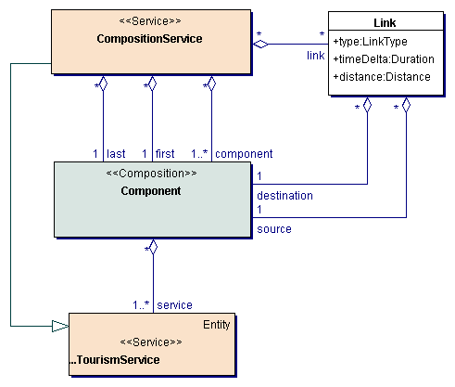
Figure 6-134: Composition services
Class descriptions
Class Component
The class Component enables to specify a component of a composition service. A component of a composition represents a tourism service or a collection of tourism services (of the same type) within an offered or potential service.

Lớp Component cho phép xác đỉnh rõ một thành phần của dịch vụ kết hợp. Một thành phần trong quá trình kết hợp biểu diễn 1 dịch vụ du lịch hoặc 1 tập các dịch vụ du lich (cùng loại) trong 1 dịch vụ tiềm năng hoặc đề nghị

Associations
The aggregation service specifies the tourism services, which are available for the component of a composition.
Class CompositionService
The class CompositionService enables to specify complex tourism services, composed of elementary tourism services, e.g. a journey, composed of a flight and a hotel. The class CompositionService can represent composition services defined by a supplier (or tour operator) as well as composition services, defined by the user during the selection process.
Lớp này xác định các dịch vụ du lịch phức tạp, được kết các dịch vụ du lịch cơ sở ví dụ: Cuộc hành trình, được kết hợp với flight và hotel. Lớp dịch vụ kết hợp có thể biểu diễn các dịch vụ kết hợp được định nghĩa bởi một supplier (hoặc nhà điều hành tour) cung như các dịch vụ kết hợp, được định nghĩa bởi người sử dụng trong suốt quy trình lựa chọn
Associations
The aggregation component specifies a collection of components of the composition service.
The aggregation first specifies the first component (concerning the usage period) of the composition.
Quan hệ đầu tiên đặc tả thành phần đầu tiên (việc sử dụng khoảng thời gian) của việc kết hợp.
Thành phần cuối cùng của việc kết hợp
The aggregation last specifies the last component (concerning the usage period) of the composition.
The aggregation link specifies the links between the components of the composition service.
Liên kết giữa các thành phần của dịch vụ kết hợp.
Class Link
The class Link enables to specify a link of a component of a composition to another component. Links enable to specify successor or complement relationships between components of a composition.
Attributes
The attribute distance specifies the allowed distance between the end point of a component and the begin point of its successor or between the begin points and end points of a component and its complement.
The attribute timeDelta specifies the time delta between the linked components. A positive delta enforces a time gap between the two components. A negative delta enforces the overlapping of the two components.
Thuộc tính delta đặc tart thời gian giữa 2 thành phần được lien kết, delta >0 có lỗ hổng thời gian giữa 2 thành phần, delta<0 có sự trùng lặp giữa 2 thành phần

The attribute type specifies the type of the link. Possible types are successor and complement.
Associations
The aggregation source specifies the source component of the link. Thành phần nguồn của lien kết
The aggregation destination specifies the component, linked to the source component. Thành phần dịch được lien kết với thành phần nguồn.

Mm

Figure 6-135 shows all evaluation instructions for the attributes of a composition service. The attributes concerning the begin state and end state of the composition service are evaluated of the corresponding attributes of the first and the last component of the composition, concerning their usage period. The price of the composition service is evaluated as the sum of the prices of all its components.

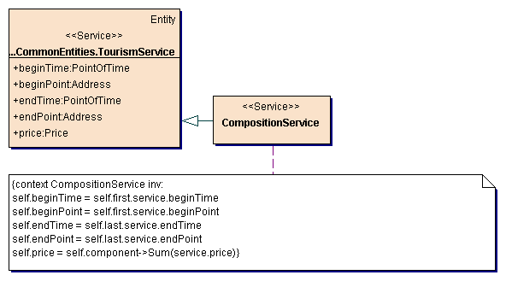
Figure 6-135: Evaluation instructions
Figure 6-136 shows all constraints, which have to be fulfilled by the components of a composition service. Depending on the link type between two components (successor or complement), the attributes of the components have to fulfill a couple of constraints. If a component is the successor of another component, the begin state has to coincide with the end state of the other component. If a component is the complement of another component, the usage period of the component has to be situated within the usage period of the other component and the locations of the two components have to coincide.
1 thành phần là phần tử kế tiếp của thành phần khác , nếu trạng thái bắt đầu của nó trùng khớp với trang tháo kết thúc của thành phần kia. Nếu 1 thành phần là phần bổ sung của thành phần khác, khoảng thời gian sử dụng của thành phần ở giữa khoảng t sử dụng của thành phần khách và các vị trí của 2 thành phần là trùng khớp.

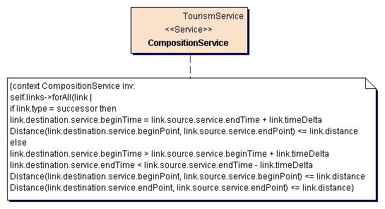
Figure 6-136: Composition constraints
Figure 6-137 and Figure 6-138 show two examples of composition services and the links between their components.

Hotel nối tiếp Flight, nối tiếp là flight. Dịch vụ event chen vào hotel. Tiếp the là dịch vụ flight
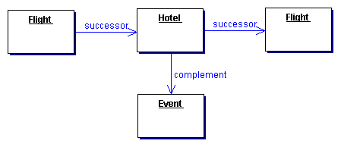
Figure 6-137: Composition service journey
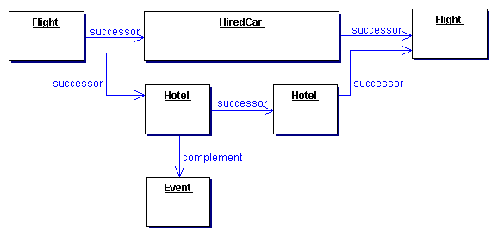
Figure 6-138: Composition service round trip
Dịch vụ thê xe và dịch vụ khách sạn nố tiếp dịch vụ flight, chèn các sự kiện khi ở khách sạn. Ở khách sạn tiếp đến là flight

Process layer
The process layer provides building blocks, which represent complex processes of the domain tourism (e.g. searching, booking, canceling) or which are necessary for the execution of such processes.

Tầng xử lý
Tầng xử lý cung cấp các khối building block, biểu diễn quy trình phức tạp của dịch vụ miền (search, booking, canceling) hoặc cần thiết cho việc thực thi quy trình

Information processe
Quy trình xử lý thông tin
Gói InformationProcesses cung cấp quy trình và các thực thể cần thiết phân phát với việc tìm kiếm thông tin về các dịch vụ du lịch (ví dujL tìm kiếm các dịch vụ du lịch, kiểm tra độ khả dụng).
Hình minh họa cấu trúc của các thành phần chợ cung cấp quy trình thông tin.

The package InformationProcesses provides processes and necessary entities dealing with the retrieval of information about tourism services (e.g. searching for tourism services, checking the availability). Figure 6-139 illustrates the structure of the market component providing the information processes.
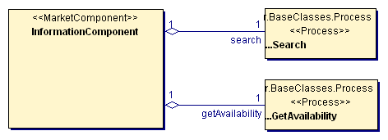
Figure 6-139: Structure of the information component

Class descriptions
Class InformationComponent
The class InformationComponent represents the information component, providing all information processes like searching for a tourism service. This class definition provides the necessary meta data about the structure of the information component, i.e. the provided processes.
Lớp informationComponent biểu diễn thành phần thông tin, cung cấp tất cả quy trình thông tin giống như tìm kiếm 1 dich vụ du lịch. Lớp định nghĩa này cung cấp siêu dữ liệu cần thiết về cấu trúc của thông tin thành phần ví dụ quy trình được cung cấp
Associations
The aggregation getAvailability specifies the get availability process of the information component.
The aggregation search specifies the search process of the information component.

The selection process
The selection and decision process can be divided into the phases information gathering, searching, evaluation and selection. The first three phases are executed iteratively to achieve a stepwise refinement of the search results.
Sự lựa chọn và quy trình quyết định có thể được phân chia vào trong các pha thu gom thông tin, tìm kiếm, định giá, lựa chọn. đầu tiên 3 pha được thực thi lặp để sang lọc từng bước các kết quả tìm kiếm.
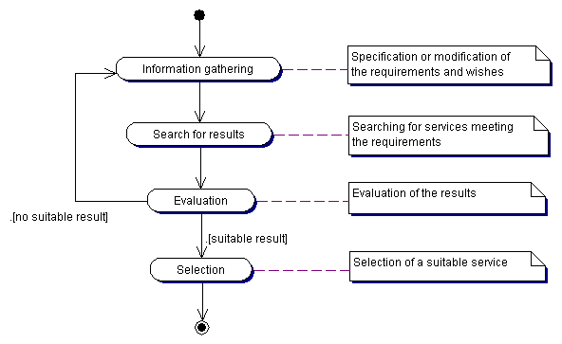
Figure 6-140: The selection process
The following aspects have to be considered to support this iterative selection process:
- Constraints can be specified in a rough, vague form and refined successively dependent on the search results (fuzziness in the request).
- Các rang buộc có thể được đăc tả thô, mập mờ và mịn hóa lien tiếp phụ thuộc các kết quả tìm kiếm
- Within the phase search for results similar services, not meeting all requirements are taken into consideration and graded according to their fulfillment of the constraints (fuzziness in the data). In this way it can be avoided that the set of results is empty, because of too restrictive constraints, and that the selection process is running into a deadlock.
- Trong pha search for result các dịch vụ tương tự, không gặp gỡ tất cả các yêu cầu trong sự cân nhắc và
The complete mechanism of selecting tourism services can now be described in the following way:
- The user starts the process of selecting a tourism service by formulating a request, consisting of a set of constraints for the requested service. Doing this, it is possible to use vague, fuzzy terms (e.g. temperature = warm).
- Người sử dụng bắt đầu quy trình lựa chọn 1 dịch vụ du lịch bằng hệ thống yêu cầu, bao gồm 1 tập các rang buộc cho dịch vụ yêu cầu. Nó có thể là các thuật ngữ mập mờ (ví dụ: nhiệt độ = ấm)
- Based on this request is searched for matching services. Due to the consideration of fuzziness in the request and in the data, the degree of fulfillment of the request has to be evaluated for each service.
- Trên cơ sở yêu cầu này được tìm kiếm so khớp các dịch vụ. Cân nhắc kỹ lưỡng trong yêu cầu và trong dữ liệu, mức độ hoàn thiện của yêu cầu được đánh giá cho mỗi dịch vụ
- The services with the highest degree of fulfillment are provided as search result to the user.
- Các dịch vụ với mức độ hoàn thiện cao hơn được cung cấp với vai trò kết quả cho người dùng.
- The provided services enable the presentation of more detailed information (e.g. descriptions or pictures of tourism services) and enable the evaluation of the services.
- Các dịch vụ được cung cấp cho phép biểu diễn thông tin chi tiết hơn (ví dụ: miêu tả hoặc các bức tranh về các dịch vụ du lịch) và cho phép có thể đánh giá các dịch vụ.
- If necessary, the user modifies the request within the next iteration step and restarts the search for results.
- Nếu thành công, người sử dụng thay đổi yêu cầu trong bước tiếp theo và bắt đầu lại việc tìm kiếm cho các kết quả.
The provided information processes to support this mechanism are searching for tourism services with specific characteristics and checking the availability of tourism services.
Quy trình xử lý thông tin được cung cấp hỗ trợ cơ chế này tìm kiếm các dịch vụ du lịch với các đặc điểm rõ rang và kiểm tra độ khả dụng của các dịch vụ

Search process
The package SearchProcess specifies the process of searching for a tourism service fulfilling specific requirements and provides all entities and scenarios for the search process. Figure 6-141 illustrates the structure of the search process.
Quy trình tìm kiếm
Gói searchProcess chỉ rõ quy trình tìm kiếm 1 dịch vụ du lịch đầy đủ các yêu cầu rõ rang và cung cấp tất cả các thực thể và kịch bản cho quy trình tìm kiếm.
Hình dưới là cấu trúc cảu quy trình tìm kiếm

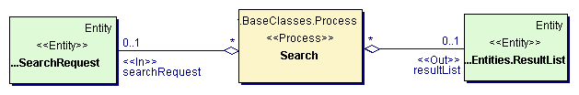
Figure 6-141 Search process
Quy trình tìm kiếm dựa trên cơ sở yêu cầu tìm kiếm
Class descriptions
Class Search
The class Search represents the process of searching for a tourism service, based on a search request.
Associations
The aggregation resultList specifies the results of the search process as a collection of tourism services, fulfilling the specified characteristics. ResultList is an output element of the search process.
Danh sách kết quả của quy trình tìm kiếm như là 1 tập các dịch vụ du lịch, nó là đầu ra của quy trình tìm kiếm
The aggregation searchRequest specifies a search request, consisting of a specification of the requested tourism service and customer data. SearchRequest is an input element of the search process.
Quan hệ cộng gộp searchRequest chỉ rõ yêu cầu tìm kiếm, bao gồm đặc tả dịch vụ du lịch được yêu cầu và dữ liệu khách hàng.Nó là đầu vào của searchProcess

Figure 6-142 illustrates the flow of activity of the search process.

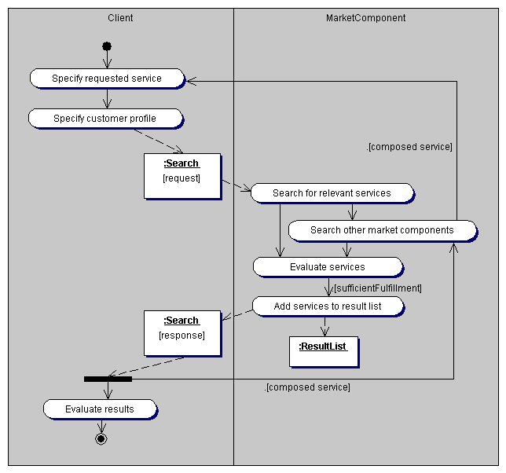
Figure 6-142: Search scenario

The search process is comprised of the following activities: quy trình tìm kiếm bao gồm các hoạt động sau:

- The client specifies the requested service, i.e. he specifies a tourism service (of a specific type) and all its characteristics, which have to be fulfilled by the requested services.
- Khách hàng đặc tả dịch vụ được yêu cầu. ví dụ: anh ấy chỉ rõ 1 dịch vụ du lịch (loại), và tất cả các đặc điểm của nó
- The client specifies a customer profile. A customer profile contains general customer data and especially preferences of the customer, concerning specific characteristics of tourism services.
- Client chỉ rõ thông tin khách hàng. 1 thông tin khách hàng bao gồm dữ liệu chung khách hàng và đặc biệt các sở thích của khách hàng,
- The search request is sent to the market component, which is responsible for executing the search (e.g. the market component of a supplier of the requested service or a broker).
- Yêu cầu tìm kiếm được gửi đến thành phần chợ, nó chịu trách nhiềm thực thi việc tìm kiếm (ví dụ: thành phần cho của 1 nhà cung cấp dich vụ được yêu cầu hoặc 1 broker)
- The market component, having received the search request, performs the search for the requested tourism services.
- Thành phần chợ nhận yêu cầu tìm kiếm, thực hiện tìm kiếm cho các dịch vụ du lịch được yêu cầu
- If necessary or desired, other market components are included into the search and corresponding search processes are created.
- Nếu cần hoặc đòi hỏi, các thành phần chợ khác bao gồm trong tìm kiếm và quy trình tìm kiếm tương ứng được tạo
- The tourism services with the highest degree of fulfillment of the search request, i.e. with the greatest similarity to the specified service within the search request, are collected in a result list.
- Các dịch vụ du lịch với
- The search response, containing the result list, is sent to the client as result of his search request.
- Việc trả lời tìm kiếm, bao gồm danh sách kết quả, được gửi đến client như kết quả yêu cầu tìm kiếm của khách
- In the case of a nested search process, the results are integrated into the overall results of the calling market component.
- Trong trường hợp quy trình tìm kiếm được lồng vào, các kết quả được tích hợp vào trong toàn bộ các kết quả gọi thành phần chợ
- The tourism service specifications, contained in the result list, enable the evaluation of the results by the client. Beside the attributes of the tourism services, further information about the tourism services are provided as links to resource locations.
- Đặc tả dịch vụ du lịch, chứa trong danh sách kết quả, cho phép đánh giá các kết quả bằng client. Bên cạnh các thuộc tính của dịch vụ du lịch, các thông tin xa hơn về các dịch vụ được cung cấp như các lien kết đến vị trí nguồn (link to resource location)

Get availability process
The package GetAvailabilityProcess specifies the process of achieving the availability of a tourism service and provides all entities and scenarios for the get availability process. Figure 6-143 illustrates the structure of the get availability process.


Figure 6-143: Get availability process
Class descriptions
Class GetAvailability
The class GetAvailability represents the process of achieving the availability of a tourism service.
Lớp GetAvailability biểu diễn quy trình xác định độ khả dụng của 1 dịch vụ du lịch
Associations
The aggregation tourismService specifies the tourism service for which the availability is achieved. TourismService is an input-output element of the get availability process. It specifies the tourism service for which the availability is requested, when the process is initiated and it contains the tourism service and the availability of all components, when the process is finished.
Quan hệ kết hợp tourismService đặc tả dịch du lịch mà độ khả dụng là đạt được. TourismService là 1 thành phần đầu vào, đầu ra của quy trình lấy tính khả dụng. Nó chỉ rõ dịch vu du lịch mà độ khả dụng được yêu cầu, khi quy trình được bắt đầu và nó bao gồm duchj vụ du lịch và độ sẵn sang của tất cả các thành phần, khi quy trình hoàn thành.
Figure 6-144 illustrates the flow of activity of the get availability process.

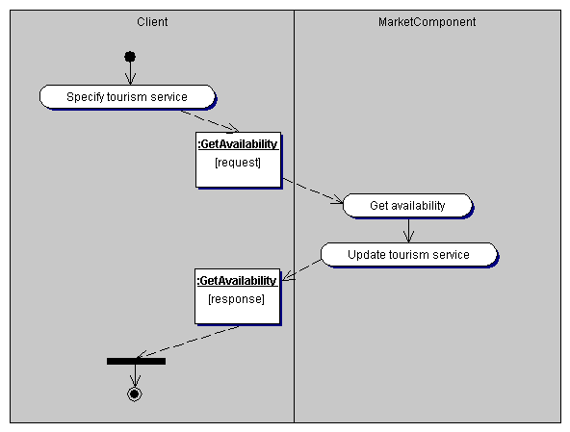
Figure 6-144: Get availability scenario
The get availability process is comprised of the following activities:
- The client specifies the tourism service, for which the availability is requested.
- The get availability request is sent to the market component, offering the tourism service.
- The market component, receiving the get availability request, achieves the availability of the tourism service and all its components.
- The tourism service, contained in the get availability request is updated, i.e. the availabilities of the service components are added to the service specification.
- The get availability response is sent to the client, containing the tourism service and its availability.

Entities
The package Entities contains all entities necessary for executing the information processes. Figure 6-145 shows all entities of the information processes.

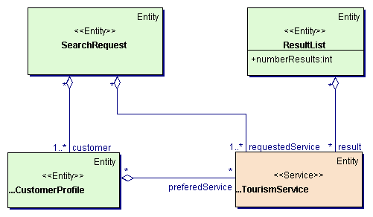
Figure 6-145: Entities of information processes
Class descriptions
Class ResultList
The class ResultList represents a list of results of a search process, consisting of a collection of offered services.
Attributes
The attribute numberResults specifies the number of results contained within the result list.
Associations
The aggregation result specifies a collection of offered services as result of a search request.
Class SearchRequest
The class SearchRequest represents a request to search for tourism services, which fulfill specific requirements. The requirements are specified as an example service.
Associations
The aggregation customer specifies the customers requesting the tourism services.
The aggregation requestedService specifies the services, requested by the search request.

Booking processes
The package BookingProcesses provides processes and necessary entities dealing with the booking of tourism services. Provided processes are booking tourism services, altering a booking and canceling a booking. Figure 6-146 illustrates the structure of the market component providing the booking processes.
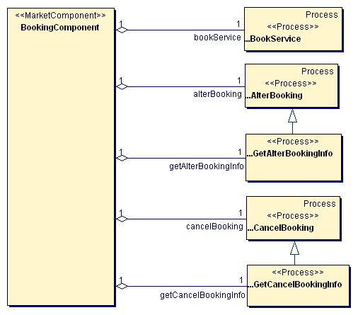
Figure 6-146: Structure of the booking component
Class descriptions
Class BookingComponent
The class BookingComponent represents the booking component, providing all booking processes like booking a tourism service or canceling a booking. This class definition provides the necessary meta data about the structure of the booking component, i.e. the provided processes.
Lớp BookingComponent biểu diễn thành phần đặt, cung cấp tất cả quy trình đặt như đặt 1 dịch vụ du lịch, hủy 1 dịch vụ đã đặt. Định nghĩa lớp này cung cấp siêu dữ liệu cần thiết về cấu trúc của thành phần đặt ví dụ: quy trình được cung cấp.
Associations
The aggregation alterBooking specifies the alter booking process of the booking component.
The aggregation bookService specifies the booking service process of the booking component.
The aggregation cancelBooking specifies the cancel booking process of the booking component.
The aggregation getAlterBookingInfo specifies the get alter booking info process of the booking component.
The aggregation getCancelBookingInfo specifies the get cancel booking info process of the booking component.

Book service process
The package BookServiceProcess specifies the process of booking a tourism service and provides all entities and scenarios for the book service process. The booked tourism service is a service offered by a supplier, normally as a result of a search request. In the case of booking a composition service, consisting of several tourism services, the booking process must be executed as an atomic transaction, i.e. all or none of the components must be booked. As soon as one of the components of a composition service cannot be booked, all already booked components must be cancelled. Hence, all suppliers must offer the possibility to cancel a booking within a definite period of time without charge or provide specific functionality for a two-phase booking process (booking request and booking confirmation).
Gói BookServiceProcess đặt tả quy trình đặt 1 dịch vụ du lịch và cung cấp tất cả các thực thể và kịch bản cho quy trình đặt dịch vụ. Việc đặt dịch vụ du lịch là 1 dịch vu đươc đưa ra bởi 1 nhà cung cấp, thông thường là 1 kết quả của yêu cầu tìm kiếm. Trong trường hợp đặt dịch vụ kết hợp gồm nhiều dịch vụ du lịch, quy trình đặt cần được thực hiện như 1 giao dịch nguyên tử. ví dụ: tất cả hoặc ko thành phần nào được đặt. Ngay khi 1 trong các thành phần của dịch vụ kết hợp ko dược đặt, tát cả các thành phần đã đặt khác bị hủy. Do đó, tất cả nhà cung cấp cần đưa ra khả năng hủy đặt trong 1 thòi gian hữu hạn mà không mất phí hoặc cung cấp chức năng rõ rang cho 2 pha xử lý đặt (yêu cầu đặt và xác nhận đặt)
Figure 6-147 illustrates the structure of the book service process.

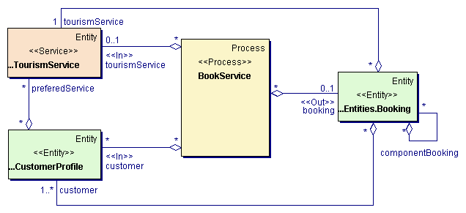
Figure 6-147: Book service process
Class descriptions
Class BookService
The class BookService represents the process of booking a tourism service.
Associations
The aggregation booking specifies the booking as result of the book service process. Booking is an output element of the book service process.
The aggregation customers specifies the customers booking the tourism service. Customers is an input element of the book service process.
The aggregation tourismService specifies the tourism service, which has to be booked. TourismService is an input element of the book service process.

Figure 6-148 illustrates the flow of activity of the book service process.

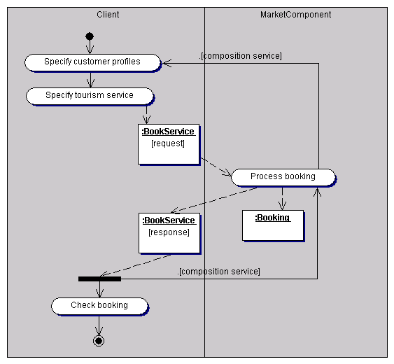
Figure 6-148: Book service scenario
The book service process is comprised of the following activities:
- The client specifies customer profiles for all traveling persons. Obligatory information are general customer data like name and address as well as payment information.
- Client xác định thông tin khách hàng cho tất cả người du lịch. Thông tin bắt buộc là dữ liệu khách hàng chung như tên, địa chỉ. cũng nhe thông tin thanh toán
- The client specifies the tourism service, which has to be booked. The specified tourism service may be an elementary service or a composition service, composed of several elementary services.
- Client đặc tả dịch vụ du lịch, cái mà được đặt. dịch vụ du lịch cụ thể có thể là 1 dịch vụ cơ bản hoặc dịch vụ kết hợp
- The book service request is sent to the market component, offering the tourism service.
- Yêu cầu đặt dịch vụ gửi đến thành phần chợ, đưa ra dịch vụ du lịch
- The market component, receiving the book service request, processes the booking. The tourism service is booked (if available) and a corresponding booking is created, containing all relevant booking information. In the case of booking a composition service consisting of elementary services from different suppliers, a booking process for all corresponding components of the composition is initiated.
- Thành phần chợ, nhận yêu cầu đặt, xử lý đặt. dịch vụ du lịch được đặt (nếu khả dụng) và việc đặt tương ứng được tạo, bao gồm tất cả thông tin đặt thích hợp. Trong trường hợp đặt 1 dịch vụ kết hợp gồm nhiều dich vụ cơ bản từ các nhà cung cấp khác nhau, quy trình đặt cho tất cả các thành phần tương ứng hợp thành đươc tạo
- The book service response, containing the created booking, is returned to the client. In the case of a composition service, the booking information are integrated into the overall booking.
- Đáp ứng book service, gồm tạo đặt dịch vụ, trả về cho client. Trong trường hợp dịch vụ kết hợp, thông tin đặt tích hợp vào toàn bộ quá trình đặt
- The client can use the returned booking information to check the executed booking or print travel documents.
- Client có thể sử dụng thông tin trả về việc đặt để kiểm trả việc thử thi đặt hoặc in tài liệu du lịch

Alter booking process
The package AlterBookingProcess specifies the process of altering a booking of a tourism service and provides all entities and scenarios for the alter booking process. By means of altering a booking, the booked tourism service as well as the customer data can be modified. Analog to the booking service process, the alter booking process must be executed as an atomic transaction. If the booking of one component cannot be modified or cancelled or one new component cannot be booked, all already executed actions must be withdrawn.
Figure 6-149 illustrates the structure of the alter booking process.

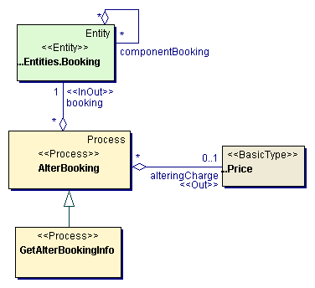
Figure 6-149: Alter booking process
Class descriptions
Class AlterBooking
The class AlterBooking represents the process of altering a booking of a tourism service.
Associations
The aggregation booking specifies the altered booking. Booking is an input-output element of the alter booking process.
The aggregation alteringCharge specifies the charge for altering the booking. AlteringCharge is an output element of the alter booking process.
Class GetAlterBookingInfo
The class GetAlterBookingInfo represents the process of achieving information about the alter booking process, especially the charge for altering the booking, without altering the booking. The get alter booking info process has the same input and output elements as the alter booking process.

Figure 6-150 illustrates the flow of activity of the alter booking process.

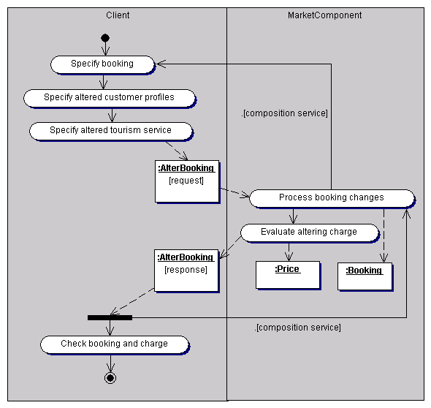
Figure 6-150: Alter booking scenario
The alter booking process is comprised of the following activities:
- The client specifies the booking, which has to be altered
- The client specifies the altered customer profiles and the altered tourism service. Within the altered tourism service, components can be deleted and new components can be added.
- The alter booking request is sent to the market component, where the original booking has been executed.
- The market component, receiving the alter booking request, processes the changes of the booking. Deleted components are cancelled, new components are booked and customer information are changed. In the case of a composition service, the alter booking process is initiated for all corresponding bookings of components of the composition. In the case of a get alter booking information process, this step is omitted and no changes of the booking are executed.
- The market component evaluates the charge for altering the booking. The charge may depend on the remaining time until the beginning of the usage period of the tourism service and the type of changes.
- The alter booking response, containing the altered booking and the altering charge, is returned to the client. In the case of a composition service, the returned information are integrated into the overall alter booking process.
- The client can check the booking information and the altering charge.

Cancel booking process
The package CancelBookingProcess specifies the process of canceling a booking of a tourism service and provides all entities and scenarios for the cancel booking process. The charge for canceling a booking may vary between no charge up to the whole price of the tourism service, depending on the remaining time until the begin of the usage period of the tourism service. Figure 6-151 illustrates the structure of the cancel booking process.
Gói CancelBookingProcess xác định quy trình hủy dịch vụ của 1 dịch vụ du lịch và cung cấp tất cả các thực thể và kịch bản cho quy trình hủy việc đặt. Cước phí cho việc hủy việc đặt có thể thay đổi từ không cước phí đến toàn bộ phí của dịch vụ du lịch, phụ thuộc vào thời gian từ lúc hủy,

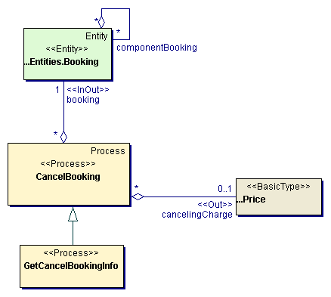
Figure 6-151: Cancel booking process
Class descriptions
Class CancelBooking
The class CancelBooking represents the process of canceling a booking of a tourism service.
Associations
The aggregation booking specifies the booking, which has to be or has been cancelled. Booking is an input-output element of the cancel booking process.
The aggregation cancelingCharge specifies the charge for canceling the booking. CancelingCharge is an output element of the cancel booking process.
Class GetCancelBookingInfo
The class GetCancelBookingInfo represents the process of achieving information about the cancel booking process, especially the charge for canceling the booking. The get cancel booking info process has the same input and output elements as the cancel booking process.

Figure 6-152 illustrates the flow of activity of the cancel booking process.

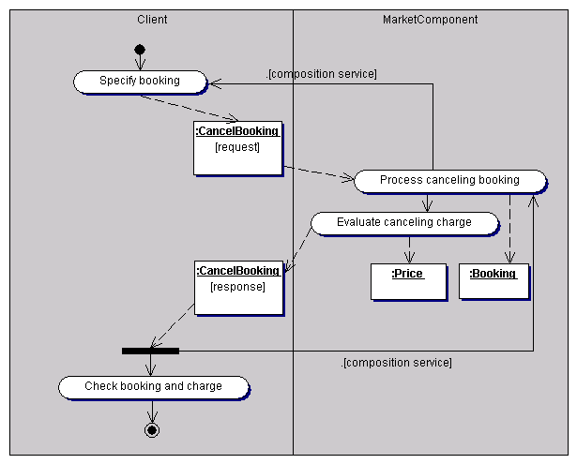
Figure 6-152: Cancel booking scenario
The cancel booking process is comprised of the following activities:
- The client specifies the booking, which has to be canceled.
- The cancel booking request is sent to the market component, where the original booking was executed.
- The market component, receiving the cancel booking request, processes the canceling of the booking. In the case of a composition service with components of different suppliers, the cancel booking process is initiated for all corresponding components. In the case of a get cancel booking info process, this step is omitted.
- The market component evaluates the charge for canceling the booking, depending on the remaining time until the beginning of the usage period of the tourism service.
- The cancel booking request, containing the cancelled booking and the canceling charge, is returned to the client. In the case of a composition service, the canceling information are integrated onto the overall cancel process.
- The client can check the booking information and the canceling charge.

Entities
The package Entities contains all entities necessary for executing the booking processes. Figure 6-153 shows all entities of the booking processes.

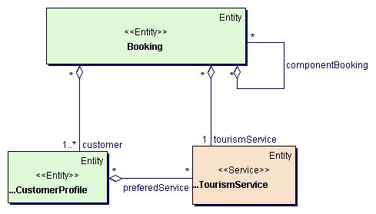
Figure 6-153: Entities of booking processes
Class descriptions
Class Booking
The class booking represents a booking of a tourism service and contains all necessary customer information and the booked tourism service. In the case of a composition service, the booking contains a booking for each component of the composition service.
Associations
The aggregation customer specifies customer profiles for all customers of the tourism service. Obligatory information are the basic customer date (name, address and person type) for each customer as well as payment information.
The aggregation tourismService specifies the booked tourism service.
The aggregation componentBooking specifies the bookings for all components of the booked tourism service (in the case of a composition service).

XML model
The reference model provides a conceptual model based on the UML. This conceptual model focuses on semantic aspects of the modelled problem domain and specifies no details of the physical representation. In order to use XML documents as communication mechanism, the exact structure of the XML documents has to be derived from the conceptual UML model. The XML model can be derived directly from the UML model., without the need to provide specific UML-extensions or building blocks. The reference model will use DTDs (Document Type Definitions) as one possible language to describe the structure of XML documents. However, any other language for describing the structure of XML documents (e.g. schemata) may be used and corresponding physical models may be derived from the conceptual UML model.
DTDs describe the exact structure of XML documents. Therefore, when deriving DTDs from an UML model, for all parts of the UML model has to be defined a physical representation within the XML document. Because XML documents can be structured in different ways, the derivation of DTDs is not unequivocal. From one UML model can be derived different XML models with different DTDs (see Jeckle 2000, Winkens 2000). E.g. attributes of elements like the category of a hotel may be modelled as XML attributes or as embedded XML elements (Element Normal Form) or aggregation relationships between elements like a room as part of a hotel may be modelled as embedded XML elements or as references. Therefore, the reference model just provides one possible schema for deriving UML models into XML DTDs. Providing a conceptual model with the possibility to derive different XML models enables interoperability between different specific XML models with different DTDs.
DTDs lack in the ability to express all information contained within a UML model. Therefore, the reference model additionally provides XMI descriptions. XMI (XML-based Metadata Interchange, Unisys 1999) is a standardized language for describing UML models. XMI descriptions can be used additionally to DTDs, in order to make the complete information of UML models available to the communication partners, or XMI descriptions can substitute DTDs. The XML documents are then constructed directly based on the XMI descriptions. In contrast to DTDs, the XMI descriptions do not specify the exact structure of XML document, because they directly correspond to the conceptual UML model. Therefore, the reference model must specify the exact XML structure for all UML elements, in order to ensure a uniform construction of XML documents.

DTD-based XML model
The reference model has to define one possible schema for deriving XML DTDs from UML models. This derivation can be executed in different ways according to different requirements (see Winkens 2000). A simple, intuitive structure of XML documents or a complete mapping of all UML concepts without loss of information are different requirements leading to different DTDs.
The basic requirement for the derivation schema, provided by the reference model, is a simple and intuitive structure of the XML document. The generated DTDs will then be similar to manually created DTDs and have no unnecessary complicated structure.
The XMI generation principles (Unisys 1999) fulfil this requirement. The XMI documents, describing a UML model are created based on specific DTDs. This DTDs specify the general structure of XMI documents and correspond to the UML metamodel. Because the UML metamodel itself is modelled by the UML, the XMI generation principles defines a schema for deriving DTDs from UML models. This schema considers all the basic concepts of the UML used within the UML metamodel, which are defined by the MOF (Meta Object Facility) as part of the general OMG meta-metamodel. The generated DTDs therefore fulfil the requirement for a simple and intuitive structure. Hence, the reference model will use the XMI schema for deriving DTDs from UML models.

XMI-based XML model
XMI documents can complement DTDs in specifying the structure of XML documents or replace them. When using XMI documents instead of DTDs, the exact XML structure has to be defined for all basic concepts of the UML, i.e. it has to be defined, how XMI descriptions have to be interpreted as a definition of XML structures.
The reference model defines the following rules for constructing XML documents for all basic UML concepts, defined within the MOF.
Classes
Instances of UML classes are represented within XML documents as XML elements, with the name of the UML class. The object identity is represented by embedding an ID attribute into the class element.
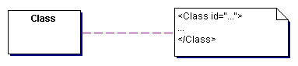
Figure 7-154: Class generation
Attributes
Attributes of an UML class are represented as XML elements embedded within the XML element of the UML class, with the name of the UML attribute. The XML elements for the attributes of a UML class are not ordered.
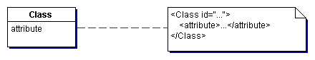
Figure 7-155: Attribute generation
Associations
Aggregation relationships are represented as XML elements embedded within the aggregating XML element, with the name of the role associated to the aggregating UML class. Within the aggregation element the aggregated element is referred to by an IDREF attribute or is embedded.
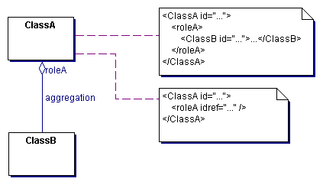
Figure 7-156: Aggregation generation
Navigable associations are represented as XML elements embedded within the XML elements of all UML classes participating in the association. The association elements have the name of the roles of the corresponding UML classes within the association. Analogues to aggregations, the associated elements are referred to by IDREF attributes or are embedded.
Not navigable associations are represented as specific XML elements containing references to all elements participating within the association.
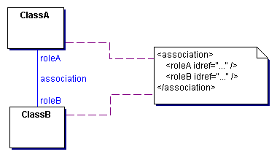
Figure 7-157: Association generation

BOI model
The conceptual model, provided by the reference model, focuses on semantic aspects of the modelled problem domain and specifies no details of any physical representation. In order to use distributed objects as communication mechanism, the exact interfaces of the distributed objects, the business object interfaces (BOIs), have to be specified. Therefore, the conceptual UML model has to be extended by object interface specific details into the direction of a physical UML model. The reference model supports the construction of a physical UML model for distributed objects by providing a metamodel (with specific UML extensions) and building blocks for business object interfaces.
In order to enable maximal flexibility and extendibility as well as seamless transition from distributed object models to XML models, the conceptual elements are reused within the modeling of the distributed objects (s. chapter 2.2.2). Each object of the business object interface model encapsulates the corresponding object of the conceptual model and refines this object by all specific details of the object interface.
Business object interfaces can be provided for conceptual elements on all different levels of granularity, i.e. for basic elements like date or time, for tourism services like hotel or flight and for processes like searching or booking. Providing business object interfaces for conceptual building blocks on all levels of granularity leads to a very tight coupling between the communication partners and less flexibility. The advantages of distributed object based communication, i.e. the communication by remote method invocation, type safety, etc. are extensively used, but the flexibility of XML is restricted to the level of attributes of building blocks. In order to make use of the flexibility of XML, the reference model only provides business object interfaces for the building blocks on the highest level of granularity, i.e. the building blocks, representing entire processes (e.g. searching or booking). When building a specific model on the level of business object interfaces, specific business object interfaces on lower levels of granularity can be provided, if necessary.
Figure 8-158 shows the package structure of the business object interface model.
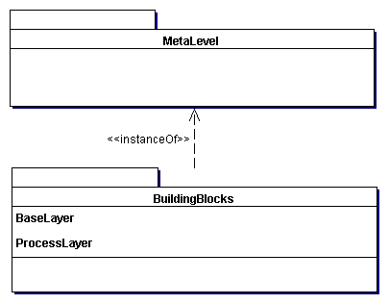
Figure 8-158: Package structure of the BOI model

Meta level
The package MetaLevel provides necessary UML extensions, i.e. stereotypes, for building a business object interface model refining the elements of a conceptual model. The UML extensions are provided as a virtual metamodel (s. chapter 5.1). Figure 8-159 shows all classes of the virtual metamodel.
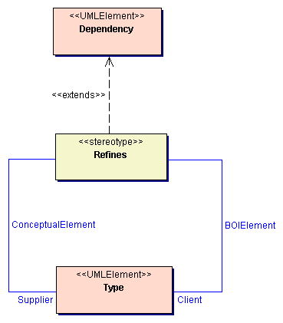
Figure 8-159: Virtual metamodel
Class descriptions
Class Refines
The class Refines enables to specify a dependency relationship between an element of the business object interface model and the corresponding, refined element of the conceptual model. The BOI element inherits the complete semantic of the conceptual element and refines the conceptual element by adding all necessary object interface specific details (i.e. operations or specific attributes). Each instance of the BOI element aggregates an instance of the refined conceptual element, which contains all characteristics defined within the conceptual model.
Associations
The association BOIElement associates a refine relationship with the refining element of the business object interface model.
The association ConceptualElement associates a refine relationship with the refined element of the conceptual model.

Building blocks
The package BuildingBlocks provides general building blocks for constructing business object interface models. The building blocks represent business object interfaces refining elements of the conceptual model and enable the flexible construction or description of specific business object interface models. The reference model only provides business object interface building blocks for specific base classes and the processes of the conceptual model. Figure 8-160 shows the package structure of the different layers of building blocks.
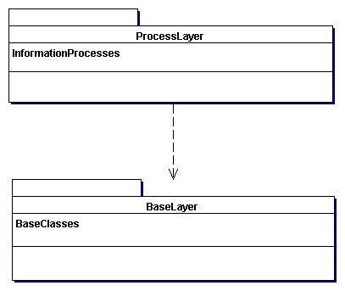
Figure 8-160: Layers of building blocks

Base layer
The base layer serves as a foundation for the higher layers. The base layer encapsulates fundamental aspects and provides base classes and common, not domain specific services. In the current version of the reference model, the base layer of the BOI model only provides necessary base classes. Figure 6-38 shows the package structure of the base layer.
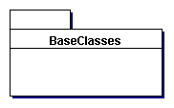
Figure 8-161: Package structure of the base layer

Base classes
The package BaseClasses provides a set of fundamental, abstract base classes. Base classes are used for deriving classes of the higher layers of building blocks and ensure uniformity and consistency of all building blocks. Figure 8-162 shows all base classes.
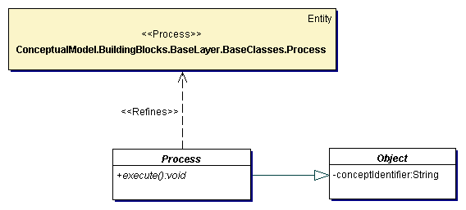
Figure 8-162: Base classes
Class descriptions
Class Object
The class Object is an abstract base class for all classes of the business object interface model and provides basic characteristics for all classes.
Attributes
The attribute conceptIdentifier specifies the element of the conceptual model, refined by this element of the business object interface model. The conceptual element is referenced by an object identifier, specified for all elements of the conceptual model.
Class Process
The class Process represents processes of market components. The class Process is an abstract base class for all concrete processes like searching or booking and specifies basic characteristics of processes.
Operations
The abstract operation execute serves for executing the process. The execute operation reads the input parameter, which must be specified as a precondition, and writes the output parameter as result of the process execution.

Process layer
The process layer provides business object interfaces for all processes defined within the conceptual model (e.g. the search process or the booking process). The current version of the reference model only provides business object interfaces for the information processes search and get availability. Figure 8-163 shows the package structure of the process layer.
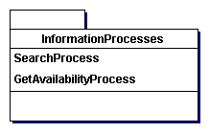
Figure 8-163: Package structure of the process layer

Information processes
The package InformationProcesses provides processes dealing with the retrieval of information about tourism services (e.g. searching for tourism services, checking the availability).

Search process
The package SearchProcess specifies the process of searching for a tourism service fulfilling specific requirements and provides all business object interfaces and scenarios for the search process. Figure 8-164 illustrates the structure of the search process.

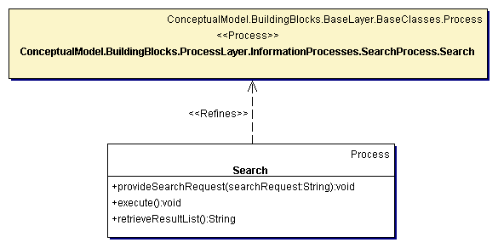
Figure 8-164: Search process
Class descriptions
Class Search
The class Search represents the business object interface for the search process. This class is a refinement of the search entity of the conceptual model and specifies all necessary operations for the business object interface.
Operations
The operation provideSearchRequest enables to provide the search request, containing all information necessary for searching for a specific tourism service. The parameter searchRequest specifies the search request as an XML document, derived from the conceptual entity SearchRequest.
The operation execute executes the search process. This operation searches for all tourism services, fulfilling the specified search request and collects all found tourism services in a result list.
The operation retrieveResultList enables to retrieve the results of the search process as a list of found tourism services. The result list is returned as an XML document, derived from the conceptual entity ResultList.
Figure 8-165 illustrates the interaction between a user (i.e. market component) and the search object provided by a market component for executing the search process.

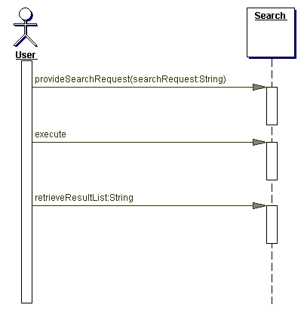
Figure 8-165: Search scenario
The search process is comprised of the following activities:
- As a precondition for executing the search process, the user has to provide a search request, containing all information, necessary for executing the search.
- The user then initiates the execution of the search process, by calling the operation execute.
- Finally, the user retrieves the results of the search process, i.e. the found tourism services, by calling the operation retrieveResultList.

Get availability process
The package GetAvailabilityProcess specifies the process of retrieving the availability of a tourism service and provides all business object interfaces and scenarios for the get availability process. Figure 8-166 illustrates the structure of the get availability process.

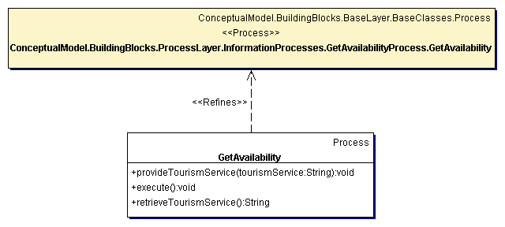
Figure 8-166: Get availability process
Class descriptions
Class GetAvailability
The class GetAvailability represents the business object interface for the get availability process. This class is a refinement of the get availability entity of the conceptual model and specifies all necessary operations for the business object interface.
Operations
The operation provideTourismService enables to provide the tourism service, which availability is requested. The parameter tourismService specifies the tourism service as an XML document, derived from the conceptual entity for the specific tourism service.
The operation execute executes the get availability process. The availability of the provided tourism service and all its components are evaluated and the results are written to the provided tourism service.
The operation retrieveTourismService enables to retrieve the tourism service, containing the evaluated availability. The tourism service is returned as an XML document, derived from the conceptual entity for the specific tourism service.
Figure 8-167 illustrates the interaction between a user (i.e. market component) and the get availability object provided by a market component for executing the get availability process.

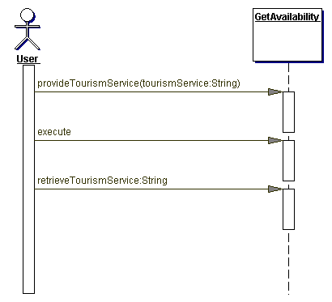
Figure 8-167: Get availability scenario
The get availability process is comprised of the following activities:
- As a precondition for executing the get availability process, the user has to provide the tourism service, which availability is requested.
- The user then initiates the execution of the get availability process, by calling the operation execute.
- Finally, the user retrieves the results of the get availability process, i.e. the availability of the tourism services and all its components, by calling the operation retrieveTourismService.

References
Bleile, G. (1995): Tourismusmärkte: Fremdenverkehrsmarkt - Hotelmarkt - Touristikmarkt - Bädermarkt - Luftverkehrsmarkt im Wandel. München, Oldenbourg.
Bohrer, K. et al. (1998): Distributed Object Applications. Communications of the ACM, Vol. 41, No. 6, pp. 43-48.
Booch, G. (1994): Objektorientierte Analyse und Design. Bonn, Addison-Wesley.
Bourret, R. et al (1999): Document Definition Markup Language (DDML) Specification, Version 1.0, W3C Note, http://www.w3.org/TR/NOTE-ddml.
Bray, T. et al (1998): Extensible Markup Language (XML) 1.0, W3C recommendation, http://www.w3.org/TR/REC-xml.
Davidson, A. et al (1999): Schema for Object-Oriented XML 2.0, W3C Note, http://www.w3.org/TR/NOTE-SOX.
Ebner, A. (1994): TIS - Tirol Informations System - Die Konsequenz einer Idee. In: Schertler, W. (Hrsg.): Tourismus als Informationsgeschäft - Strategische Bedeutung neuer Informations- und Kommunikationstechnologien im Tourismus. Wien, Ueberreuter.
Glushko, R.J., Tenenbaum, J.M., Meltzer, B. (1999): An XML framework for agent-based E-commerce. Communications of the ACM, Vol. 42, No. 3, pp. 106-114.
Jeckle, M. (2000): Entwurf von XML-Sprachen. Java Spektrum – XML Spektrum, Ausgabe 6, Nr. 28, http://www.jeckle.de/entwurfxml/entwurfxml.html.
Layman, A. et al (1998): XML-Data, W3C note, http://www.w3.org/TR/1998/NOTE-XML-data-0105
Mundt, J.W. (1996): Reiseveranstaltung. München, Oldenbourg.
Pröll, B., Retschitzegger, W., Kroiß, P., Wagner, R.R. (1998): Online Booking On The Net - Problems, Issues and Solutions. In: Buhalis, D., Tjoa, A M., Jafari, J. (eds.): Information and Communication Technologies in Tourism, Istanbul, Springer, pp. 268-277.
Schmid, B. (1994): Electronic Markets in Tourism. In: Schertler, W., Schmid, B., Tjoa, A.M., Werthner, H. (eds.): Information and Communications Technologies in Tourism, Innsbruck, Spinger-Verlag, pp. 1-8.
Schroeder, G. (1995): Lexikon der Tourismuswirtschaft. Hamburg, TourCon Hannelore Niedecken GmbH.
Symons, C. (1988): Function Point Analysis: Difficulties and Improvements. IEEE Transactions on Software Engineering, Vol. (14)1.
Tenenbaum, J.M., Chowdhry, T.S., Hughes, K. (1997): Eco System: An Internet Commerce Architecture. IEEE Computer 30 (5), pp. 48-55.
TIN (1992): Die Touristische Informations-Norm (TIN) für den deutschen Fremdenverkehr - Empfehlung für Informations- und Reservierungssysteme. Bonn/München.
UML (1999): OMG Unified Modeling Language Specification, Version 1.3, OMG.
Unisys Corp. et al (1999): XML Metadata Interchange (XMI) 1.1, ftp://ftp.omg.org/pub/docs/ad/99-10-02.pdf.
Weber, M. (1995): Changes in the Leisure Travel Market Result in New Requirements for Tour Operator Systems. In: Schertler, W., Schmid, B., Tjoa, A M., Werthner, H. (eds.): Information and Communication Technologies in Tourism, Innsbruck, Springer-Verlag, pp. 95-102.
Winkens, D., Moerkotte, G. (2000): Variationsmöglichkeiten bei Transformation von Basiskonzepten aus UML-Klassendiagrammen in Dokumenttypdefinitionen. Modellierung 2000, pp.163 – 177.

From a technical point of view, an electronic market consists of one or more co-operating tourism information systems (TIS).
Typical tourism services are accommodation services, transportation services, car hire services, events, package tours, etc.
An electronic market is not to be equated with a tourism information system but is formed by a multitude of co-operating systems (components).
An entity is understood as an element of a problem domain, which represents a delimited part of the problem domain and can exist independent of other elements.
The association extends between the metaclass BasicType and the UML element Type denotes that BasicType is an extension of the UML element Type and the stereotype BasicType can be assigned to all Type elements. Most of the metaclasses of the reference model are extensions of the UML element Type and therefore, when extending the UML element Type the association extends is omitted in further diagrams.
Evaluation instructions are specified by the Object Constraint Language (OCL), which is part of the UML.

